A Project-1 Report

on

**Data Preprocessing using Web Interface**

Submitted to

The Department of Computer Science and Engineering

In partial fulfillment of the academic requirements of

Jawaharlal Nehru Technological University

For

The award of the degree of

Bachelor of Technology

in

Computer Science and Engineering

(2018 – 2022)

By

GUNDLA KAVYA 18311A05T3

CHITYALA UDHAY 18311A05R4

RISHABH SEMWAL 18311A05W2

Under the Guidance of

Archana Nagelli (Assistant Professor)



Sreenidhi Institute of Science and Technology

*(An Autonomous Institution)*

Yamnampet,Ghatkesar,R.R. District,Hyderabad-501301

Department of Computer Science and Engineering

Sreenidhi Institute of Science and Technology

**CERTIFICATE**



This is to certify that this Group Project report on “**Data Preprocessing using Web Interface**”, submitted by G.KAVYA(18311A05T3), CHITYALA UDHAY(18311A05R4),RISHABH SEMWAL(18311A05W2) in the year 2021 in partial fulfillment of the academic requirements of Jawaharlal Nehru Technological University for the award of the degree of Bachelor of Technology in Computer Science and Engineering, is a bonafide work that has been carried out by them as part of their **Group Project during Fourth Year First Semester** , under our guidance. This report has not been submitted to any other institute or university for the award of any degree.

Archana Nagelli Dr . Aruna Varanasi

Assistant Professor Head, Department of CSE

Department of CSE

Internal Guide

External Examiner

Date:-

**DECLARATION**

We, **G.Kavya (18311A05T3), Chityala Udhay(18311A05R4) and Rishabh Semwal (18311A05W2),** students of **SREENIDHI INSTITUTE OF SCIENCE AND TECHNOLOGY, YAMNAMPET, GHATKESAR,** studying 4th year 1st semester, **COMPUTER SCIENCE AND ENGINEERING** solemnly declare that the Group project work, titled **“Data Preprocessing using Web Interface”** is submitted to **SREENIDHI INSTITUTE OF SCIENCE AND TECHNOLOGY** for partial fulfillment for the award of degree of Bachelor of technology in **COMPUTER SCIENCE AND ENGINEERING**.

It is declared to the best of our knowledge that the work reported does not form part of any dissertation submitted to any other University or Institute for award of any degree

**ACKNOWLEDGEMENT**

I would like to express my gratitude to all the people behind the screen who helped me to transform an idea into a real application.

I would like to express my heart-felt gratitude to my parents without whom I would not have been privileged to achieve and fulfill my dreams. I am grateful to our principal, **Dr. T. Ch. Siva Reddy,** who most ably run the institution and has had the major hand in enabling me to do my project.

I profoundly thank Dr. **ARUNA VARANASI**, Head of the Department of Computer Science & Engineering who has been an excellent guide and also a great source of inspiration to my work.

I would like to thank my internal guide **Archana Nagelli** for his/her technical guidance, constant encouragement and support in carrying out my project at college.

The satisfaction and euphoria that accompany the successful completion of the task would be great but incomplete without the mention of the people who made it possible with their constant guidance and encouragement crowns all the efforts with success. In this context, I would like thank all the other staff members, both teaching and non-teaching, who have extended their timely help and eased my task.

**G.Kavya 18311A05T3**

**chityala udhay 18311A05R4**

**rishabh semwal 18311A05W2**

**Abstract**

Data Preprocessing for Data Mining addresses one of the most important issues within the well-known Knowledge Discovery from Data process. Data directly taken from the source will likely have inconsistencies, errors or most importantly, it is not ready to be considered for a data mining process. Furthermore, the increasing amount of data in recent science, industry and business applications, calls to the requirement of more complex tools to analyze it.

The idea is to make one such tool that helps in preprocessing the data as per the user convenience with a proper and comprehensive set of functions and to preprocess the data with a interactive web interface.

|  |  |  |  |
| --- | --- | --- | --- |
|  | **LIST OF FIGURES** | |  |
| **S.No** | **Fig No** | **Title of Figure** | **Page No** |
| 1 | 3.1 | Figure 1: Architecture Diagram | 05 |
| 2 | 3.2 | Figure 2: Use Case Diagram | 07 |
| 3 | 3.3 | Figure 3: Class Diagram | 08 |
| 4 | 3.4 | Figure 4: Sequence Diagram | 09 |
| 6 | 5.1 | Figure 5: Activity Diagram | 10 |

|  |  |
| --- | --- |
| **INDEX** | **Page Number** |
| **Abstract** | i |
| **List of Figures** | ii |
| **1. INTRODUCTION** | 1 |
| 1.1 Scope | 1 |
| 1.2 Existing System | 2 |
| 1.3 Proposed System | 2 |
| **2. SYSTEM ANALYSIS** | 3 |
| 2.1 Functional Requirement Specifications | 3 |
| 2.2 Performance Requirements | 3 |
| 2.3 Software Requirements | 4 |
| 2.4 Hardware Requirements | 4 |
| **3. SYSTEM DESIGN** | 5 |
| 3.1 Architecture of Proposed System | 5 |
| 3.2 Modules | 6 |
| 3.3 UML Diagrams | 7 |
| 3.3.1 Use Case Diagram | 7 |
| 3.3.2 Class Diagram | 8 |
| 3.3.3 Sequence Diagram | 9 |
| 3.3.4 Activity Diagram | 10 |
| **4. SYSTEM IMPLEMENTATION** | 11 |
| **5.OUTPUT SCREENS** | 29 |
| **6. CONCLUSION AND FUTURE SCOPE** | 38 |
| **7. BIBLIOGRAPHY** | 39 |
| **8. APPENDIX-A(PYTHON)** | 40 |
| **9.APPENDIX-B(MACHINE LEARNING)** | 46 |
| **10. ABSTRACT** | 48 |
| **11. PROJECT CORRELATION WITH APPROPRIATE POs/PSOs** | 49 |
| **12. NATURE OF THE PROJECT WORK** | 49 |
| **13. DOMAIN OF THE PROJECT WORK** | 50 |

**1. INTRODUCTION**

Real-world data is often noisy, incomplete with missing entries, and more often than not unsuitable for direct use for building models or solving complex data-related problems. There might be erroneous data, or the data might be unordered, unstructured, and unformatted.

The above reasons render the collected data unusable for machine learning purposes. It’s seen that the same data when formatted and cleaned produces more accurate and reliable results when used by machine learning models other than their unprocessed counterparts.

This tool helps the user to preprocess the data with the functionalities of data cleaning, data transformation, data inspection, data encoding, splitting the data etc..

**1.1 Scope**

**Data Preprocessing** is a technique that is used to convert the raw data into a clean data set. In other words, whenever the data is gathered from different sources it is collected in raw format which is not feasible for the analysis. Therefore, certain steps are executed to convert the data into a small clean data set. This technique is performed before the execution of the **Iterative Analysis**. The set of steps is known as Data Preprocessing. It includes -

* Data Cleaning
* [Data Integration](https://www.xenonstack.com/blog/data-integration-tools/)
* [Data Transformation](https://www.xenonstack.com/insights/data-transformation/)
* Data Reduction

### ****Need of Data Preparation Process and Preprocessing****

For achieving better results from the applied model in [Machine Learning](https://www.xenonstack.com/big-data-analytics/machine-learning/) and Deep Learning projects the format of the data has to be in a proper manner, this is where term Data Preparation is used. Some specified Machine Learning and Deep Learning model need information in a specified format, for example, Random Forest algorithm does not support null values, therefore to execute random forest algorithm null values has to be managed from the original raw data set. Another aspect of Data Preparation and analysis is that the data set should be formatted in such a way that more than one Machine Learning and Deep Learning algorithms are executed in one data set, and the best out of them is chosen.

**1.2 Existing System:**

* Frame works like R, Numpy, pandas exist to preprocess the data using the environments like R studio, Jupyter notebook, anaconda which requires programming skills and frame work knowledge.
* A command line interface for preprocessing the data with less user interaction and very less functionalities
* Closed Softwares like Weka, Rapid miner preprocess the data in their own data analytical and data mining environment

**1.3 Proposed System**

* The idea is to create a tool with the sole purpose of preprocessing the datasets before training the machine learning algorithms by providing various data preprocessing functionalities like :
* Data description
* Data cleaning : handling missing data, ignoring tuples, filling the missing values
* Data transformation: min max normalization, feature scaling
* Data encoding: one hot encoding, label encoding
* Splitting the datasets: into testing and training datasets

**2. SYSTEM ANALYSIS**

This System Analysis is closely related to [requirements analysis](http://en.wikipedia.org/wiki/Requirement_analysis). It is also "an explicit formal inquiry carried out to help someone (referred to as the decision maker) identify a better course of action and make a better decision than he might otherwise have made."This step involves [breaking down](http://en.wikipedia.org/wiki/Work_breakdown_structure) the system in different pieces to analyze the situation, analyzing project goals, breaking down what needs to be created and attempting to engage users so that definite requirements can be defined.

The user interfaced system of this tool is web interfaced which helps the user to interact in the process of preprocessing the data.

The front end of the tool is developed using flask, html, javascript provides flexibility with aesthetic looking interface.

**2.1 Functional Requirement Specification**

The System after careful analysis has been identified to be present with the following modules.

* 1. **Description Module:**

The properties and column info is shown in this module.It includes the rangeindex ,the number of entries and memory usage.

**2. Handling Missing Data Module:**

This module handles the missing data in the csv file.This module is responsible for ignoring the missing data and filling the null values.

**3. Feature Scaling Module:**

Feature scaling is a method used to normalize the range of independent variables or features of data. In data processing, it is also known as data normalization and is generally performed during the data preprocessing step.The techniques include min-max normalization and standardization.

**4. Encoding Module:**

This is done for categorical data so that it is converted to machine readable code.The techniques include One hot Encoding and Label Encoding.

**5.Split Dataset Module:**

To train any machine learning model irrespective what type of dataset is being used you have to split the dataset into training data and testing data.

**2.2 Performance Requirements**

Performance is measured in terms of the output provided by the application. Requirement specification plays an important part in the analysis of a system. Only when the requirement specifications are properly given, it is possible to design a system, which will fit into required environment. It rests largely with the users of the existing system to give the requirement specifications because they are the people who finally use the system. This is because the requirements have to be known during the initial stages so that the system can be designed according to those requirements. It is very difficult to change the system once it has been designed and on the other hand designing a system, which does not cater to the requirements of the user, is of no use.

**2.3 Software Requirements**:

* OS : windows / mac / linux
* Browser : chrome / safari / edge / firefox
* Frame works: pandas, numpy, flask

**2.4 Hardware Requirements**:

* RAM: 16GB DDR4
* Hard Disk: 256GB ssd drive.
* Processor: i5 / i7 /i9 take latest version.
* Graphics: Media latest version.

**3.SYSTEM DESIGN**

Systems design is the process of defining the architecture, components, modules, interfaces, and [data](http://en.wikipedia.org/wiki/Data) for a [system](http://en.wikipedia.org/wiki/System) to satisfy specified [requirements](http://en.wikipedia.org/wiki/Requirement). One could see it as the application of [systems theory](http://en.wikipedia.org/wiki/Systems_theory) to [product development](http://en.wikipedia.org/wiki/Product_development). [Object-oriented analysis and design](http://en.wikipedia.org/wiki/Object-oriented_analysis_and_design) methods are becoming the most widely used methods for computer systems design.

**3.1 Architectural Design**

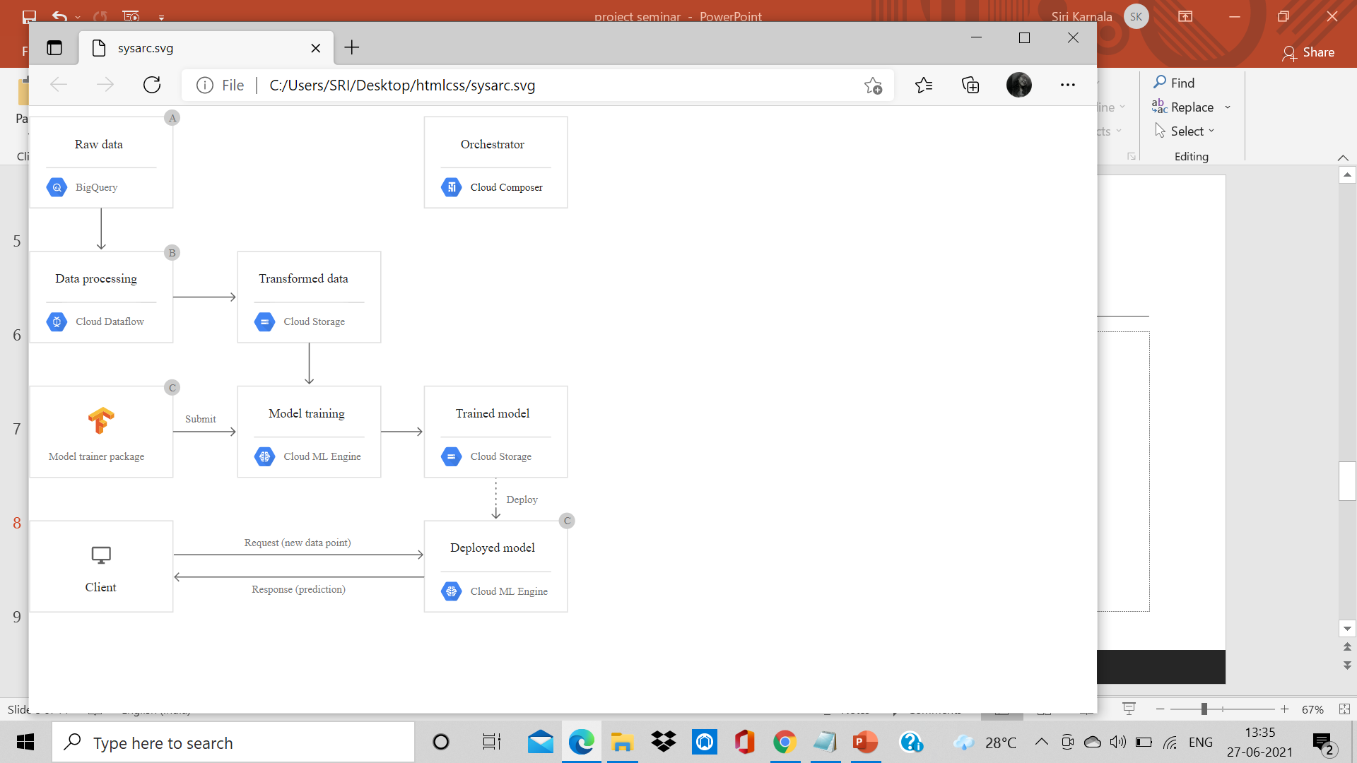

Fig 3.1 Architectural Design

A system architecture is the conceptual model that defines the structure, behavior and more views of a system. An architecture description is a formal description and representation of a system, organized in a way that supports reasoning about the structures and behaviour's of the system.

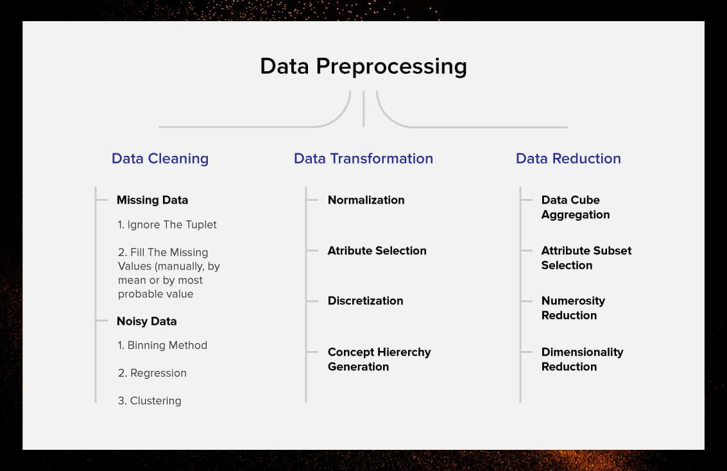

A flowchart is simply a graphical representation of steps. It shows steps in sequential order and is widely used in presenting the flow of algorithms, workflow or processes. Typically, a flowchart shows the steps as boxes of various kinds, and their order by connecting them with arrows.

**3.2 UML Diagrams**

UML Diagrams for our application are as follows:

**3.2.1 Use Case Diagrams**

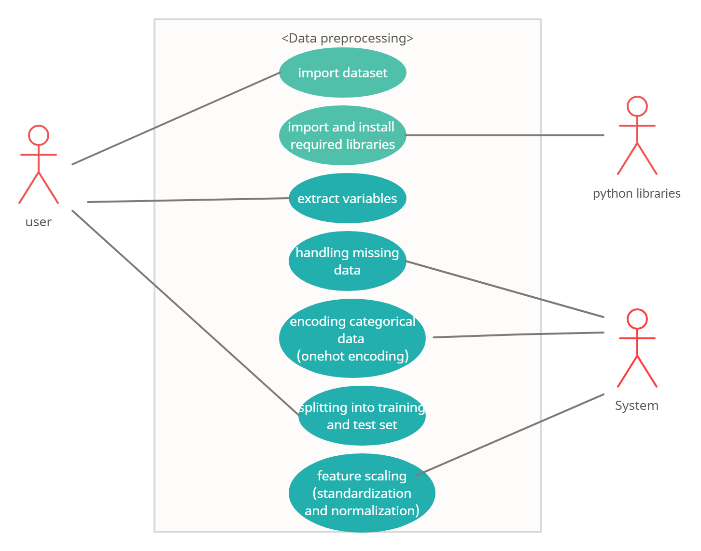

Fig 3.2 Usecase Diagram

A use case diagram is a graphical depiction of a user's possible interactions with a system. A use case diagram shows various use cases and different types of users the system has and will often be accompanied by other types of diagrams as well. The use cases are represented by either circles or ellipses. The actors are often shown as stick figures.

**3.2.2 Class Diagrams**

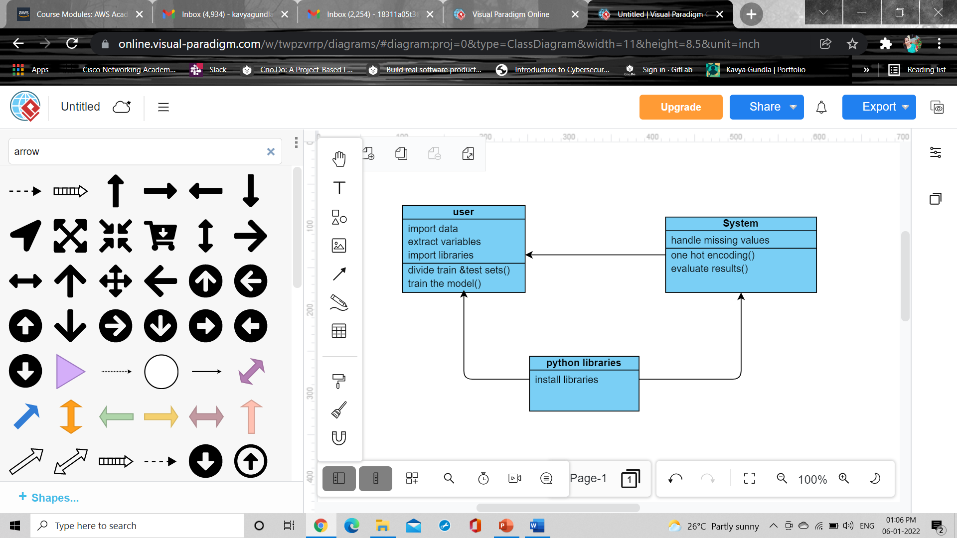

Fig 3.5 Class Diagram

Class diagram is a static diagram. It represents the static view of an application. Class diagram shows a collection of classes, interfaces, associations, collaborations, and constraints. It is also known as a structural diagram.

**3.2.3 Sequence Diagrams**

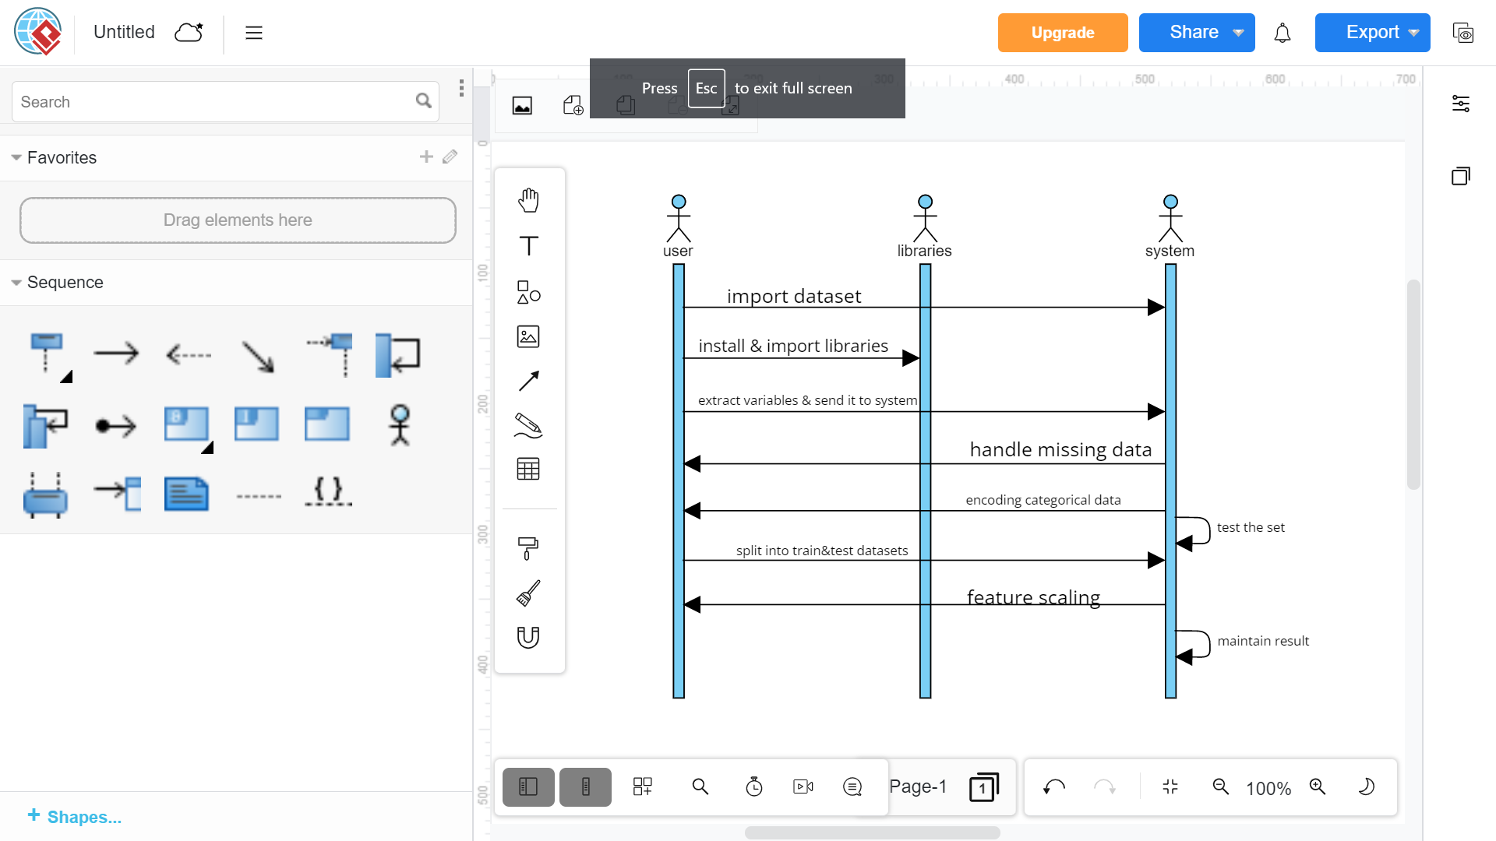

Fig 3.6 Sequence Diagram

A sequence diagram is a type of interaction diagram because it describes how and in what order a group of objects works together.  Sequence diagrams are sometimes known as event diagrams or event scenarios.

**3.2.4 Activity Diagram:**

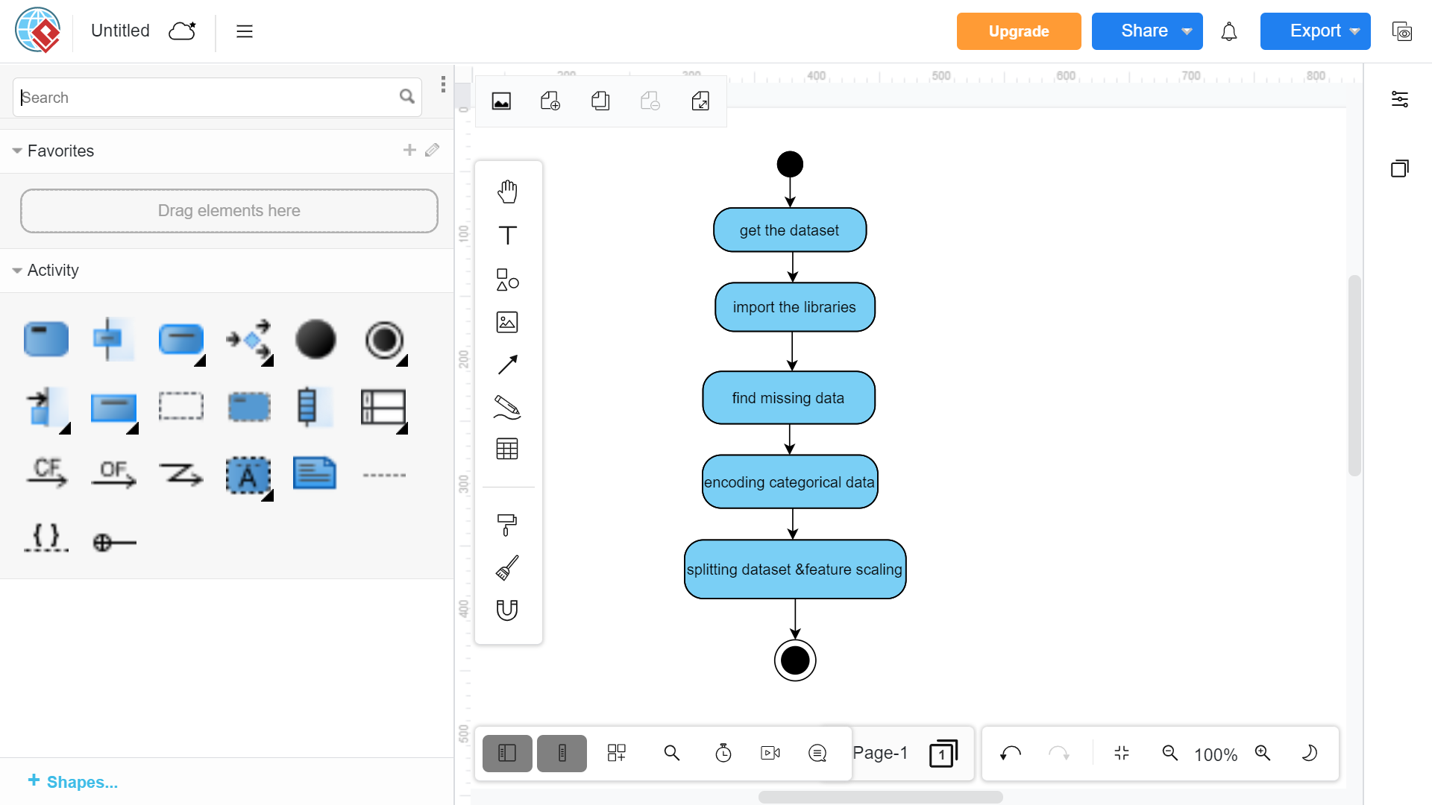

An Activity in the activity diagram is also known as Activity state. It is used to represent the invocation of operation, a step in an entire business process. Swimlane is a way in which the performed activities can be grouped by the same actor on an Activity diagram

**4.SYSTEM IMPLEMENTATION**

The implementation stage of any project is a true display of the defining moments that make a project a success or a failure. The implementation stage is defined as the system or system modifications being installed and made operational in a production environment. The phase is initiated after the system has been tested and accepted by the user. This phase continues until the system is operating in production in accordance with the defined user requirements.

**4.1 Python code:(main.py)**

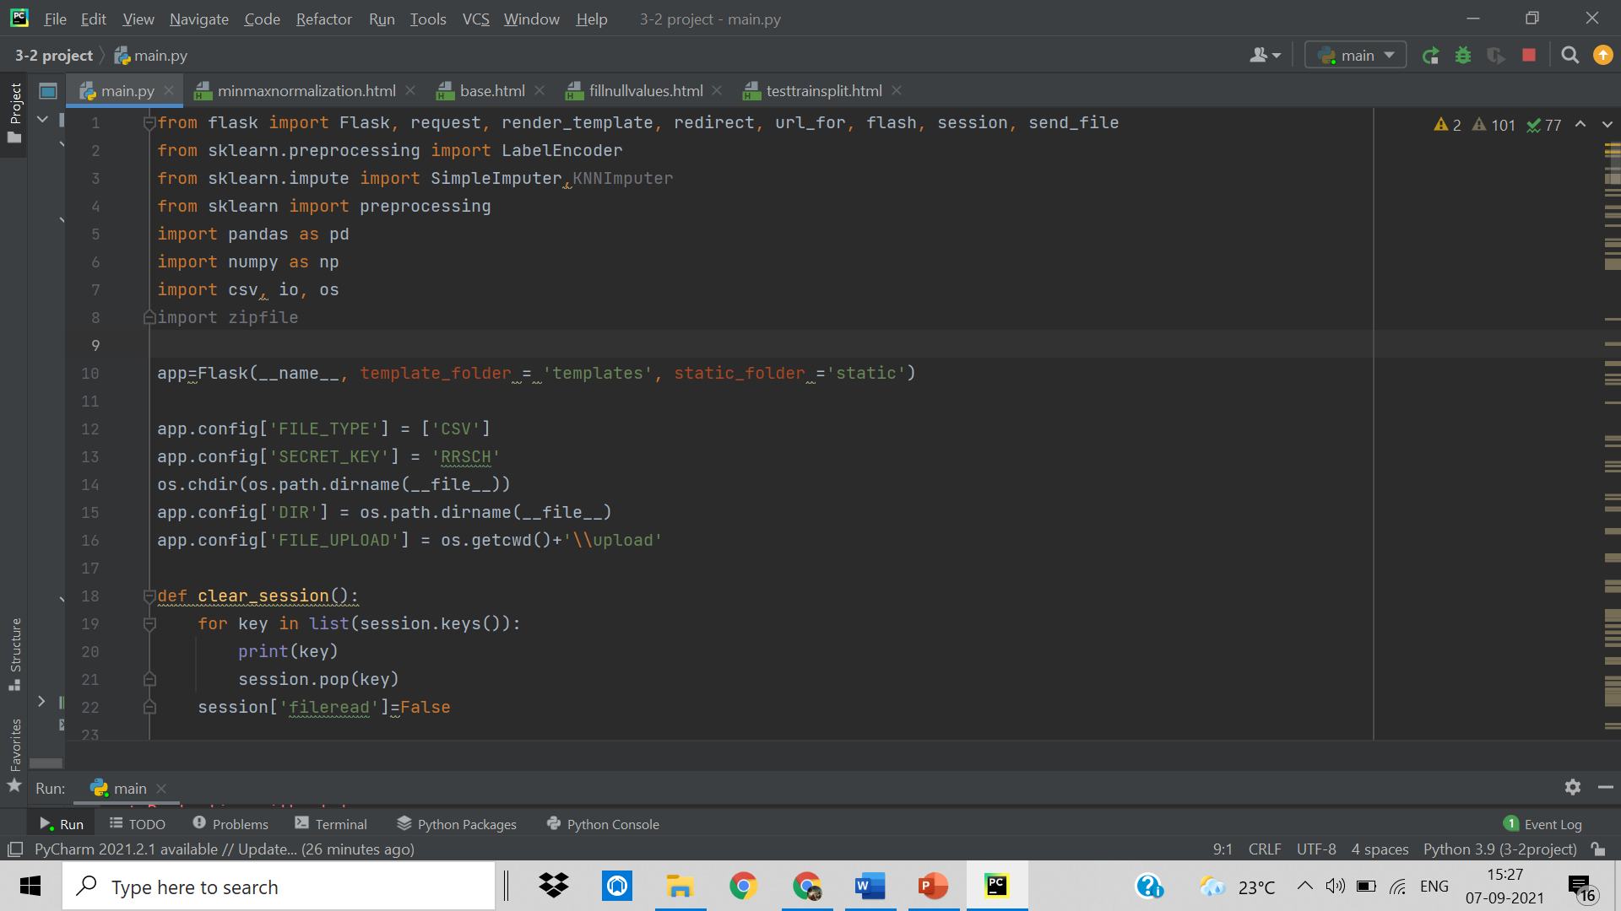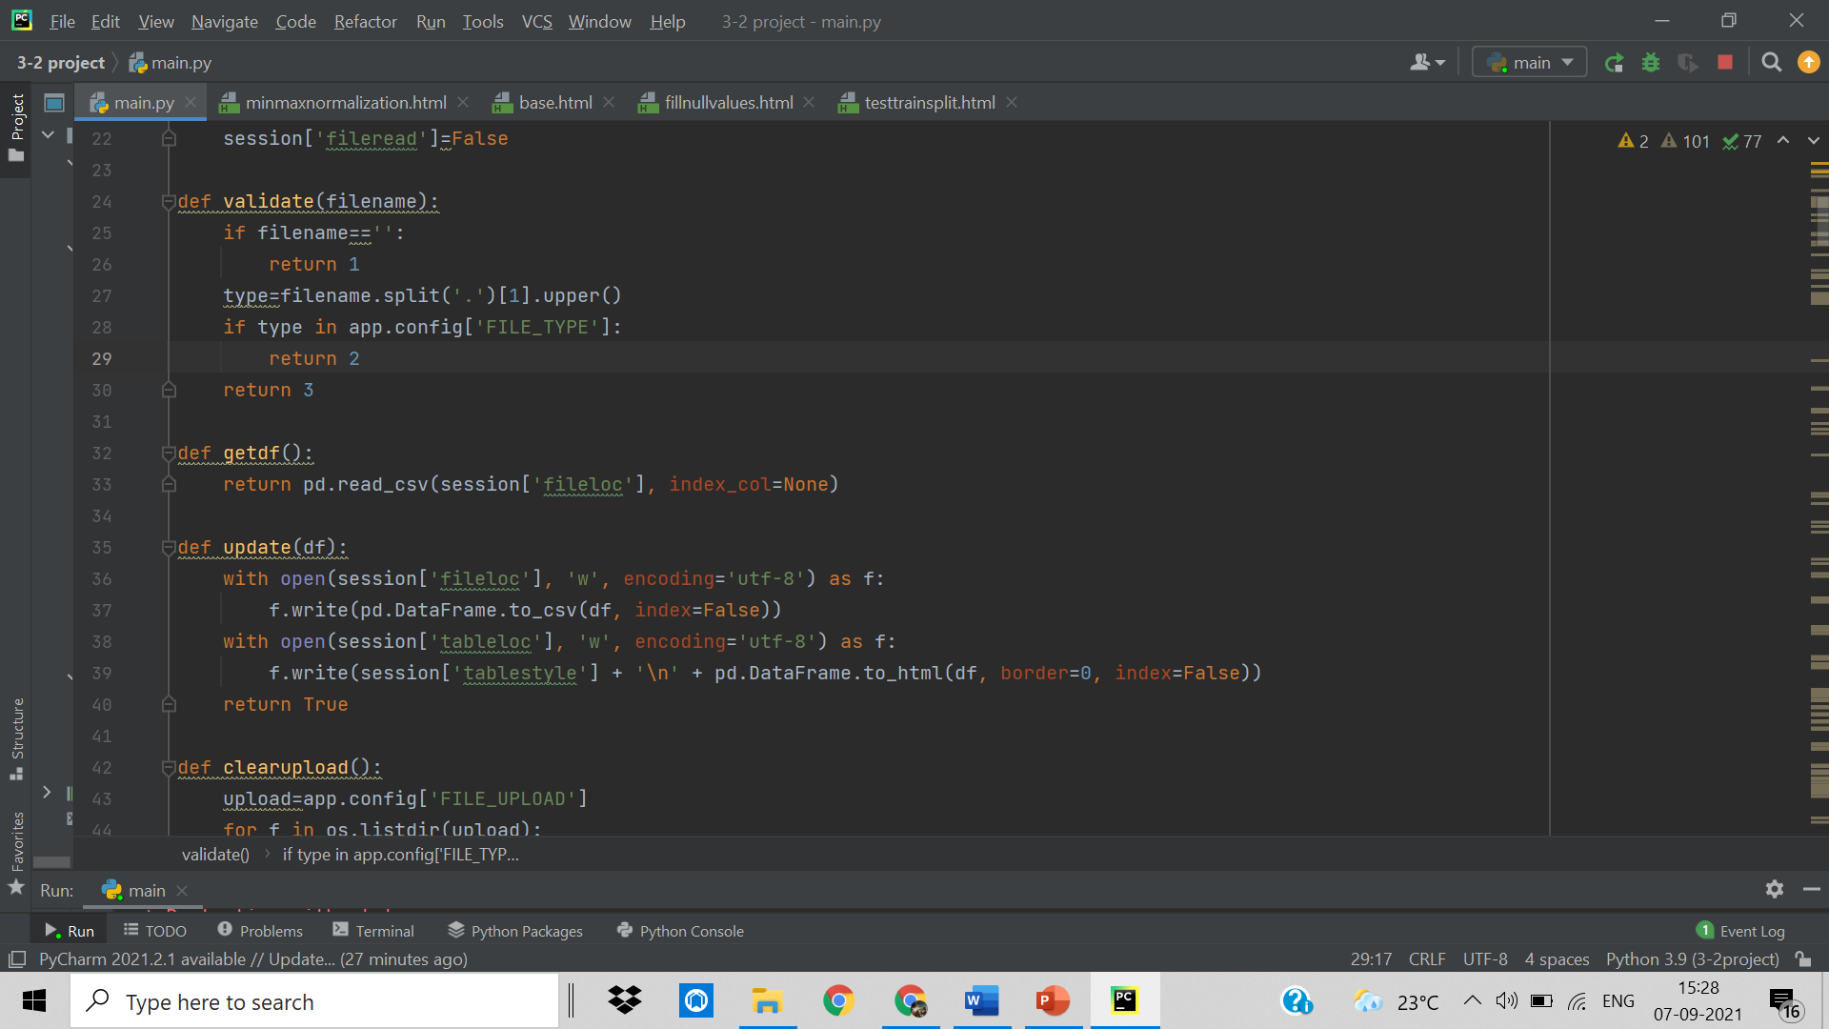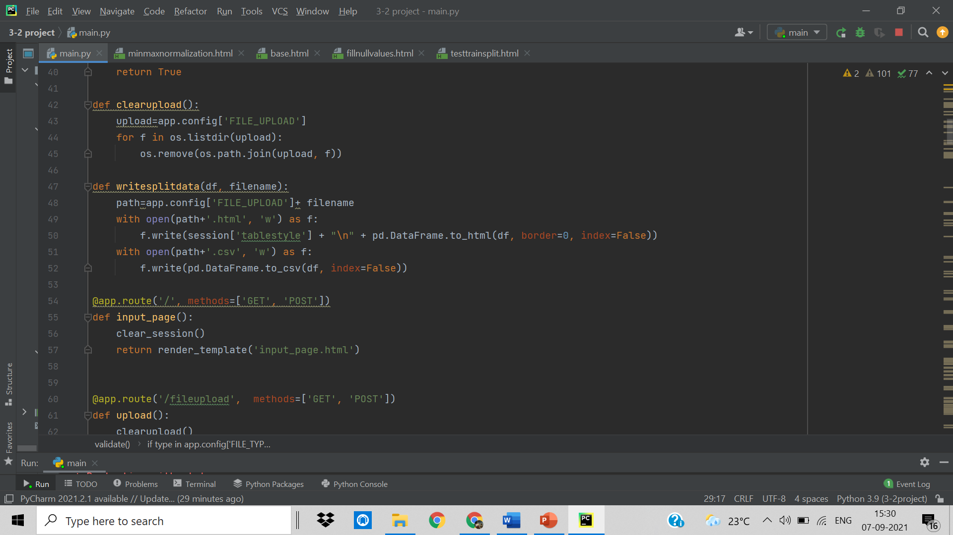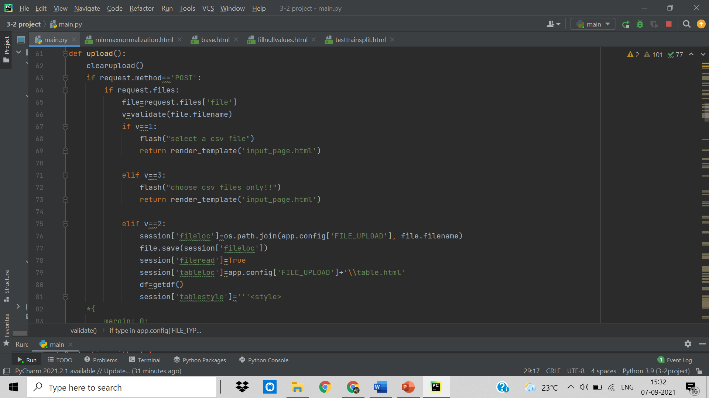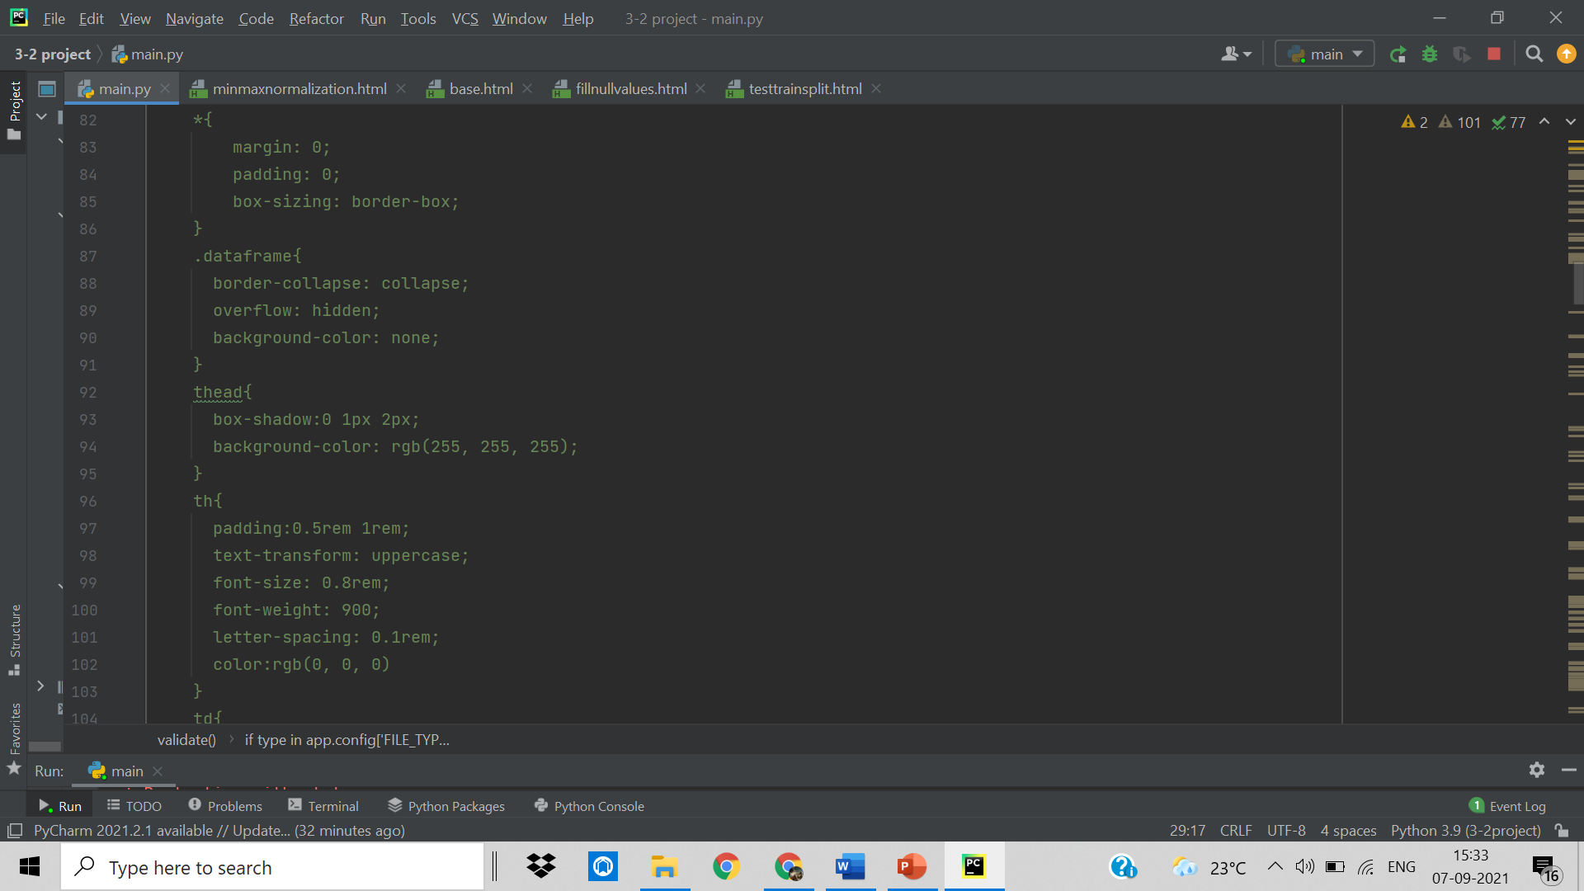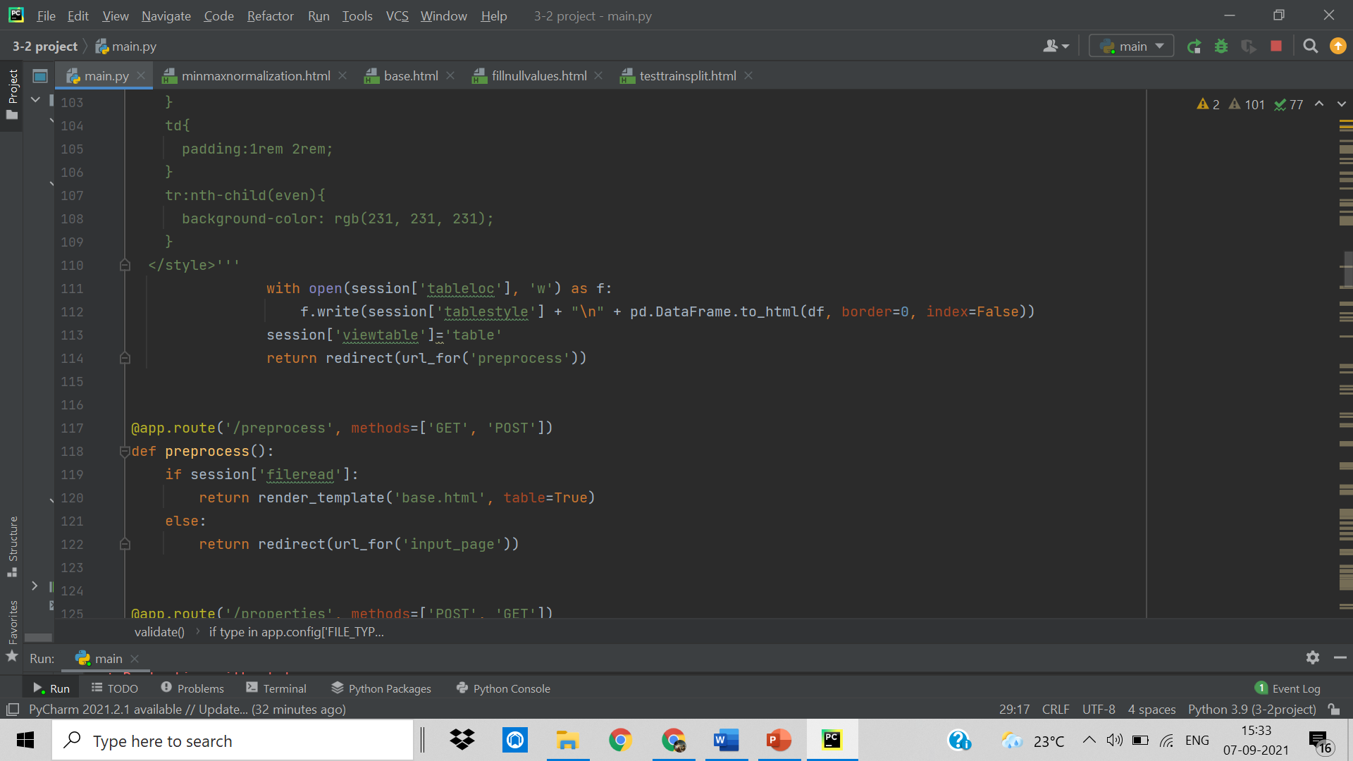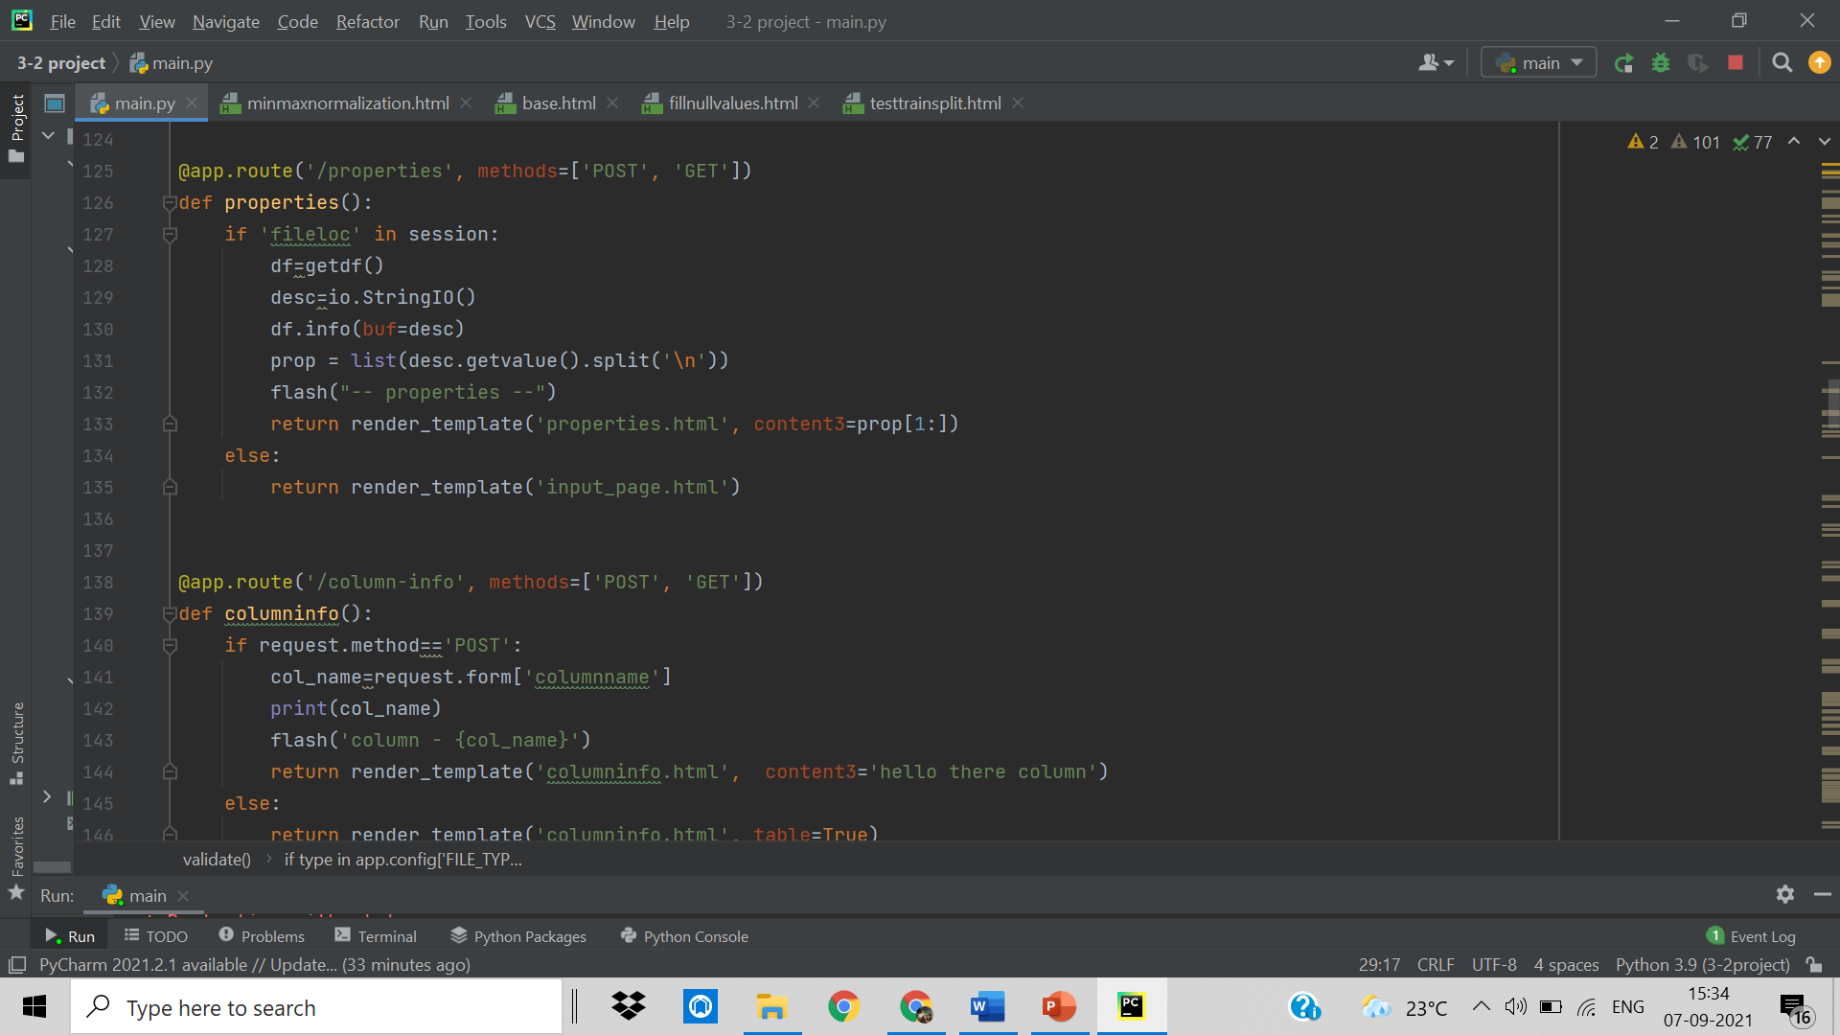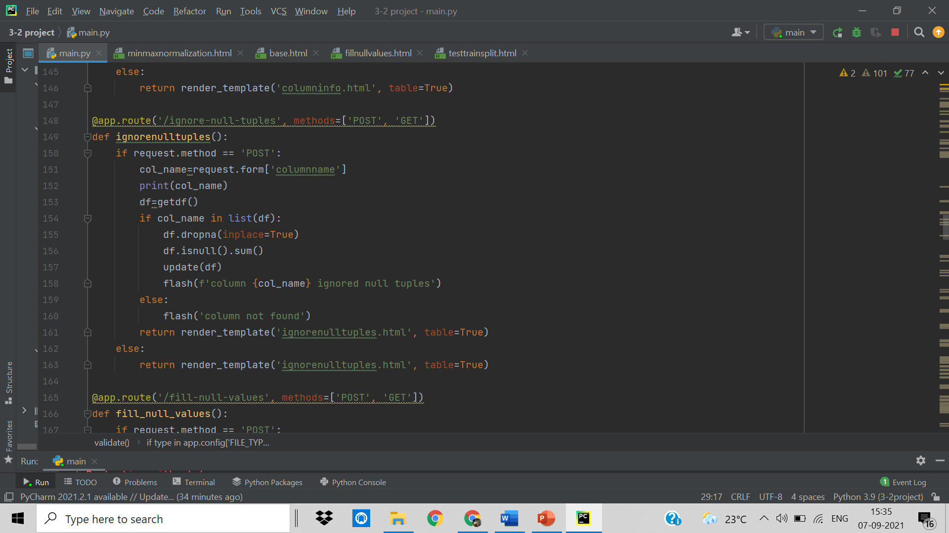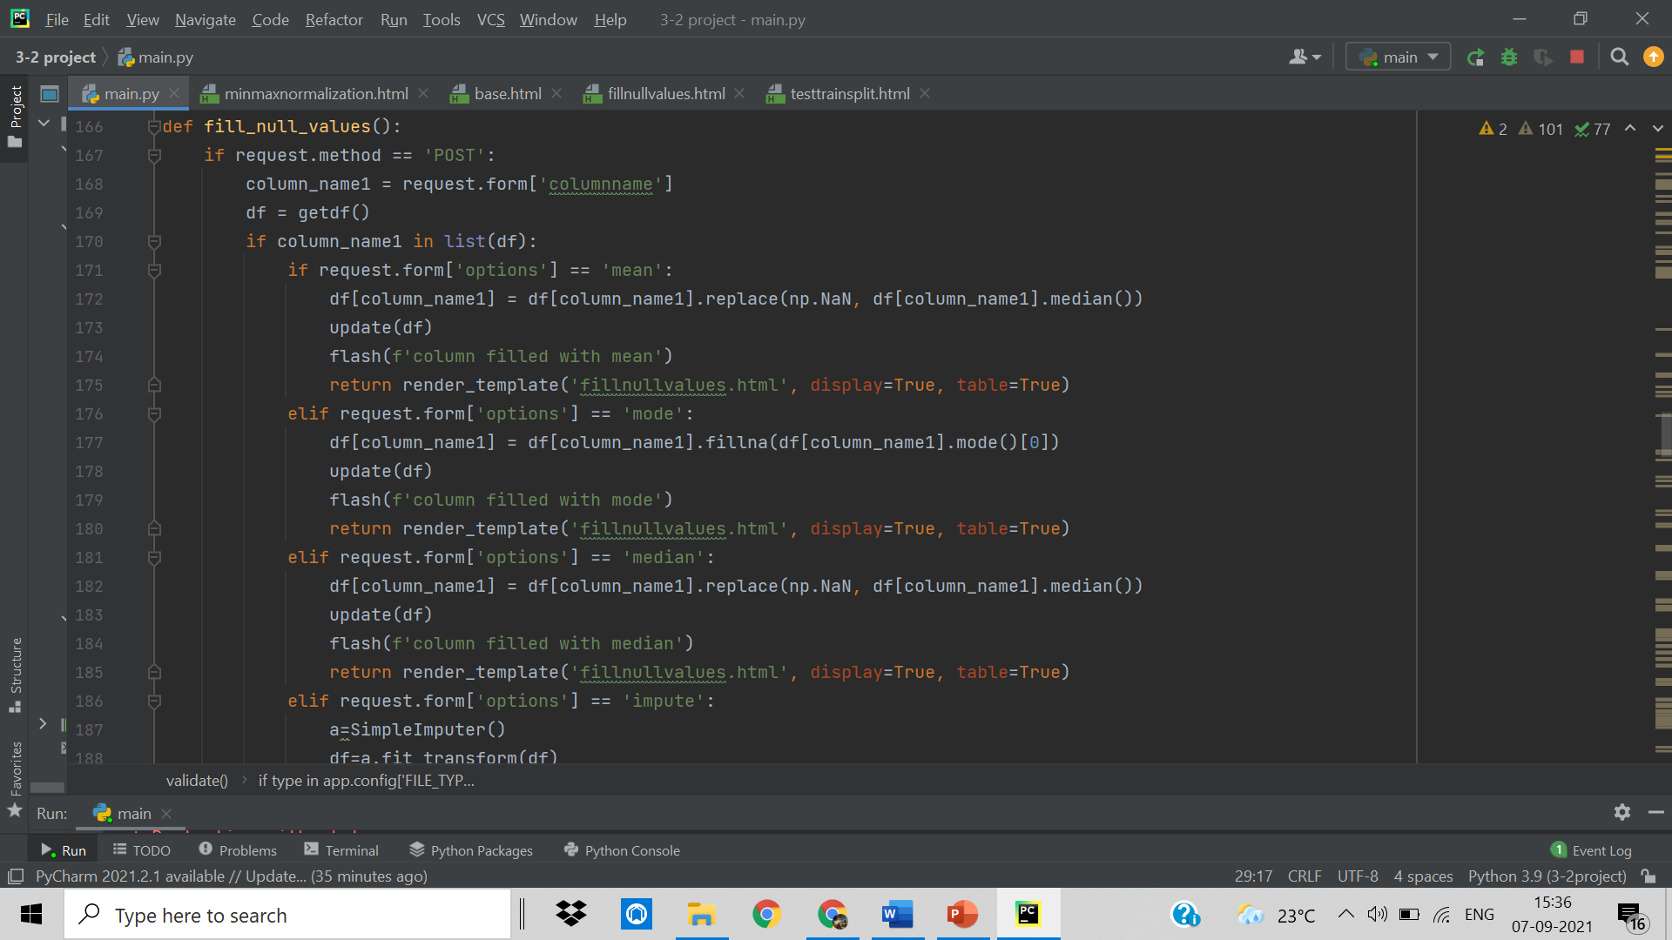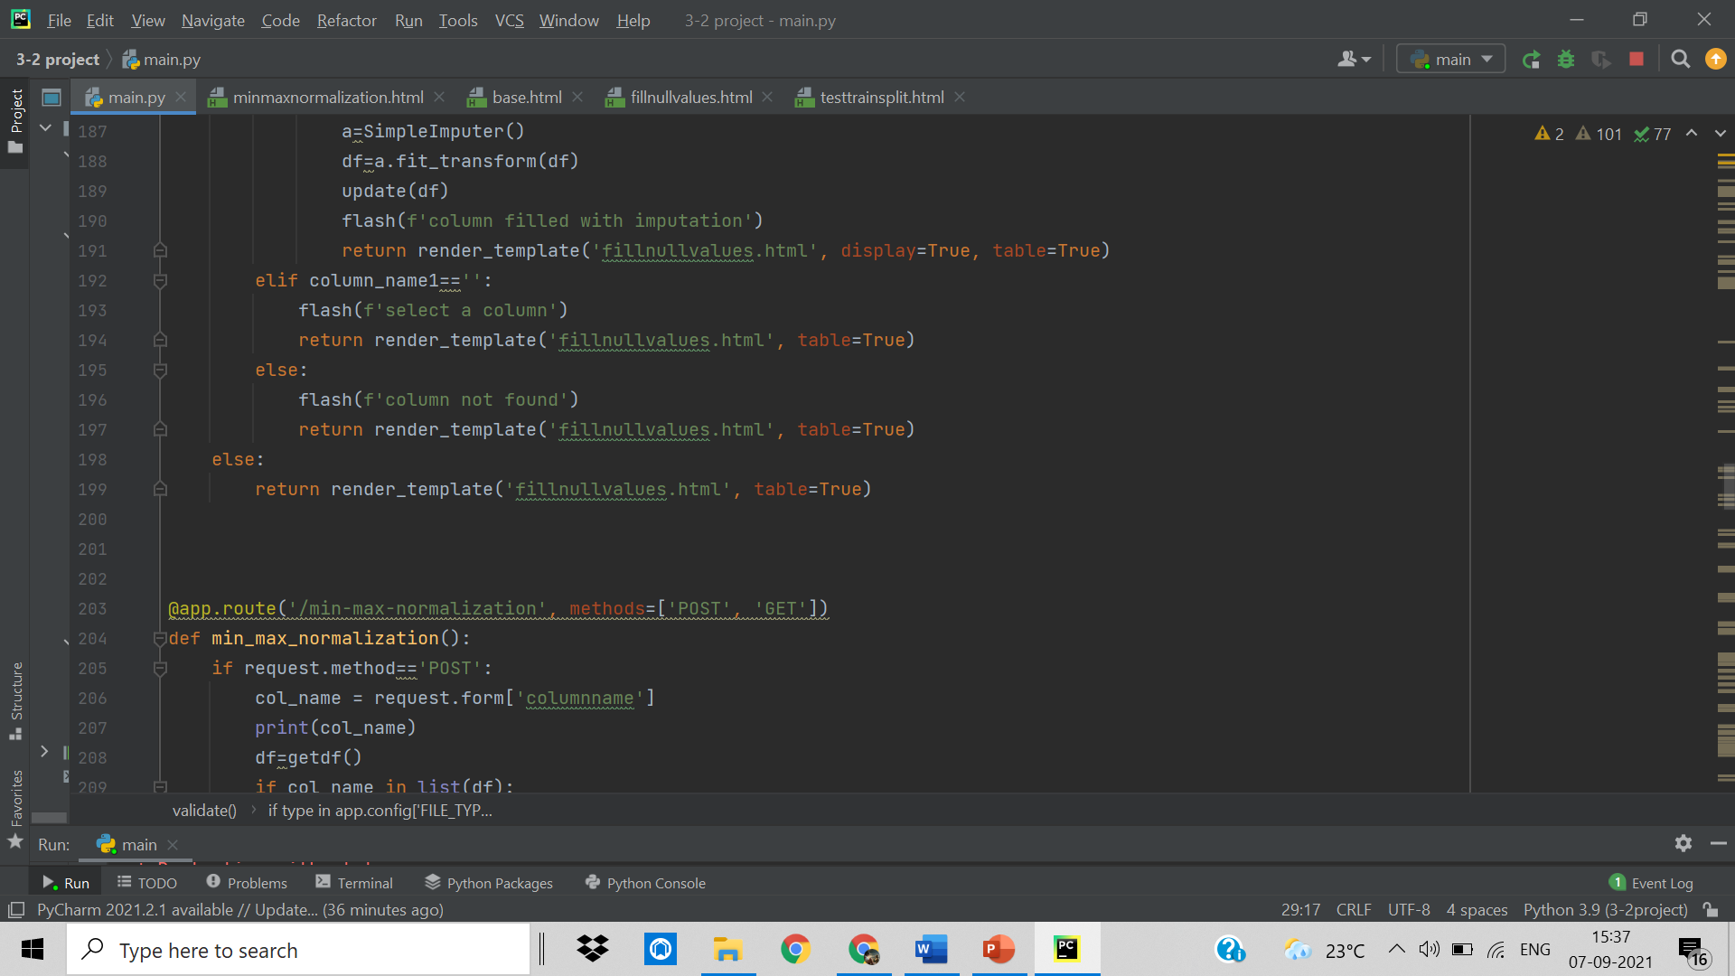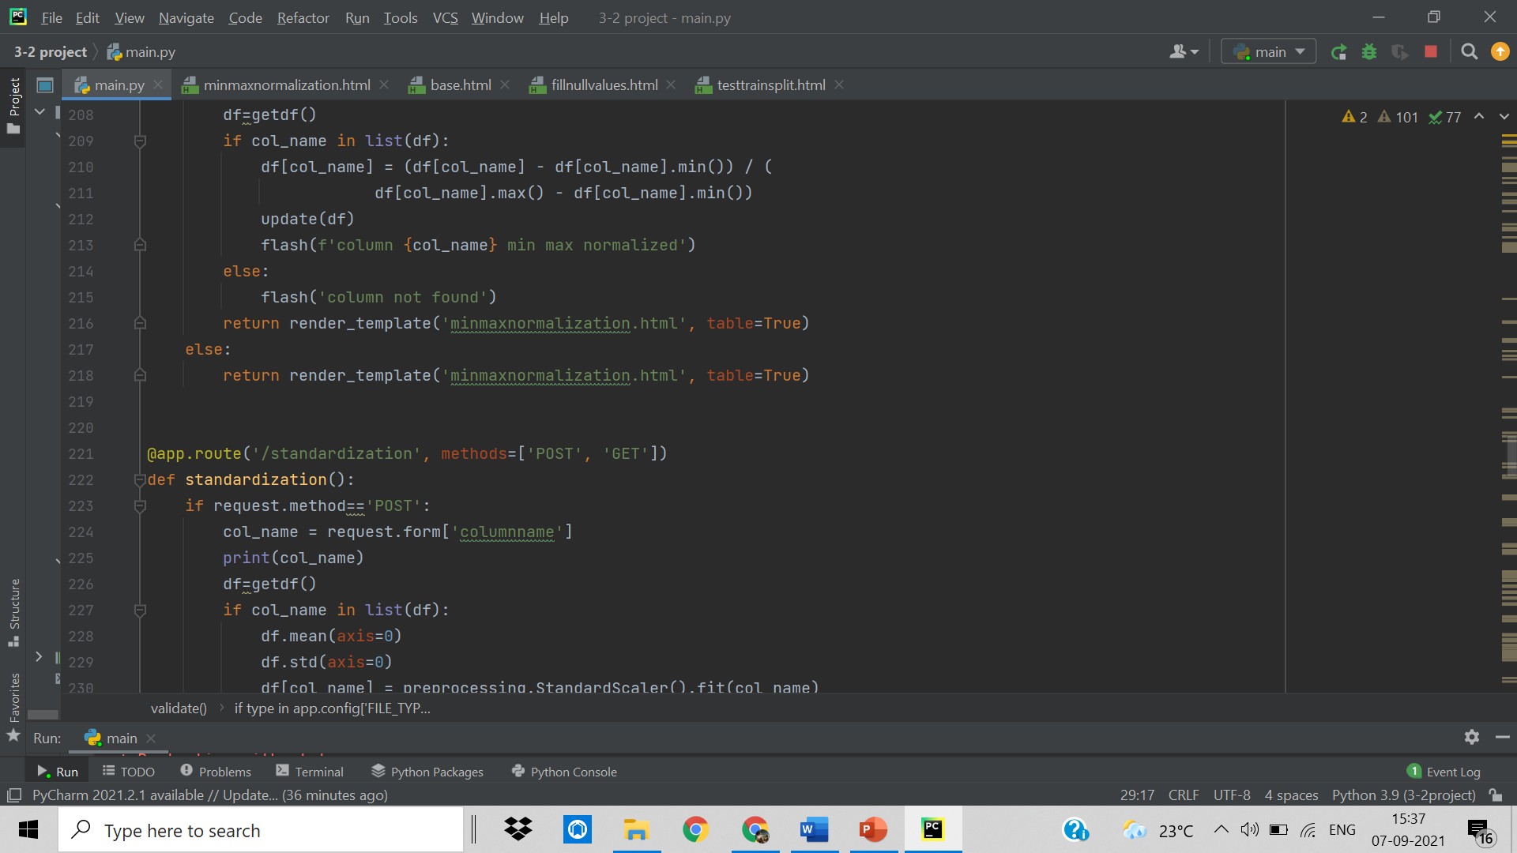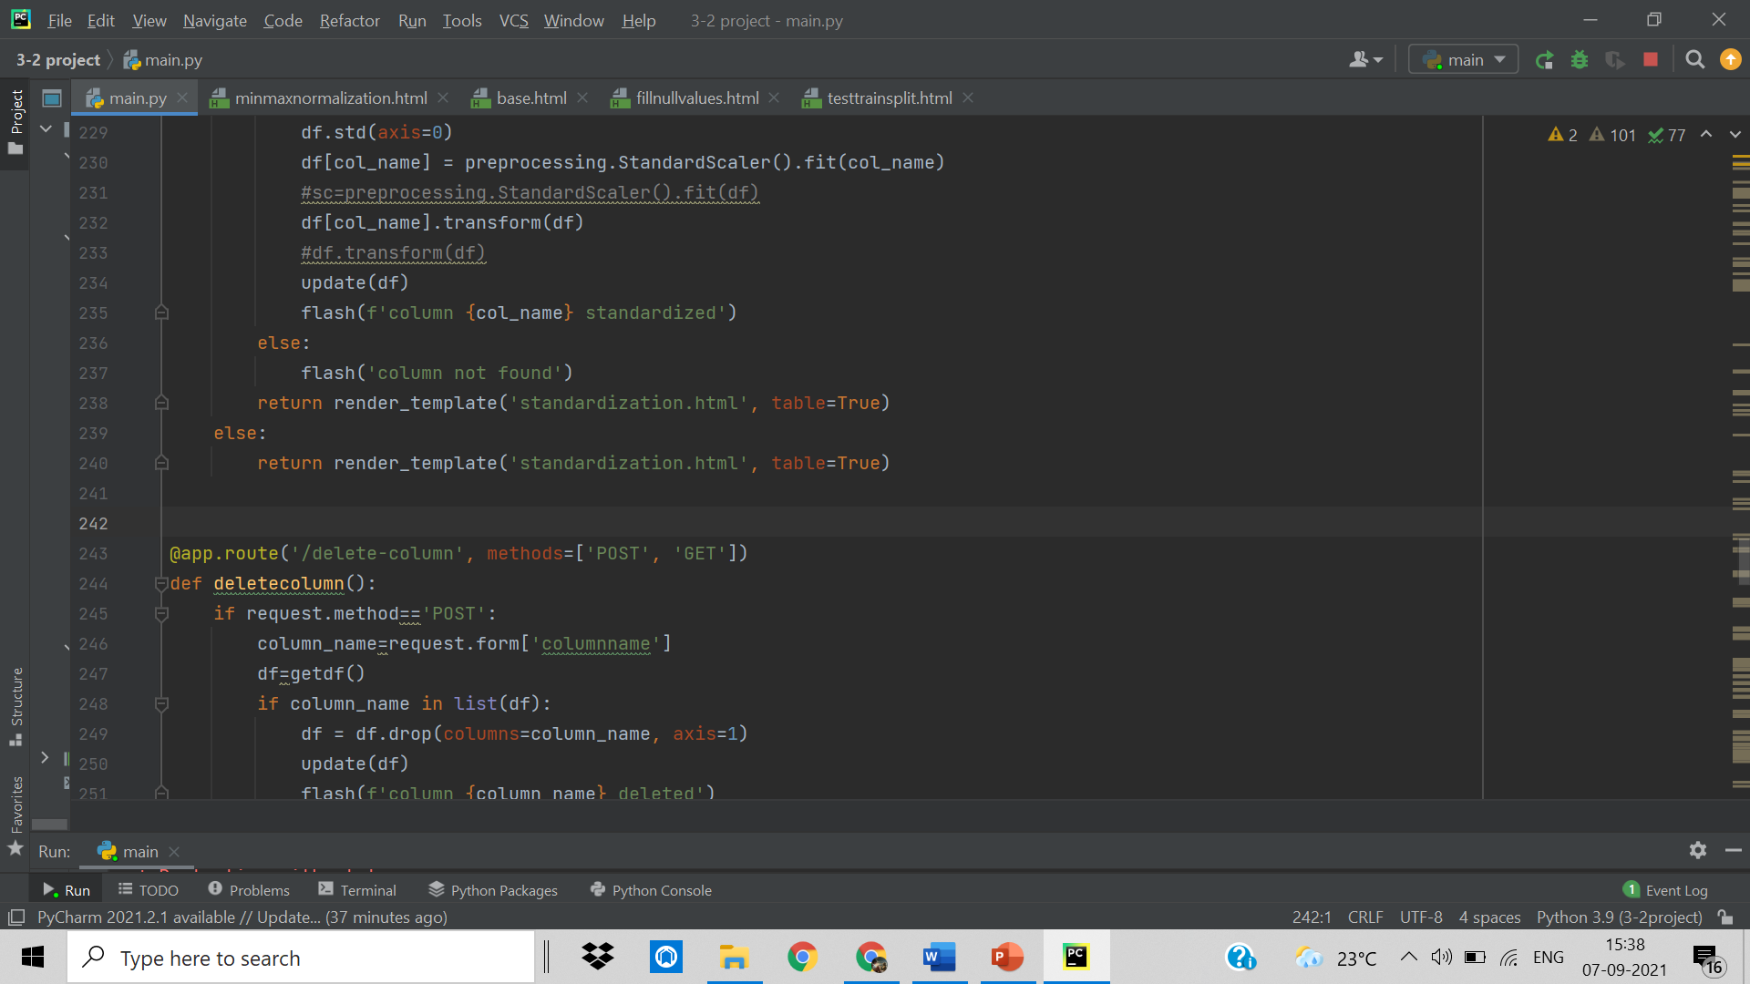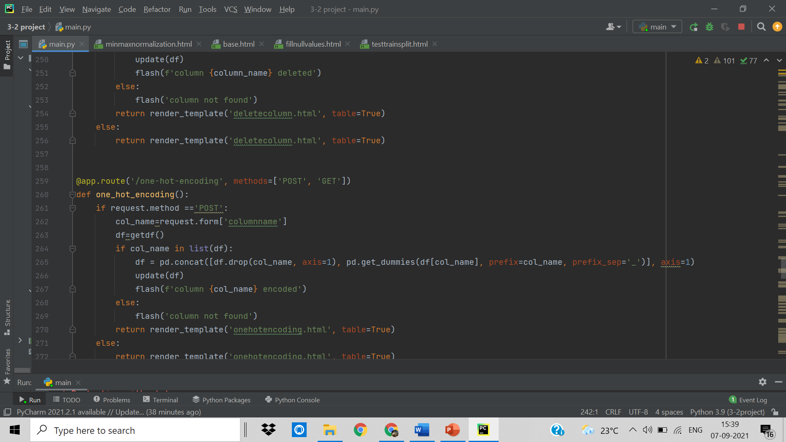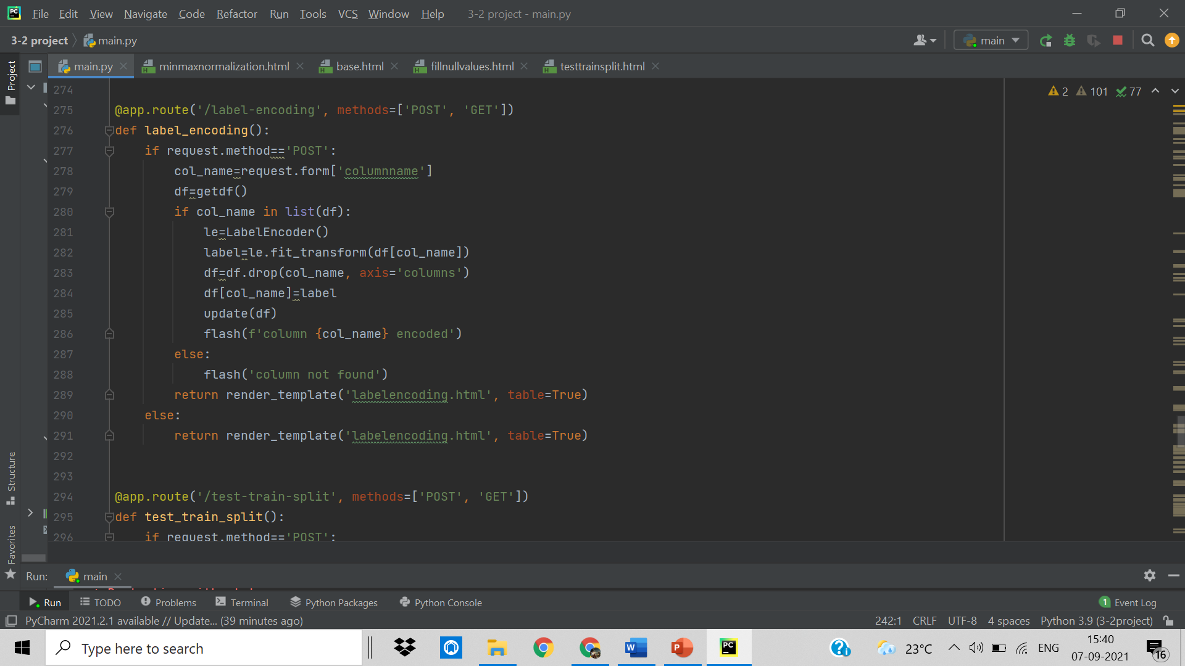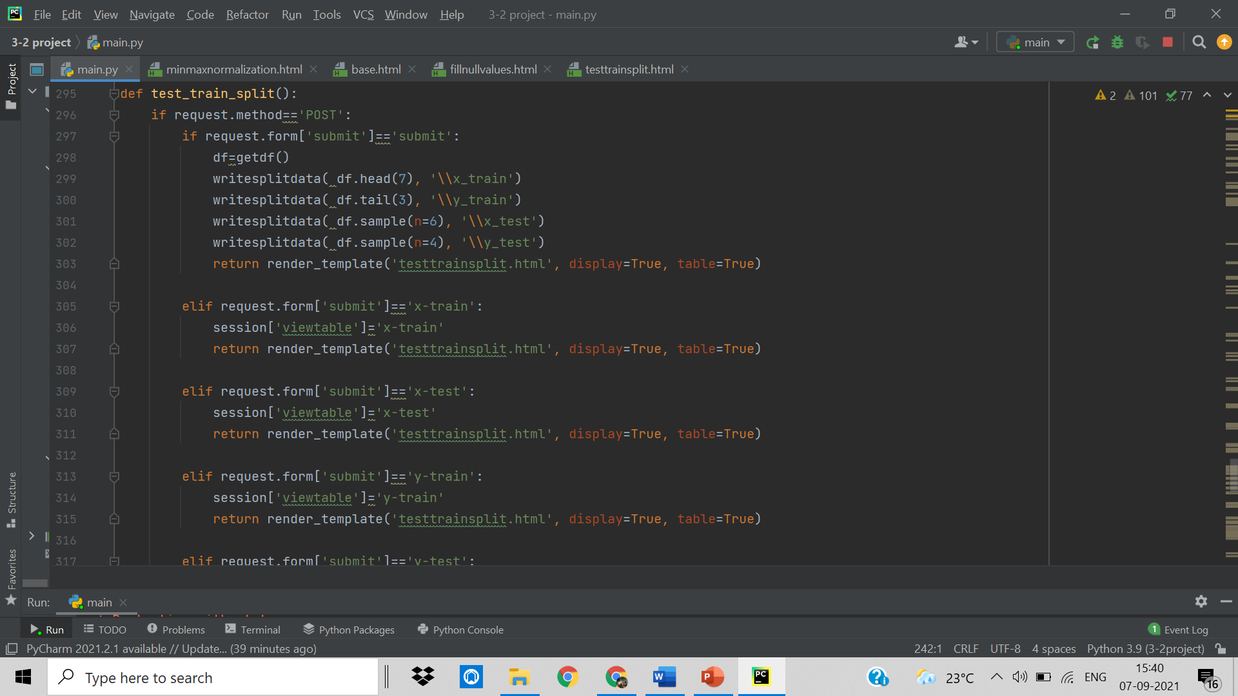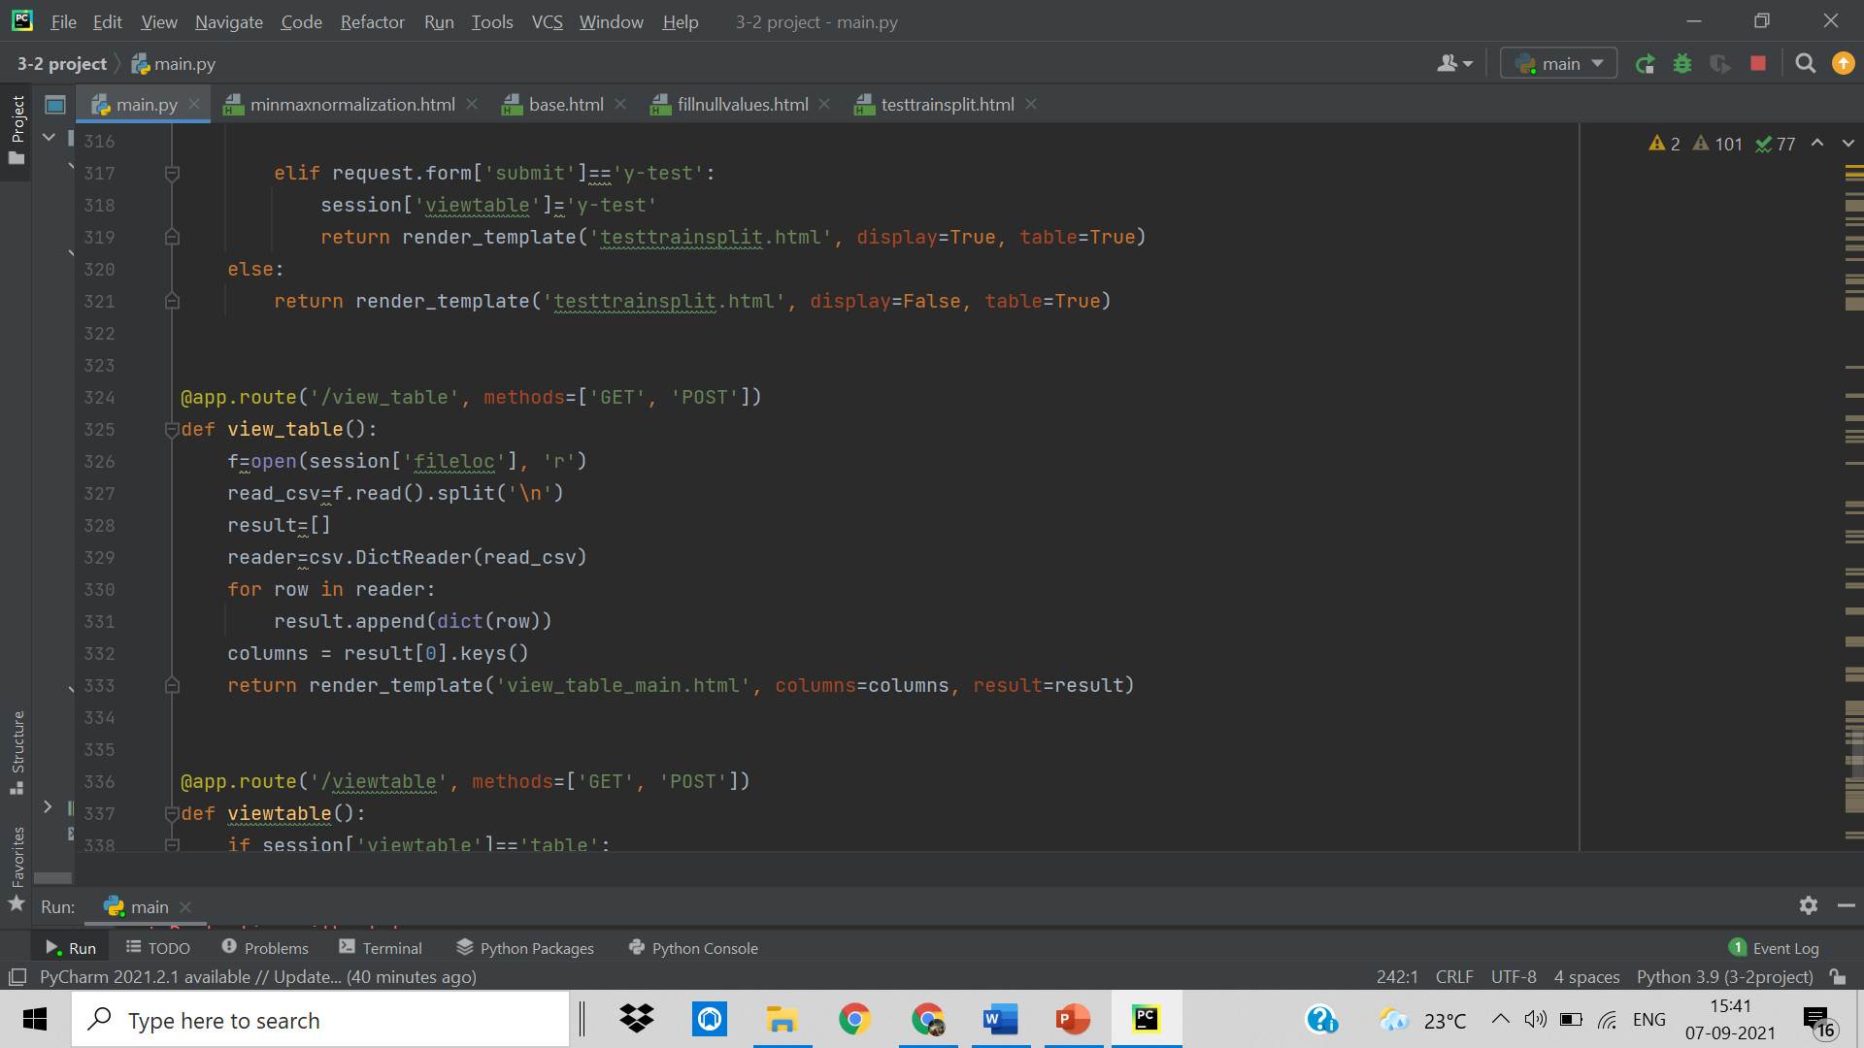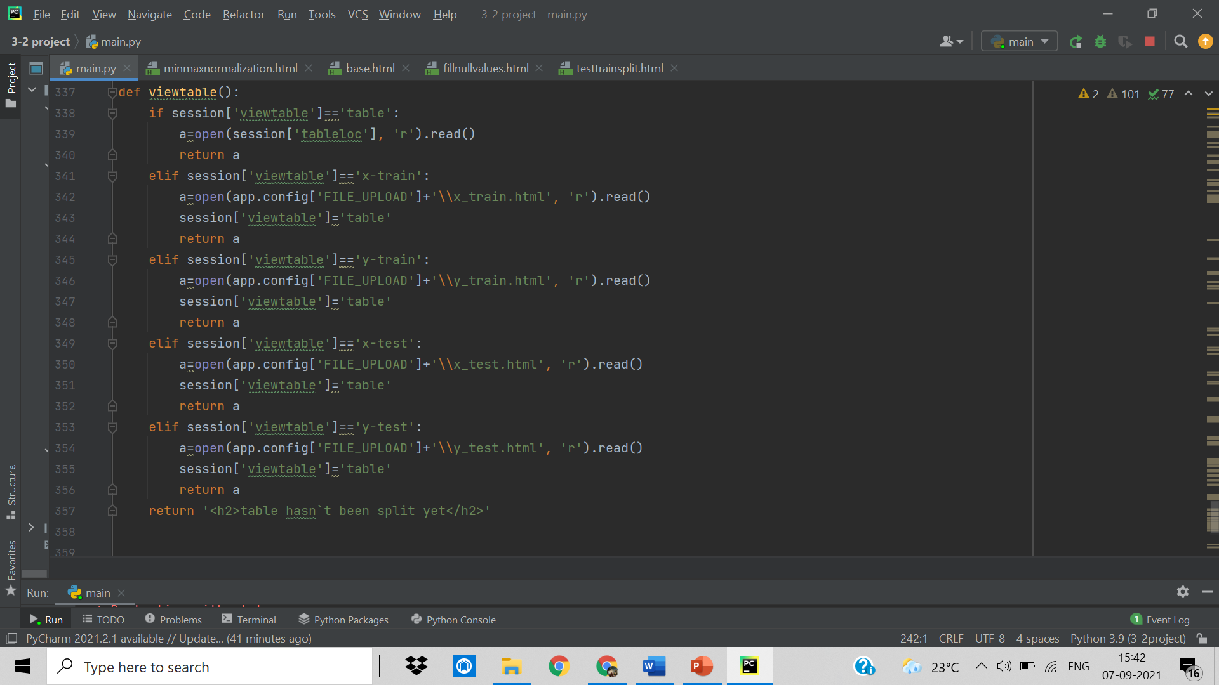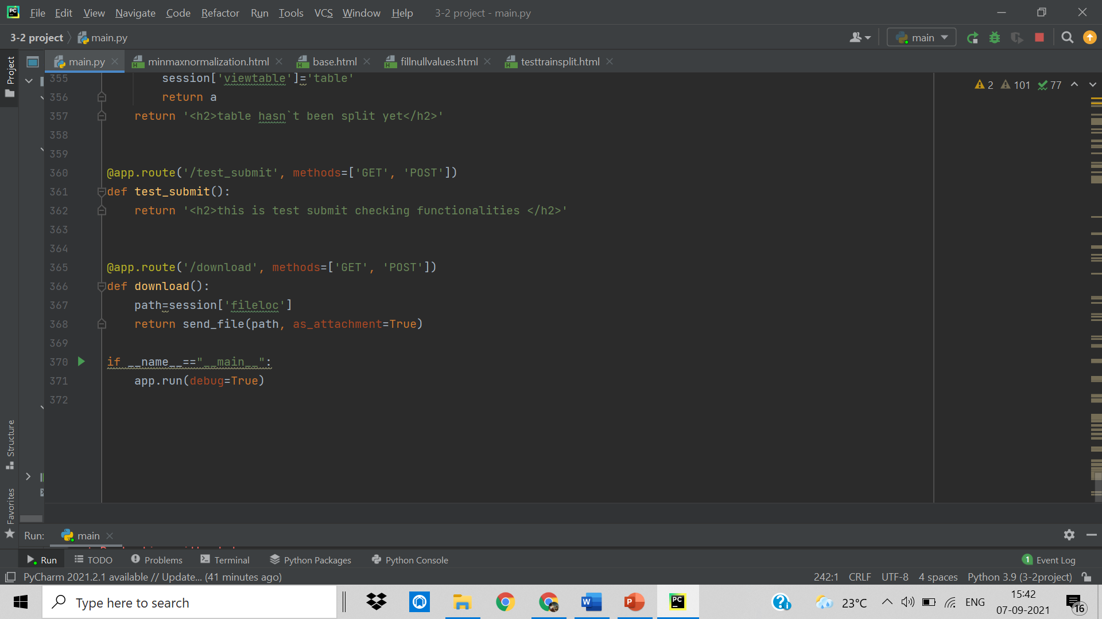

**4.2 HTML Files:**

**4.2.1 Base.html**

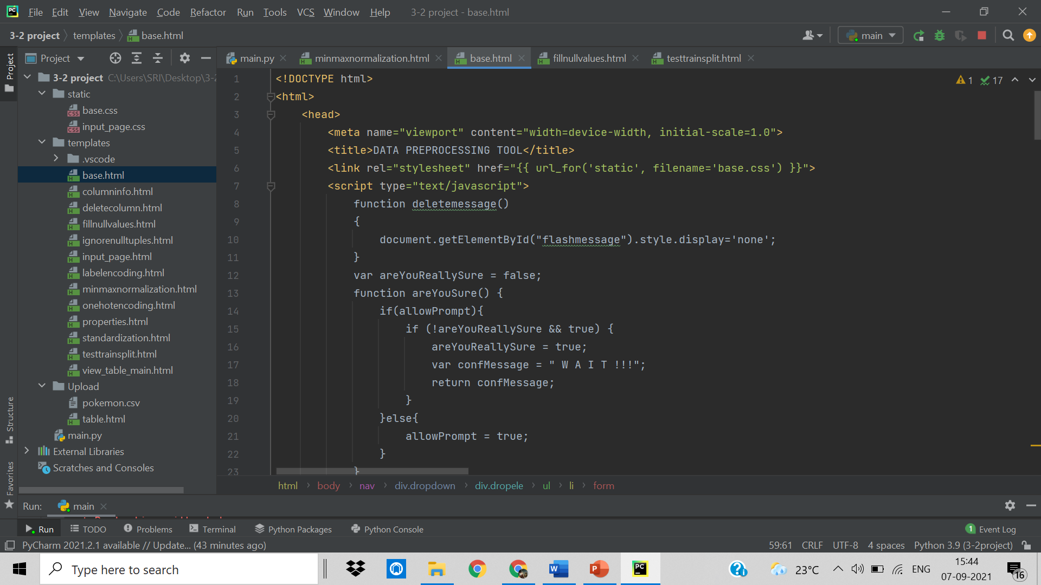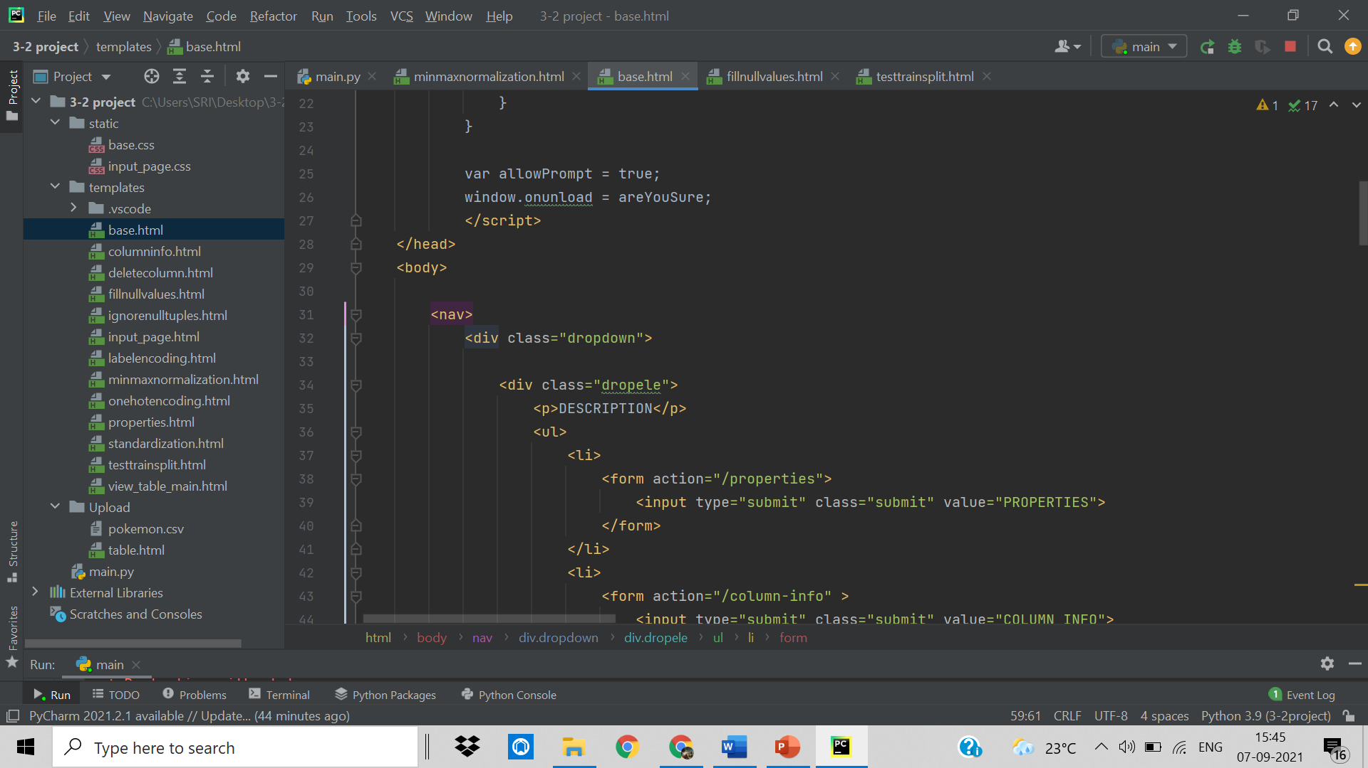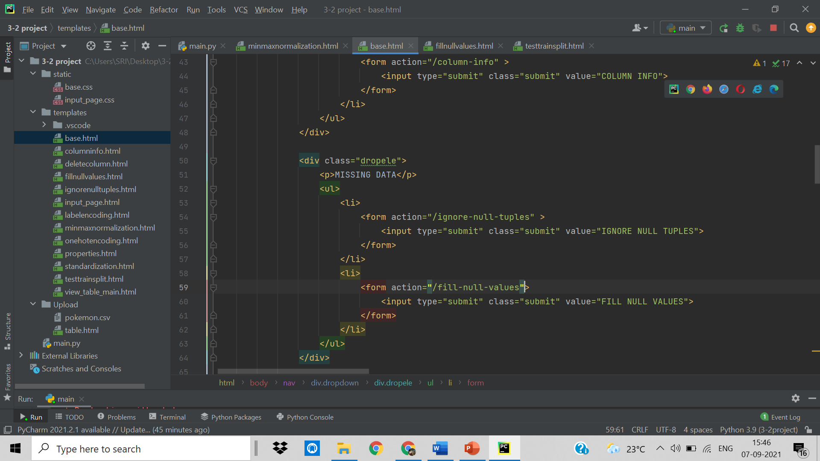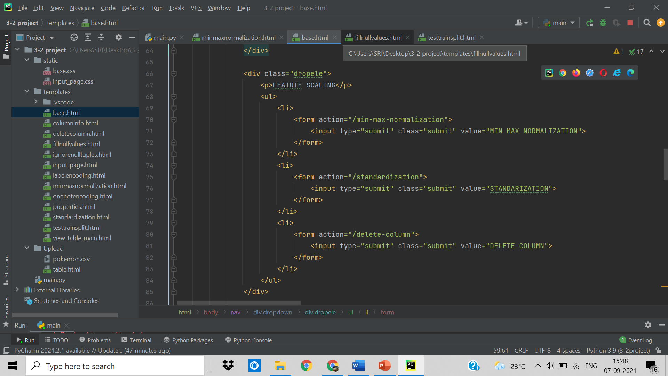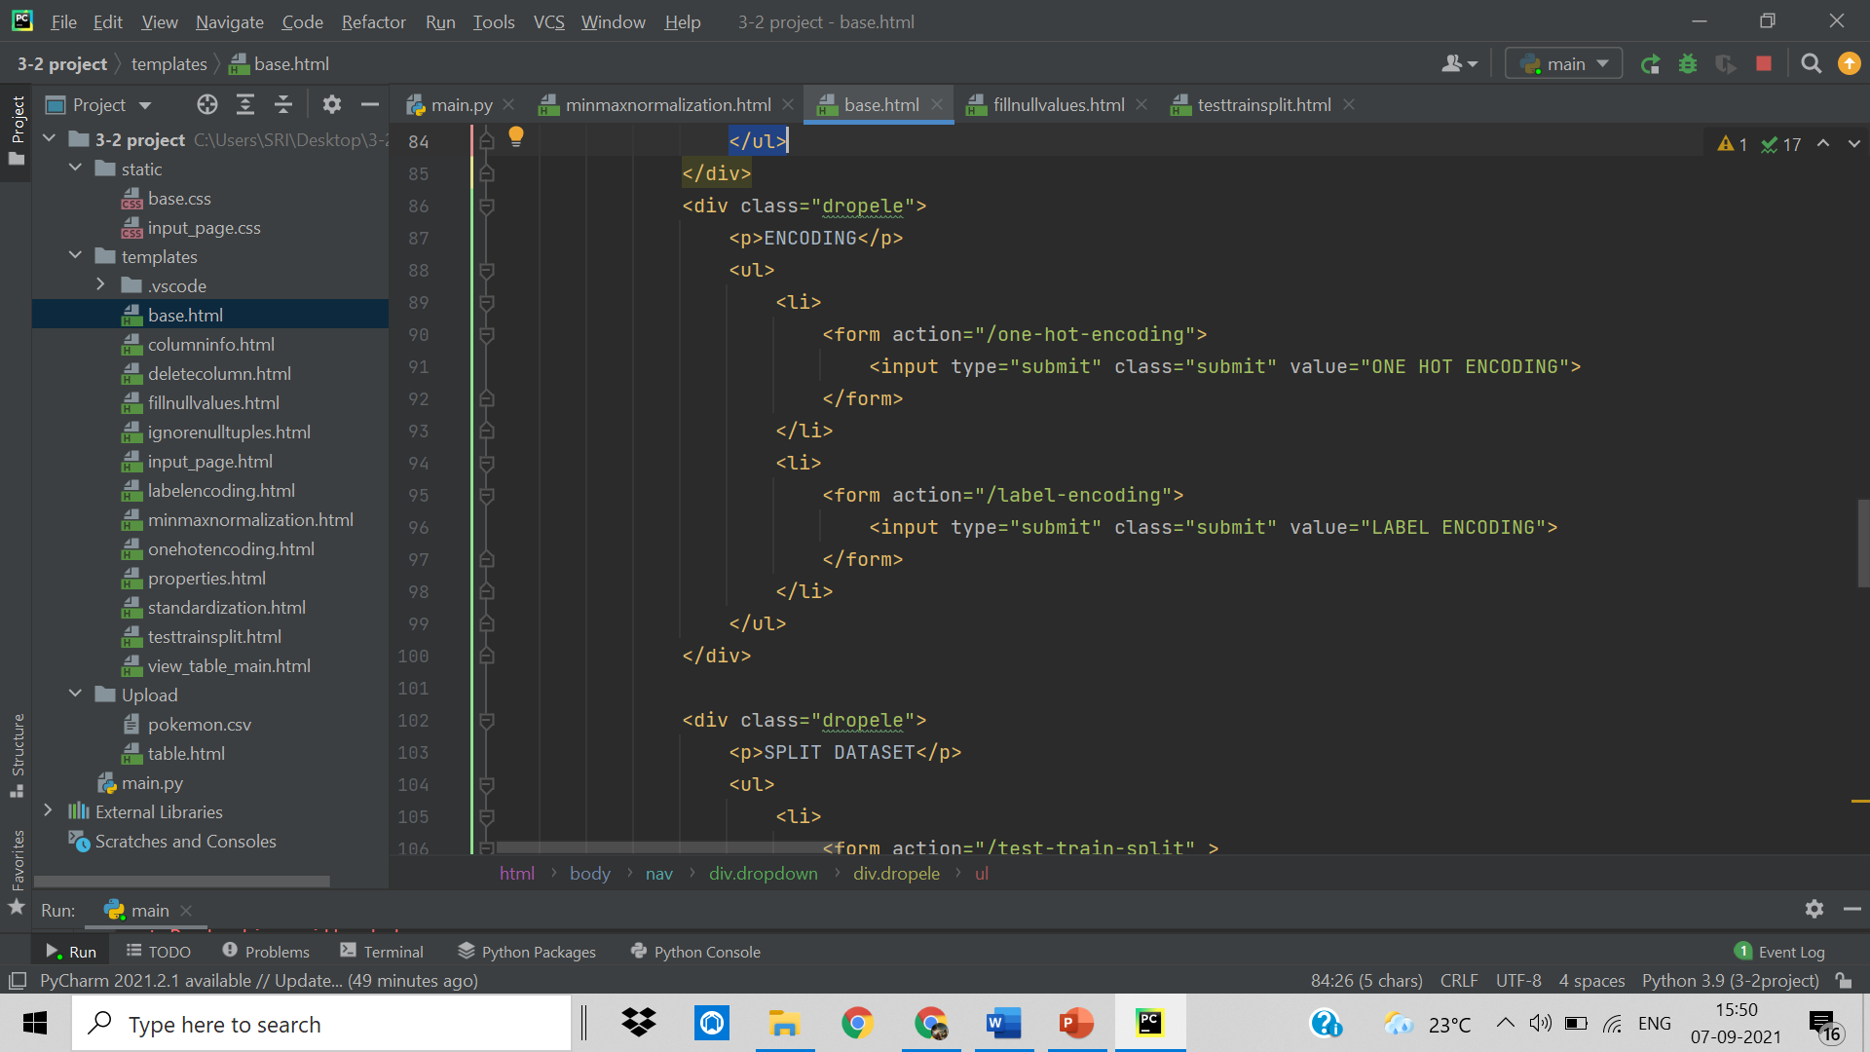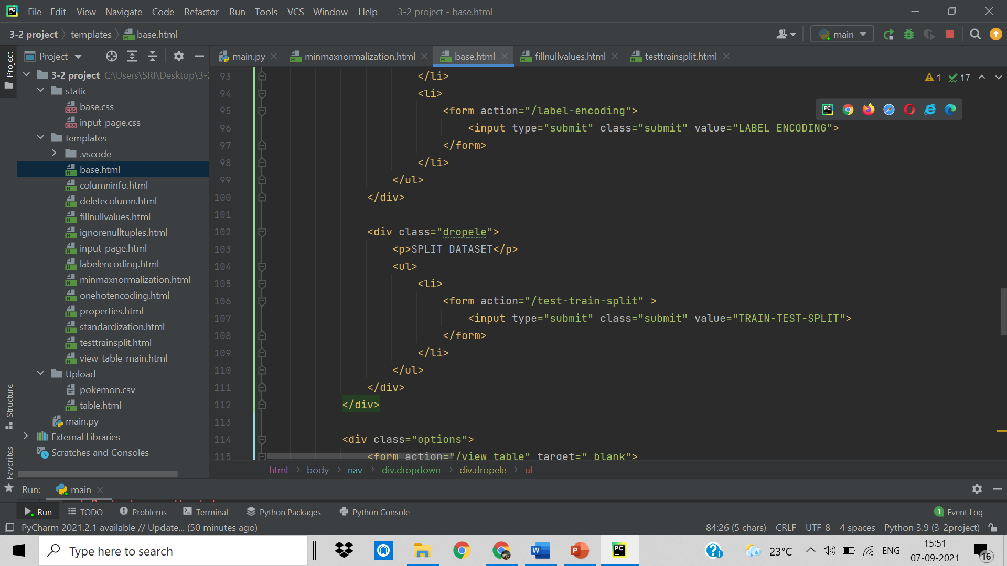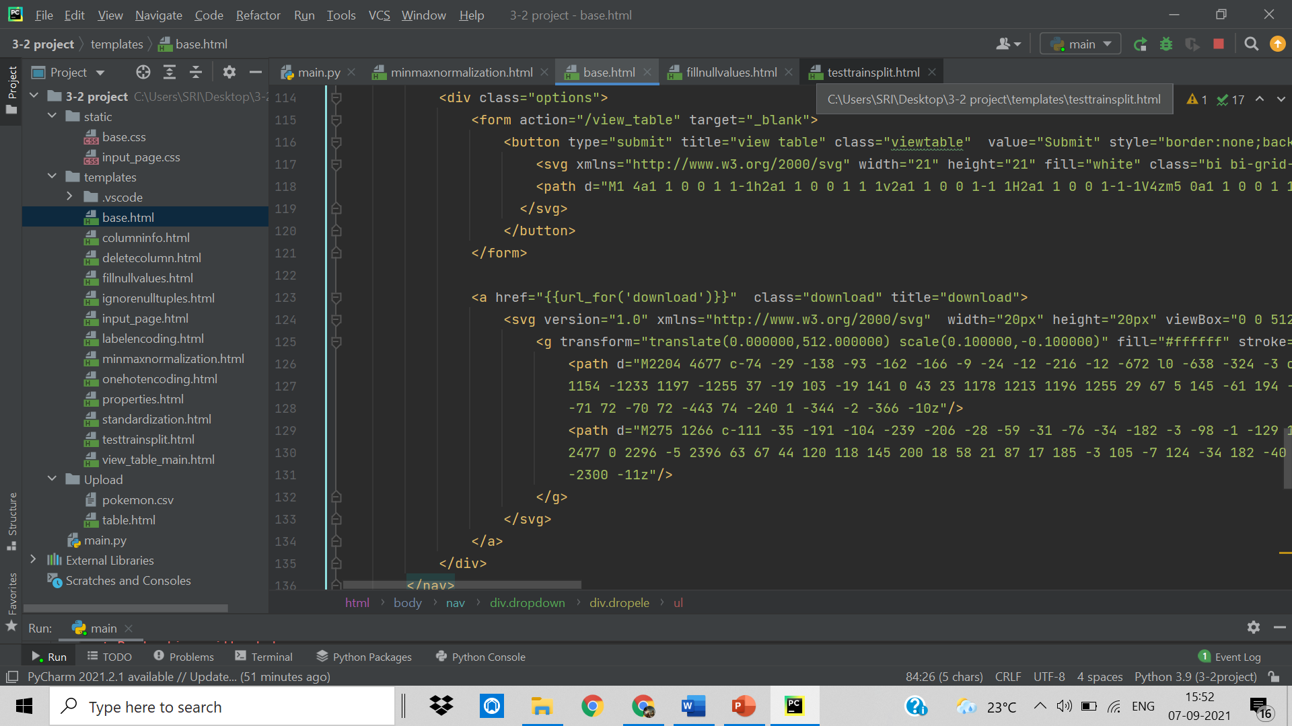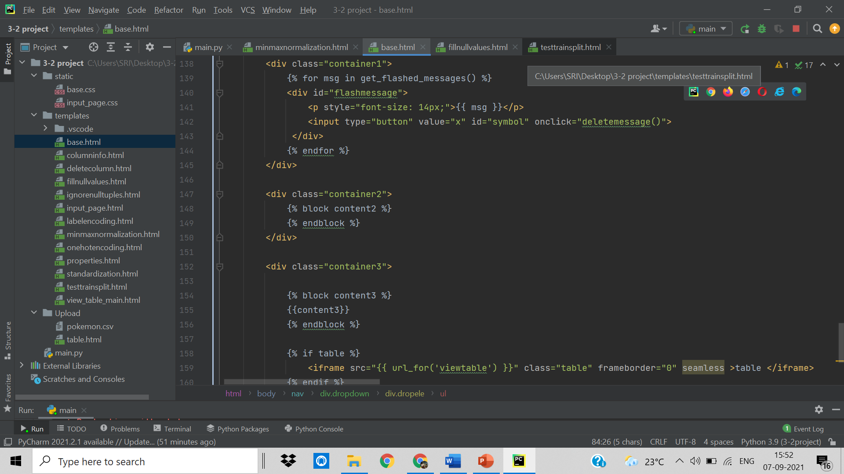

4.2.2 Column.html

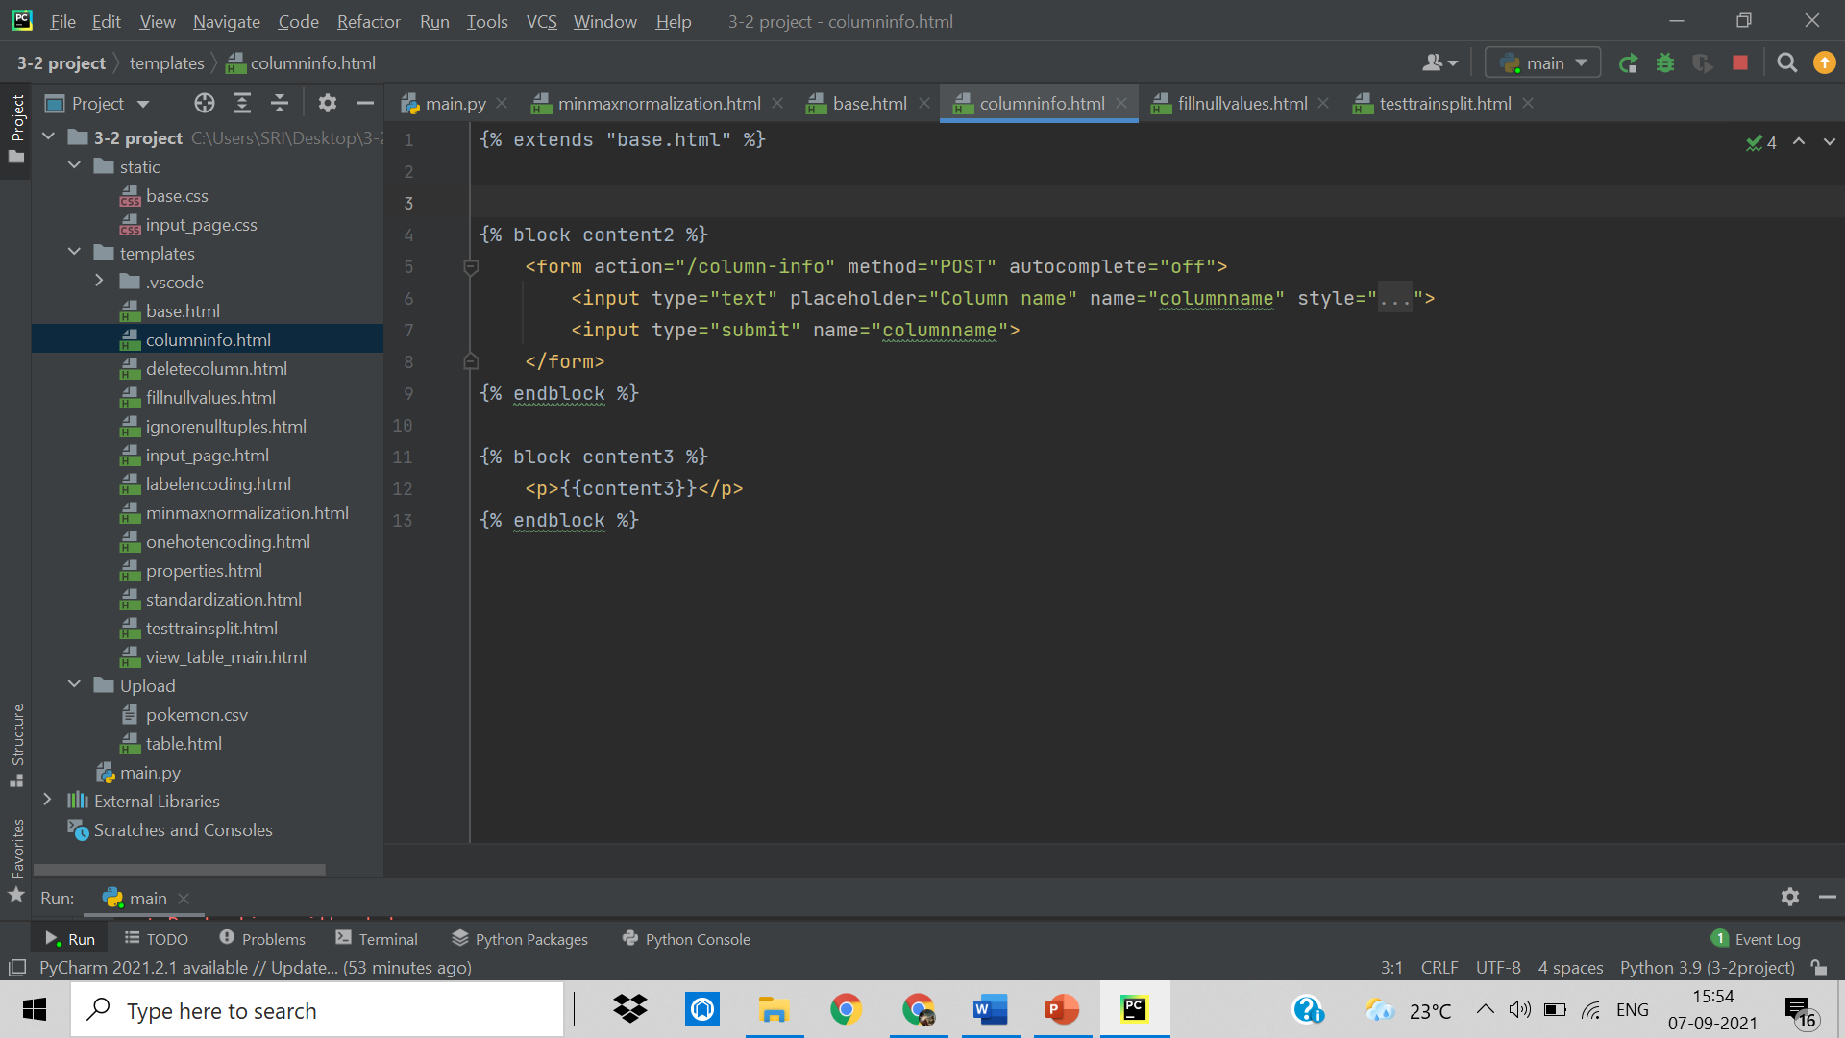

4.2.3 Deletecolumn.html

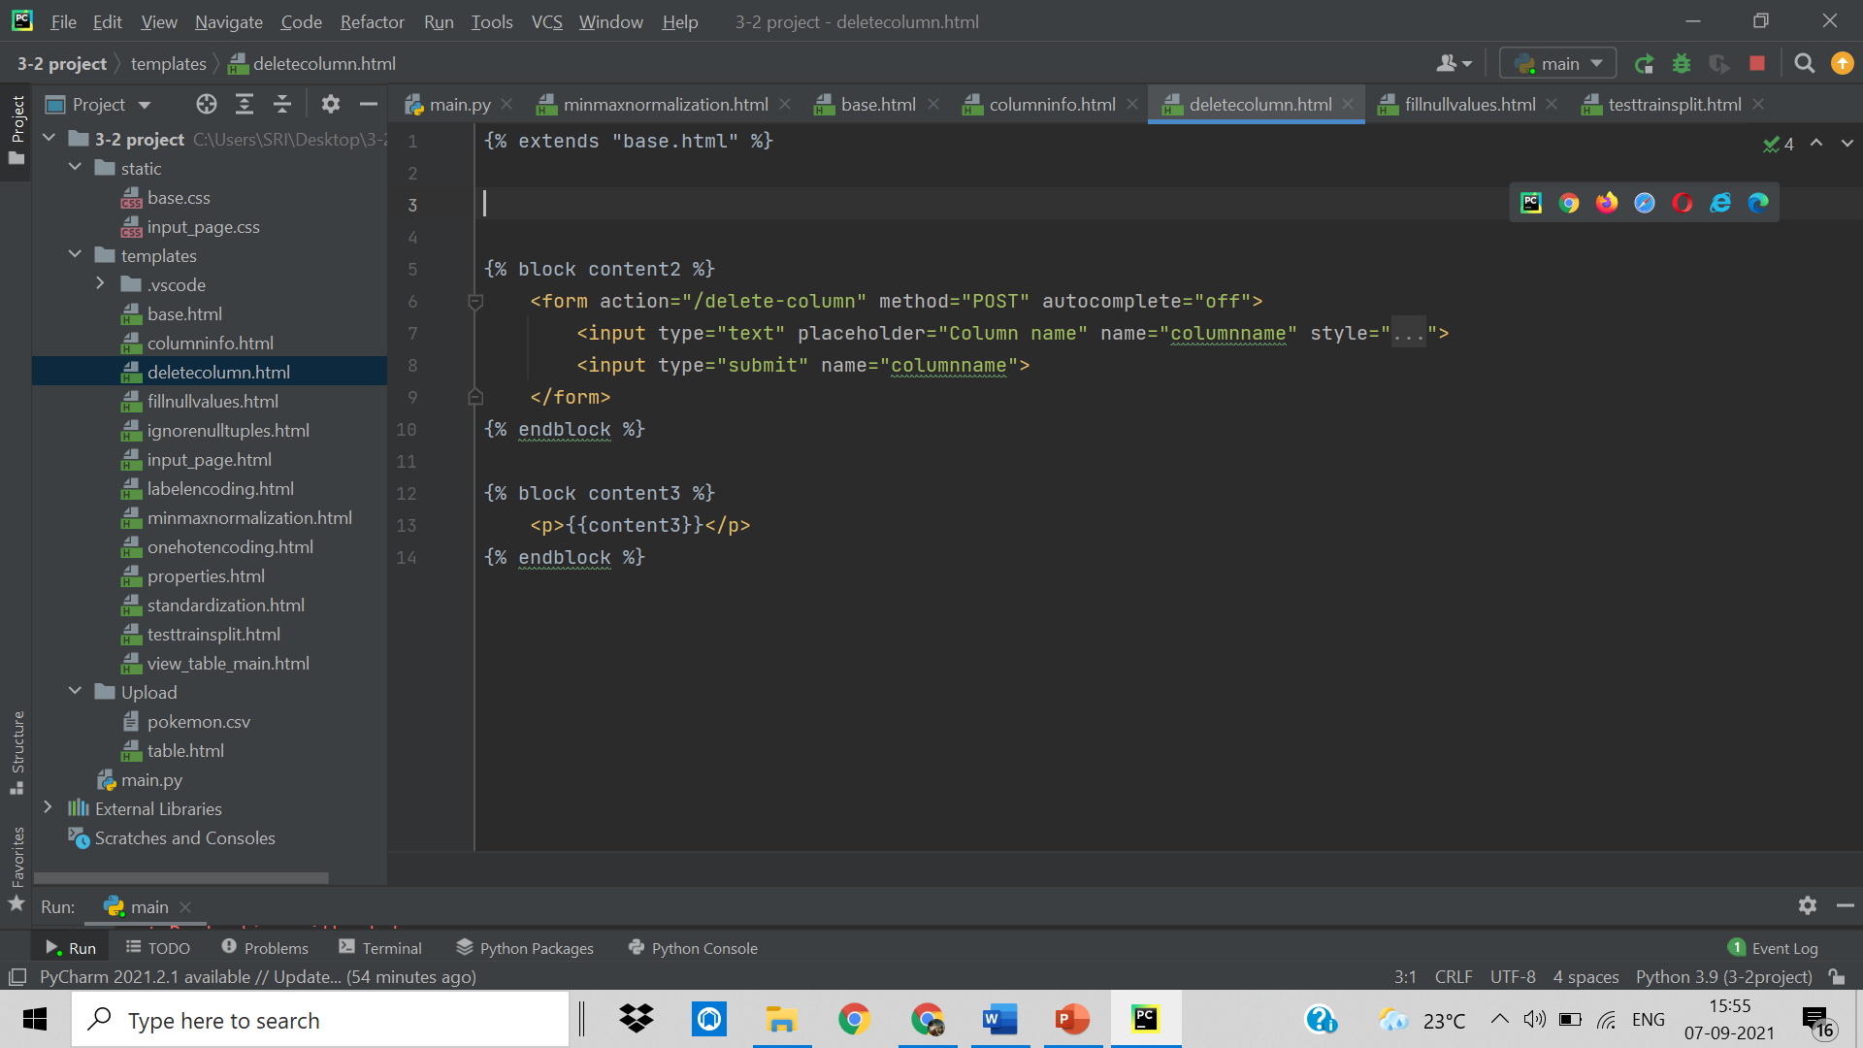

4.2.4 Fillnullvalues.html

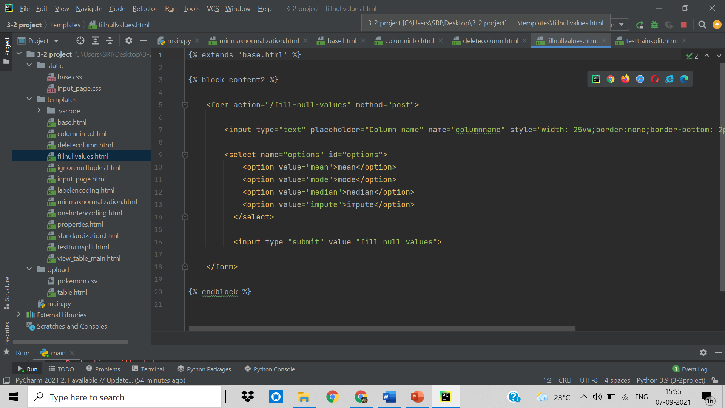

4.2.5 Ignorenulltuples.html

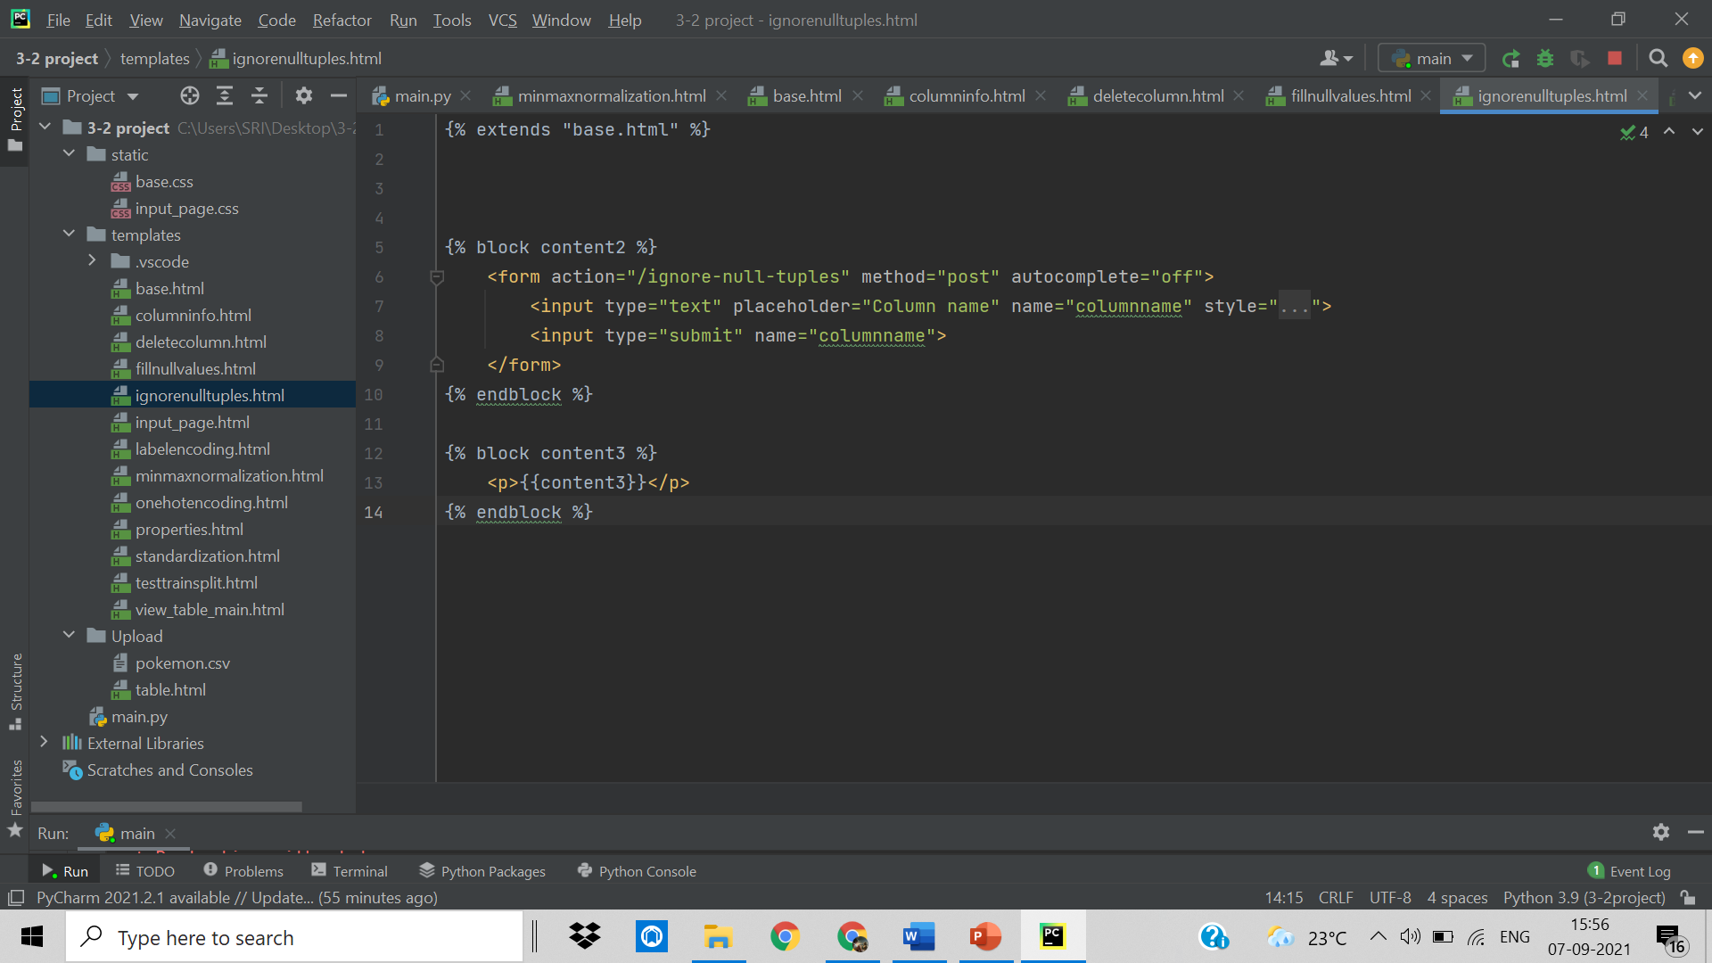

4.2.6 Input_page.html

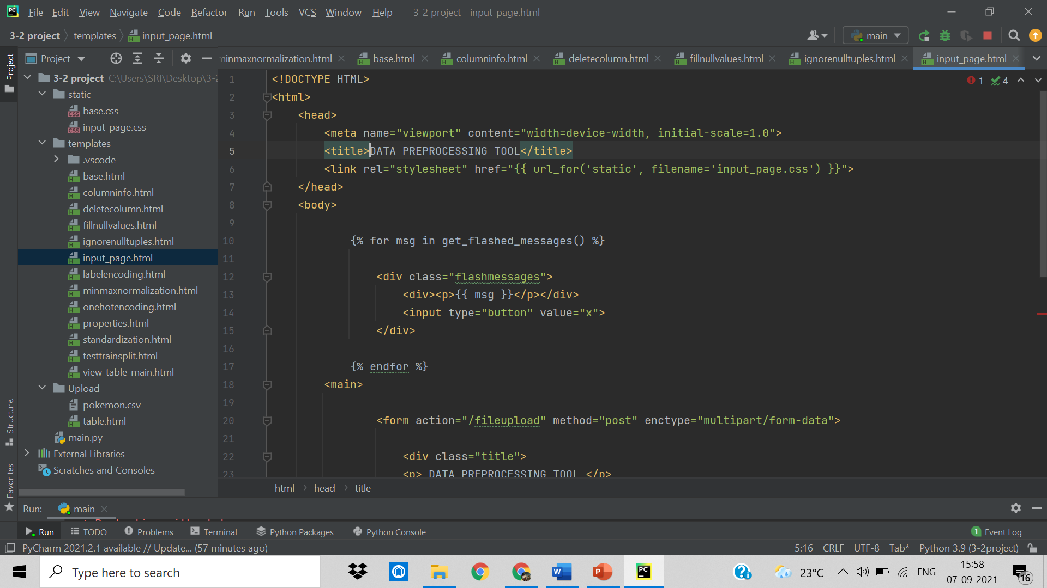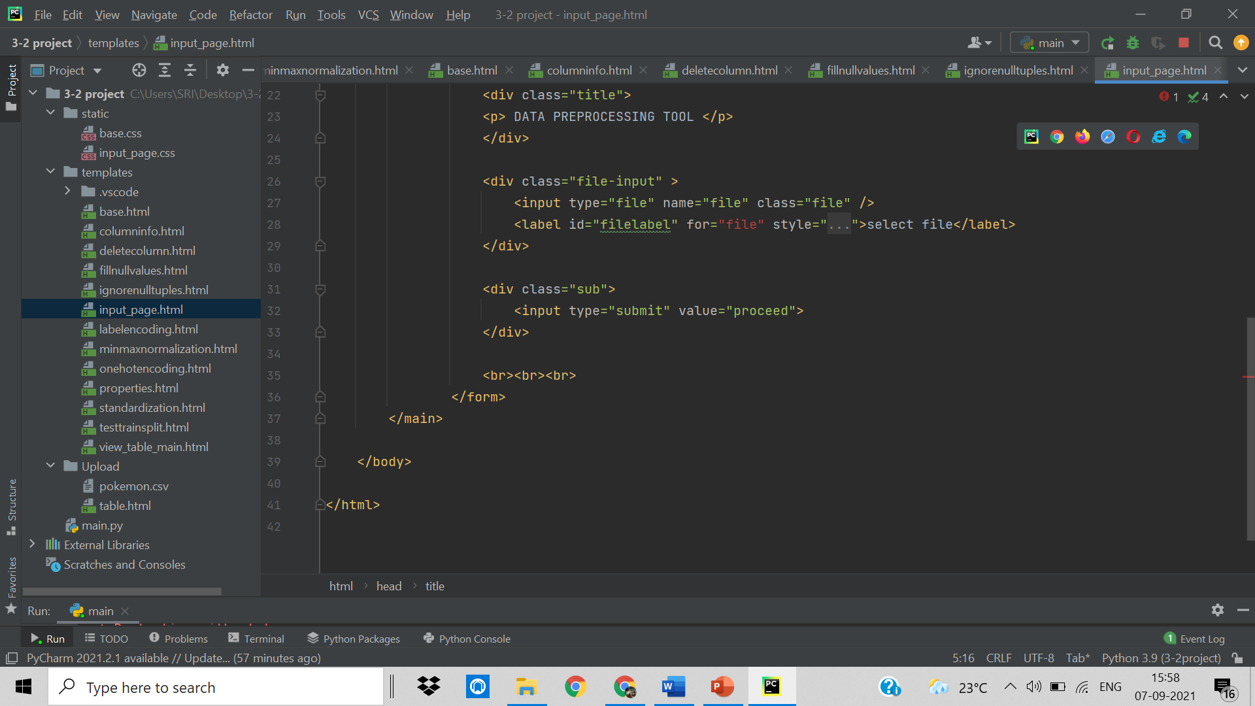

4.2.7 Labelencoding.html

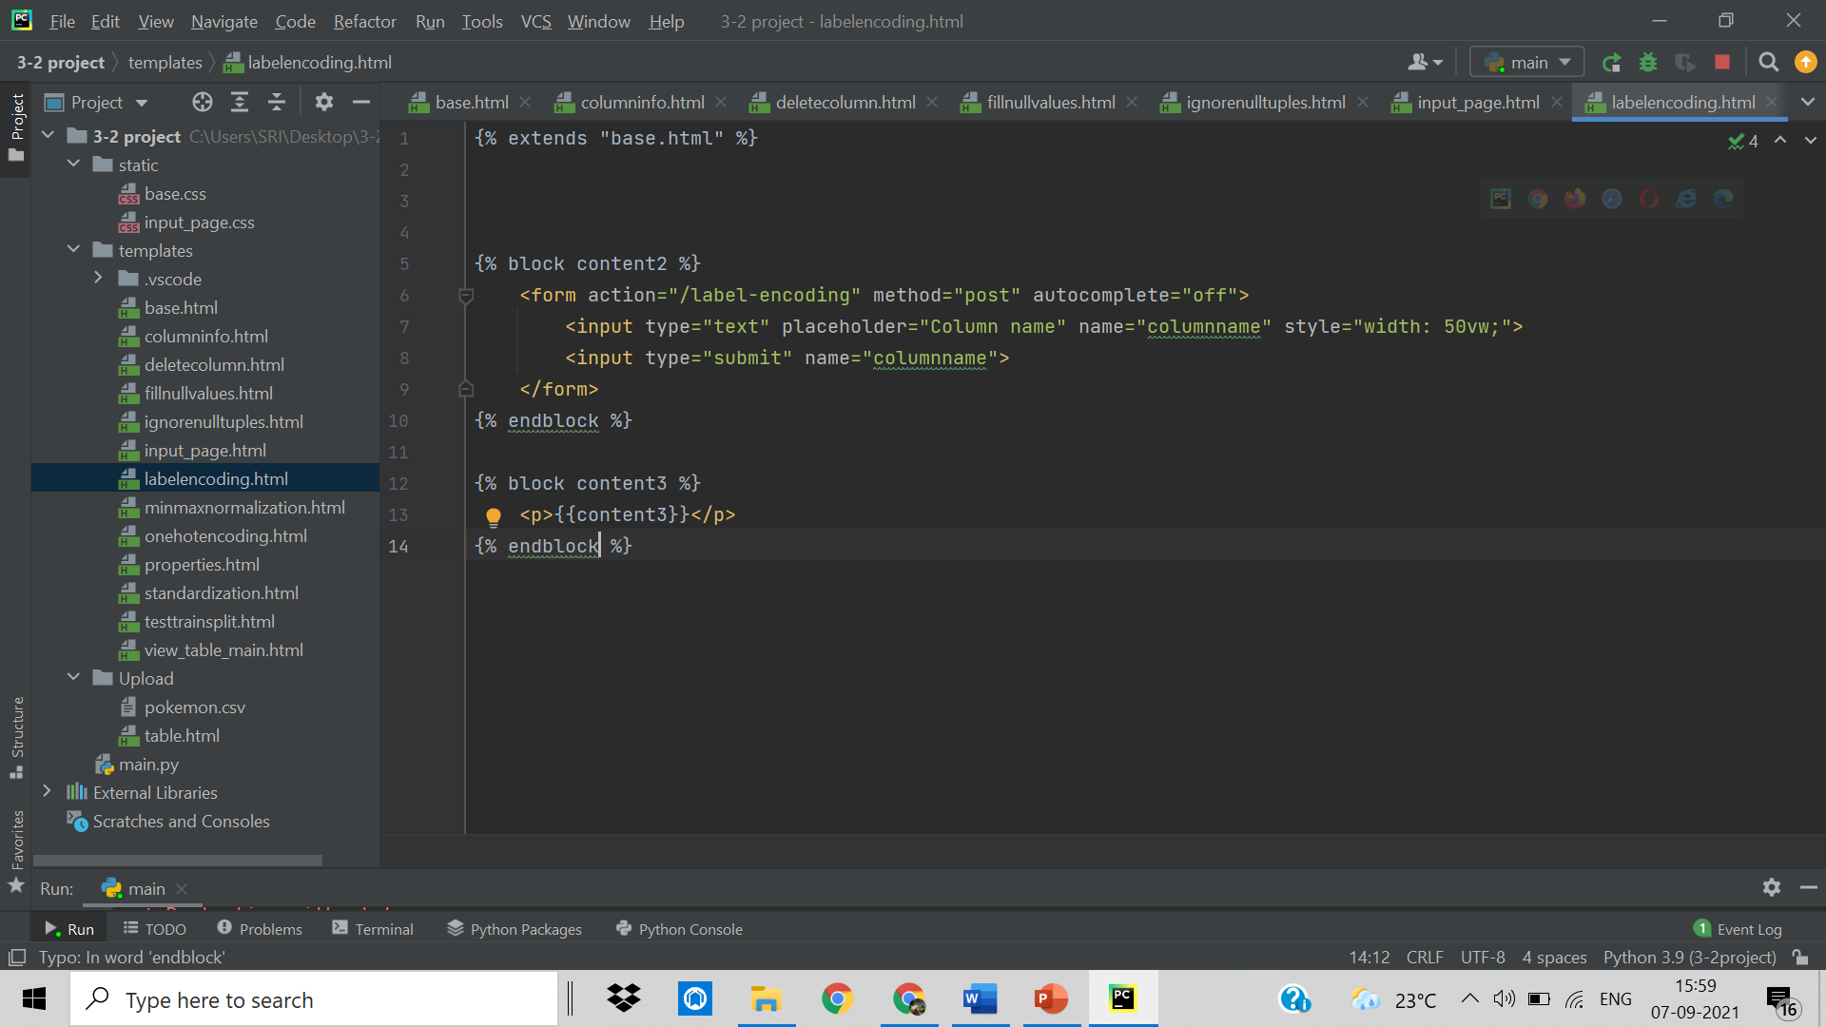

4.2.8 Mimax normalization.html

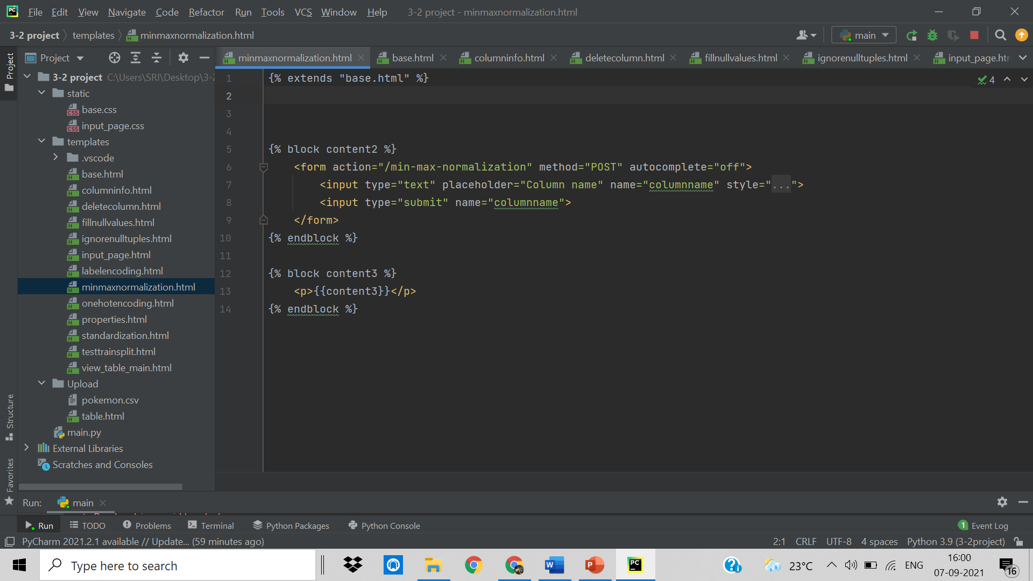

4.2.9 One hot encoding.html



4.2.10 Properties.html

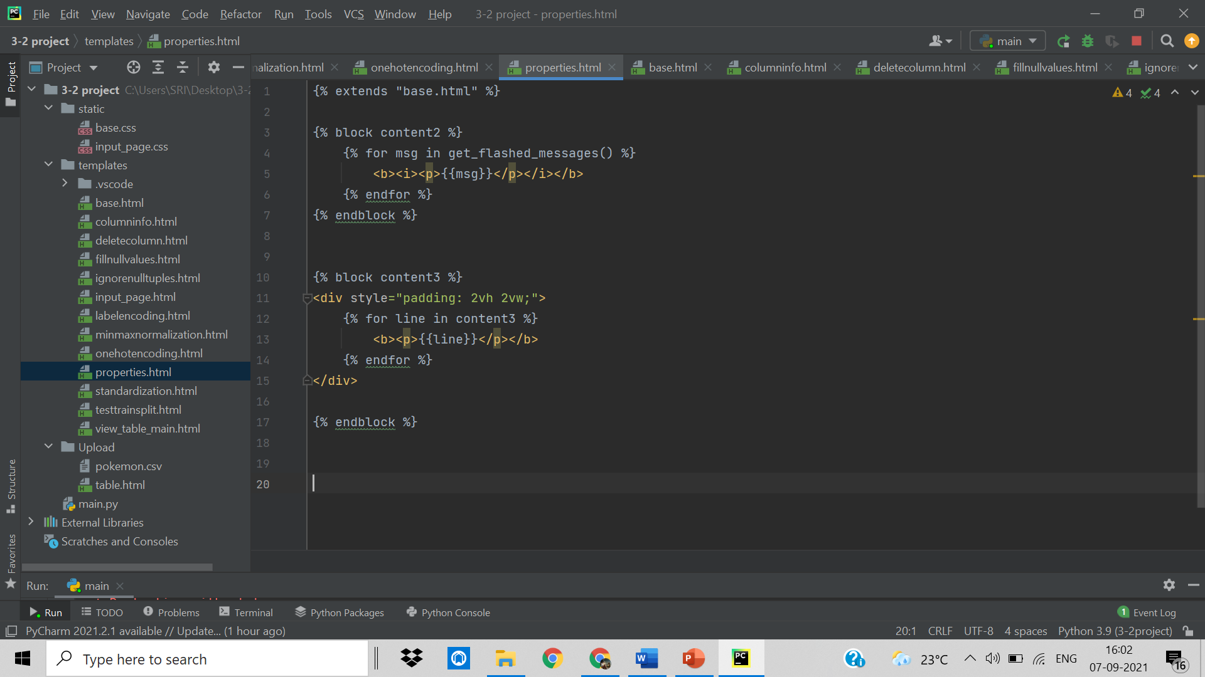

4.2.11 Standardization.html

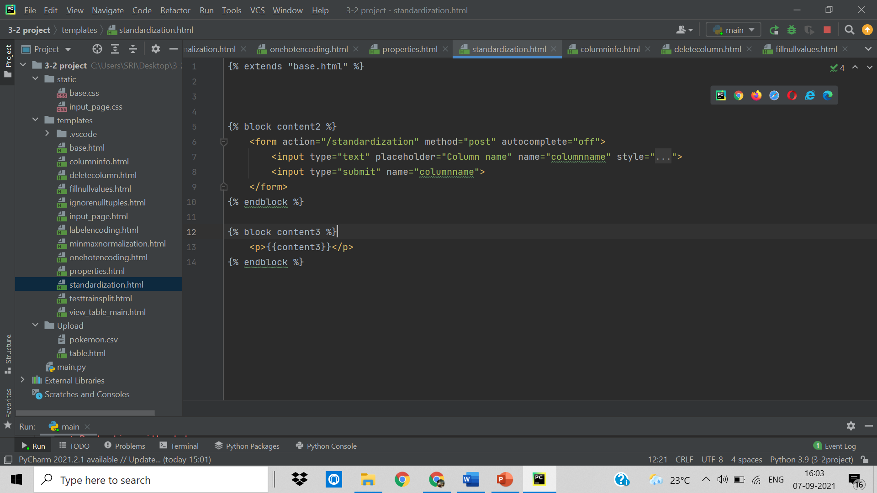

4.2.12 Testtrainsplit.html

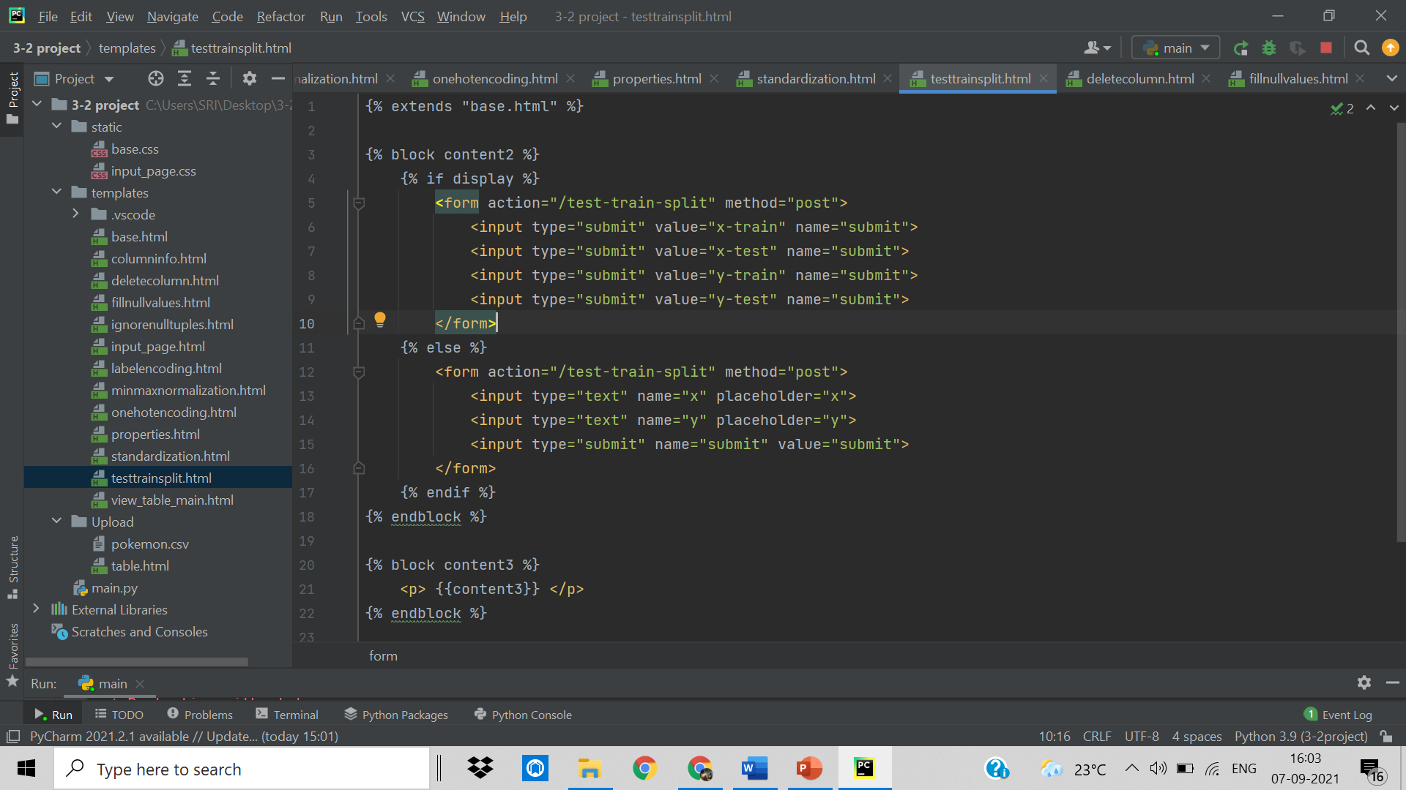

4.2.13 Viewtablemain.html

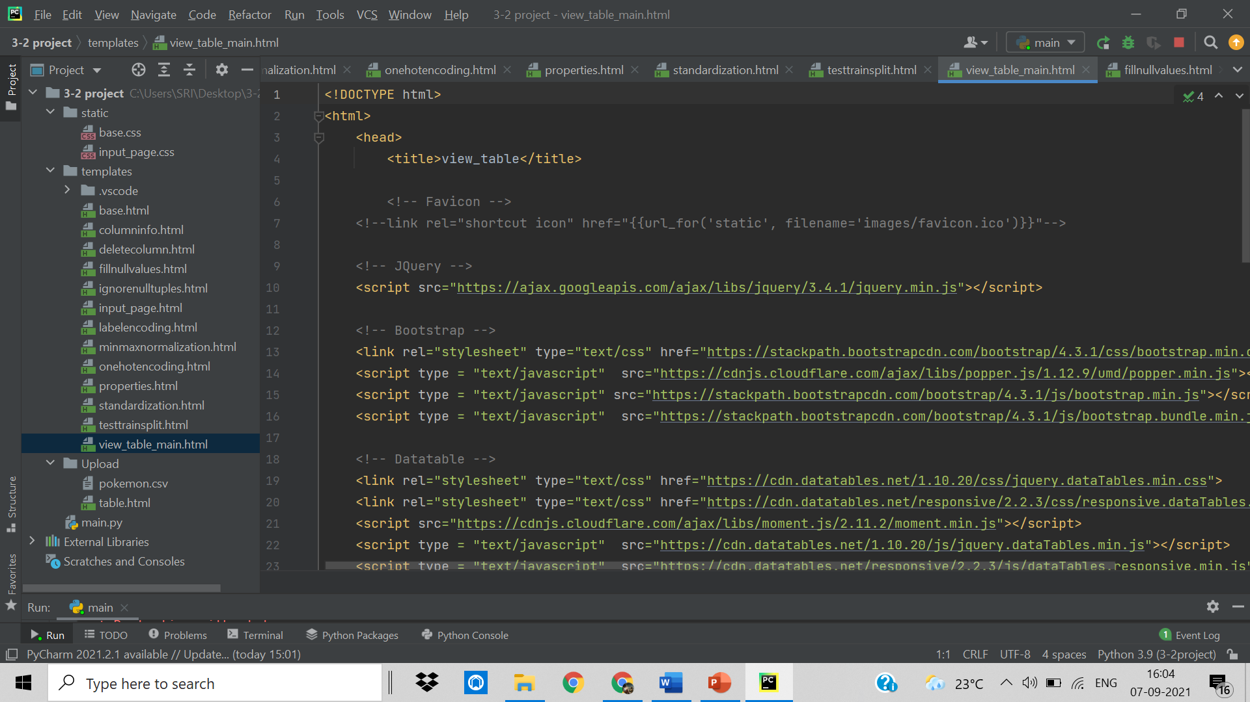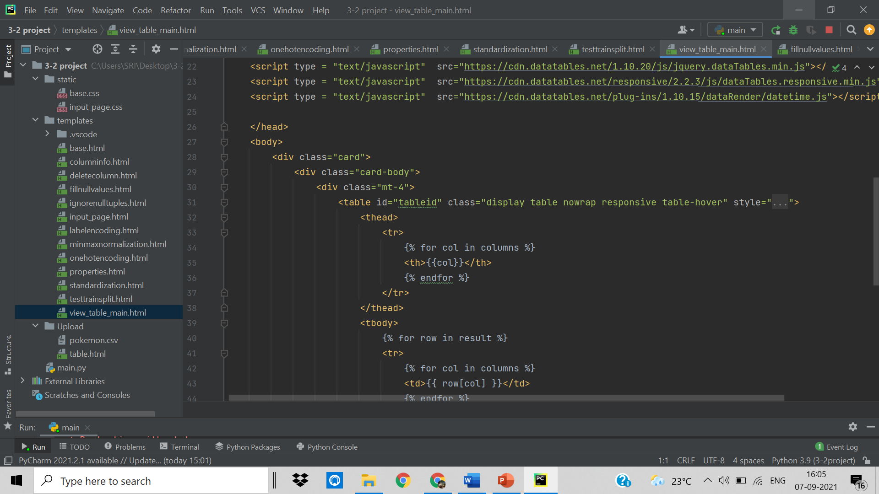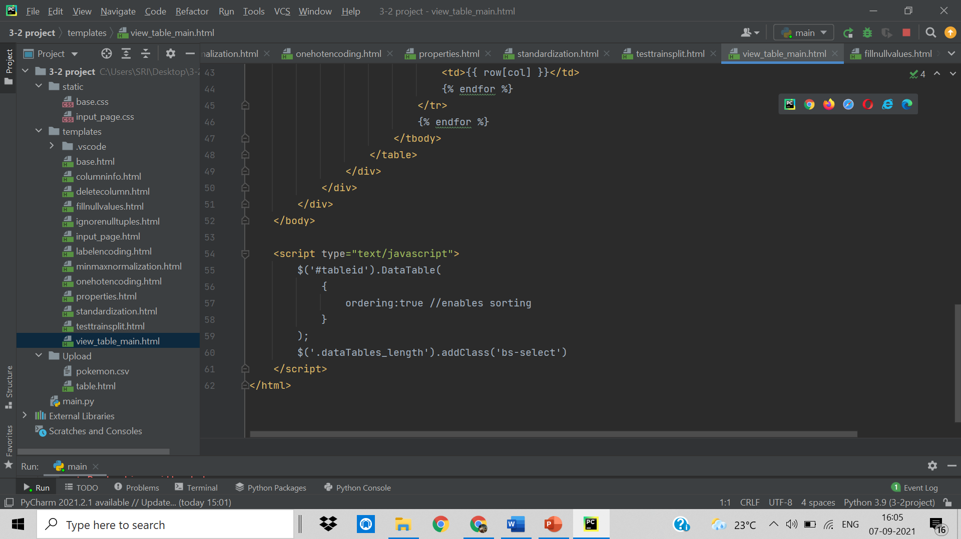

**4.3 CSS files:**

**4.3.1 Base.css**

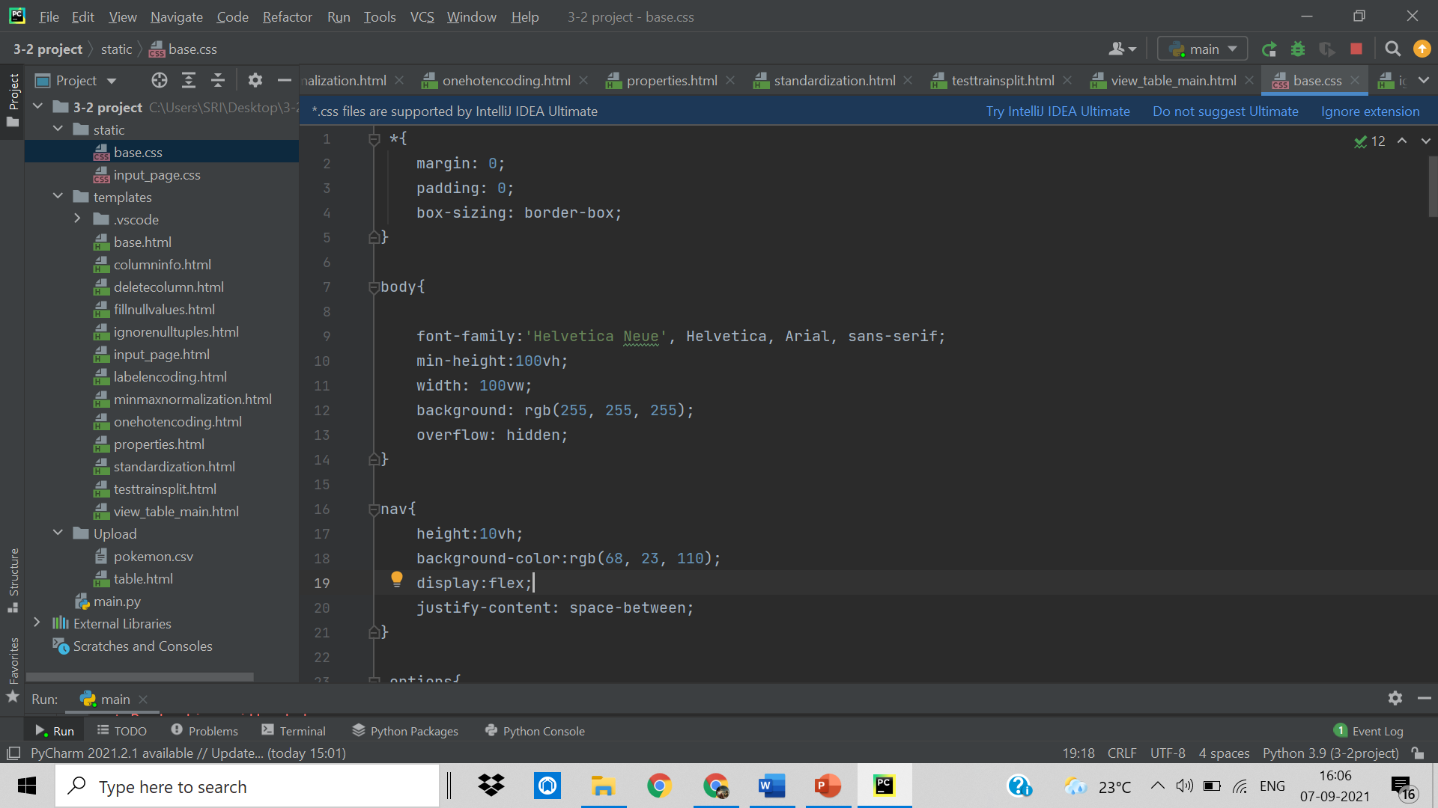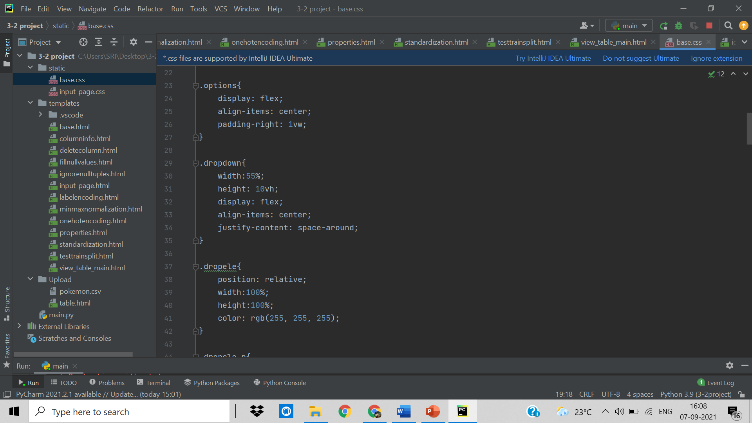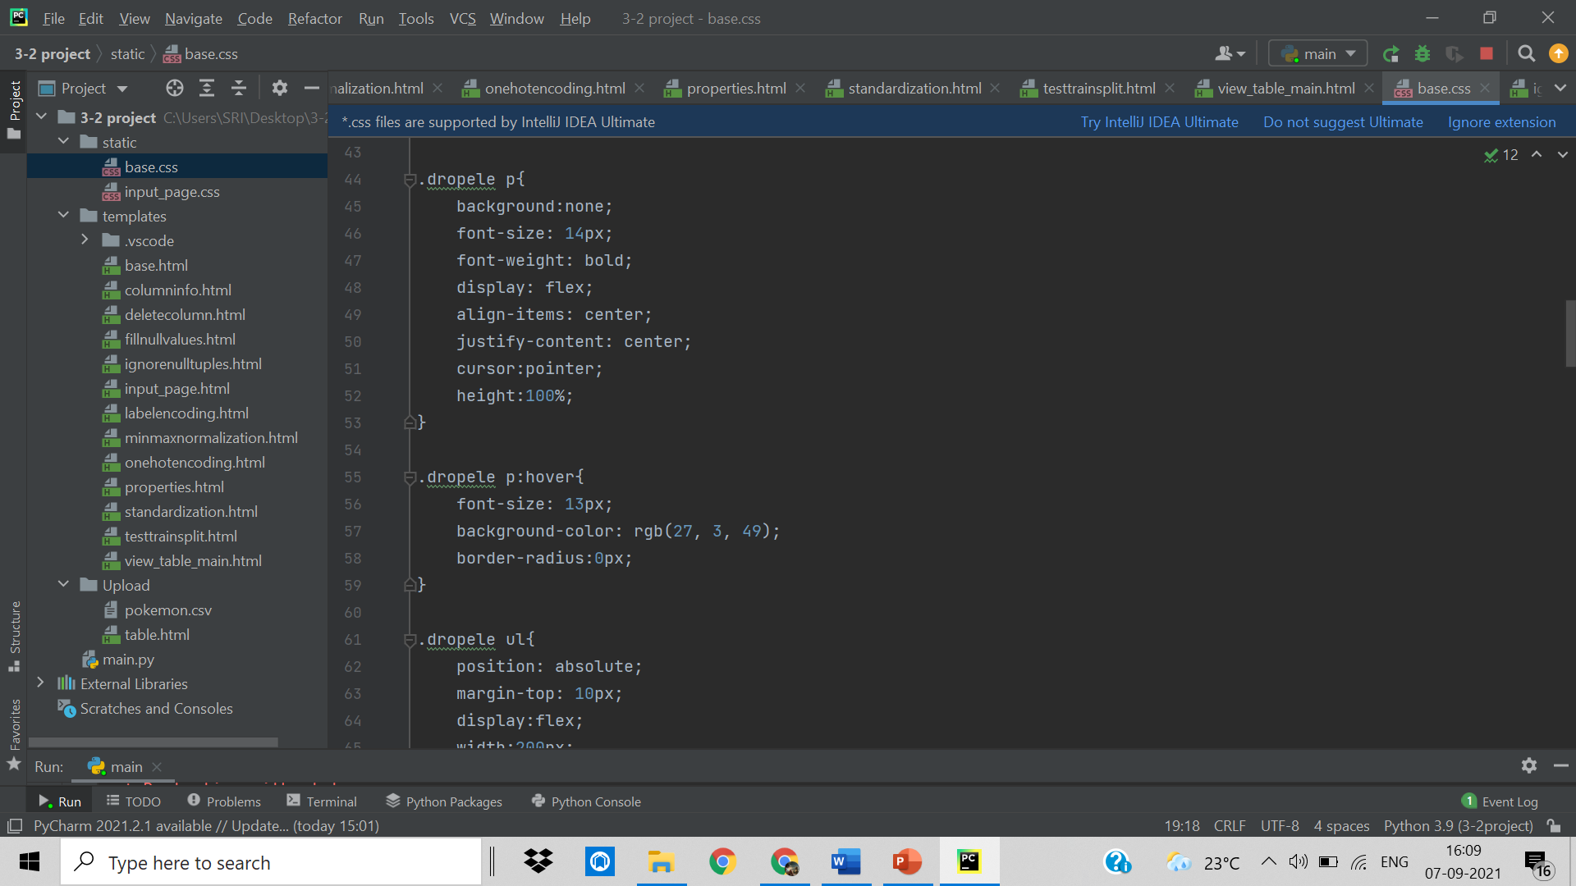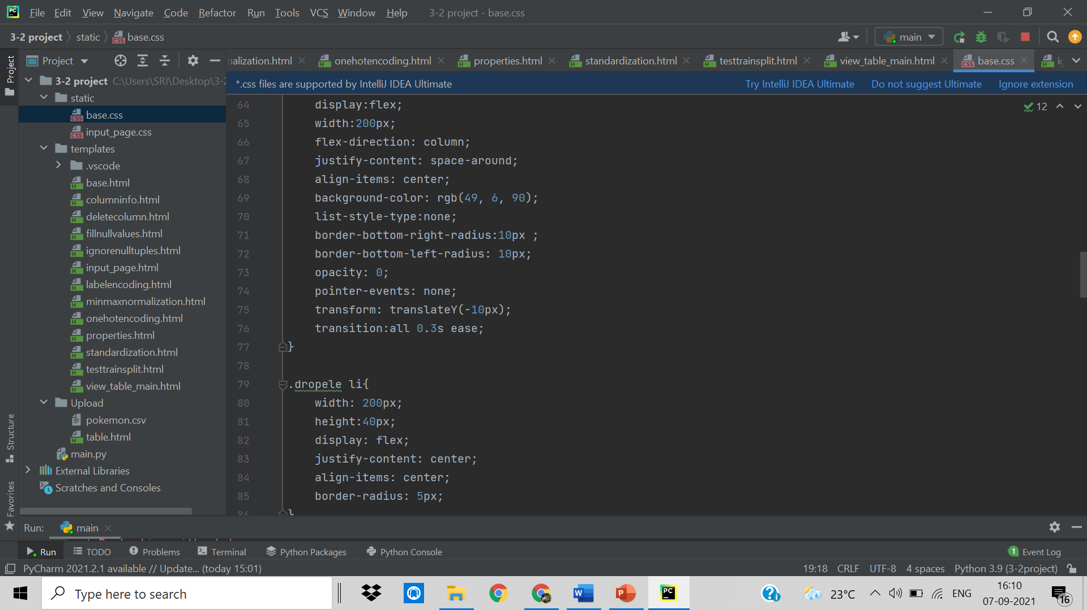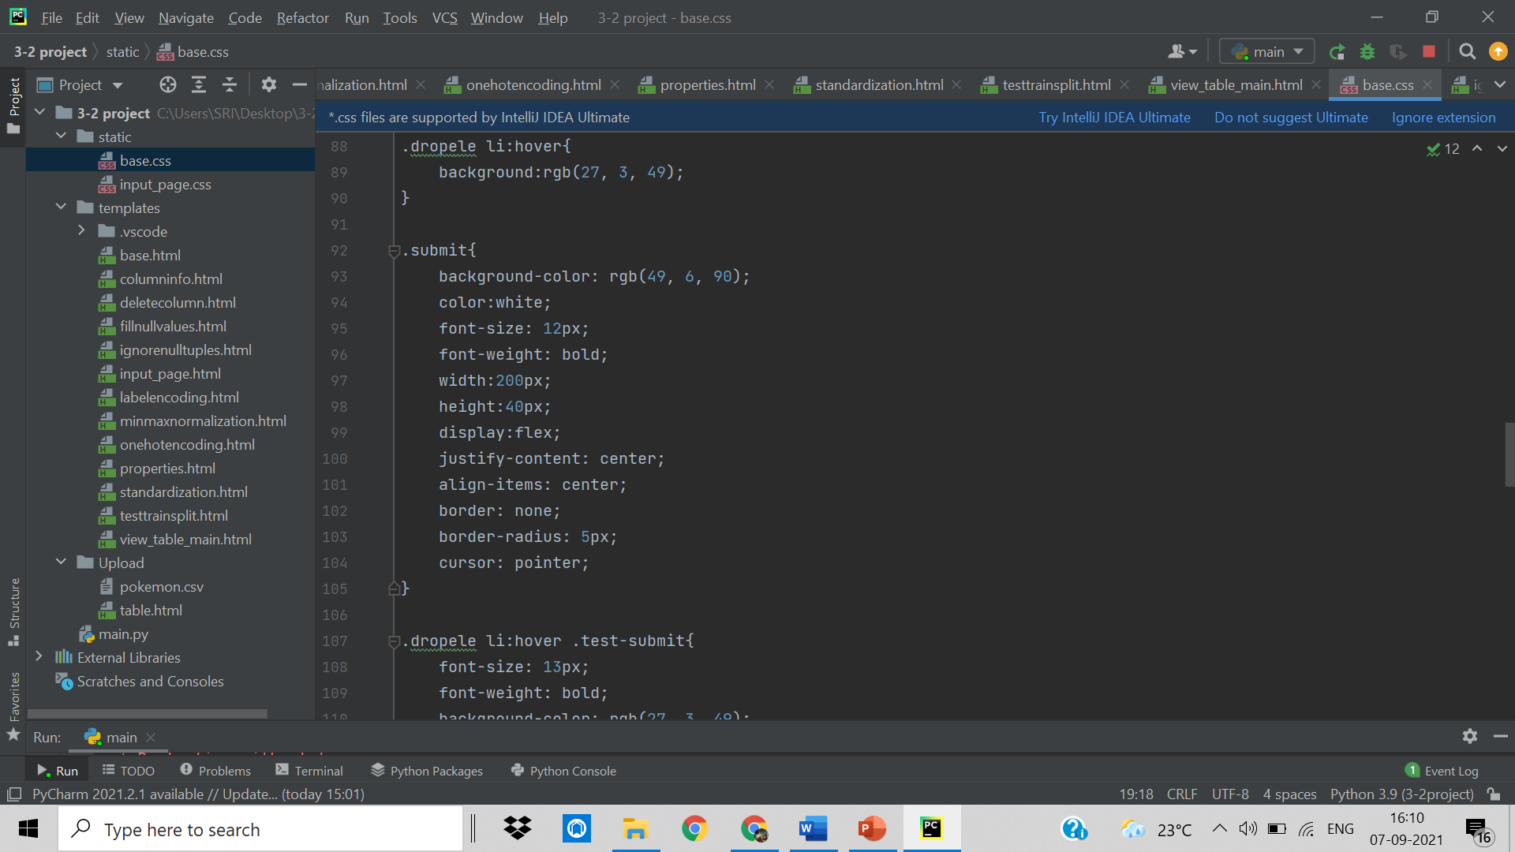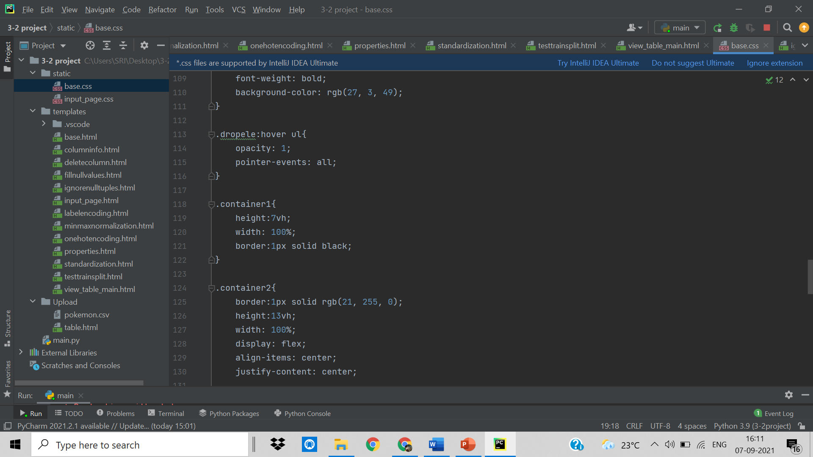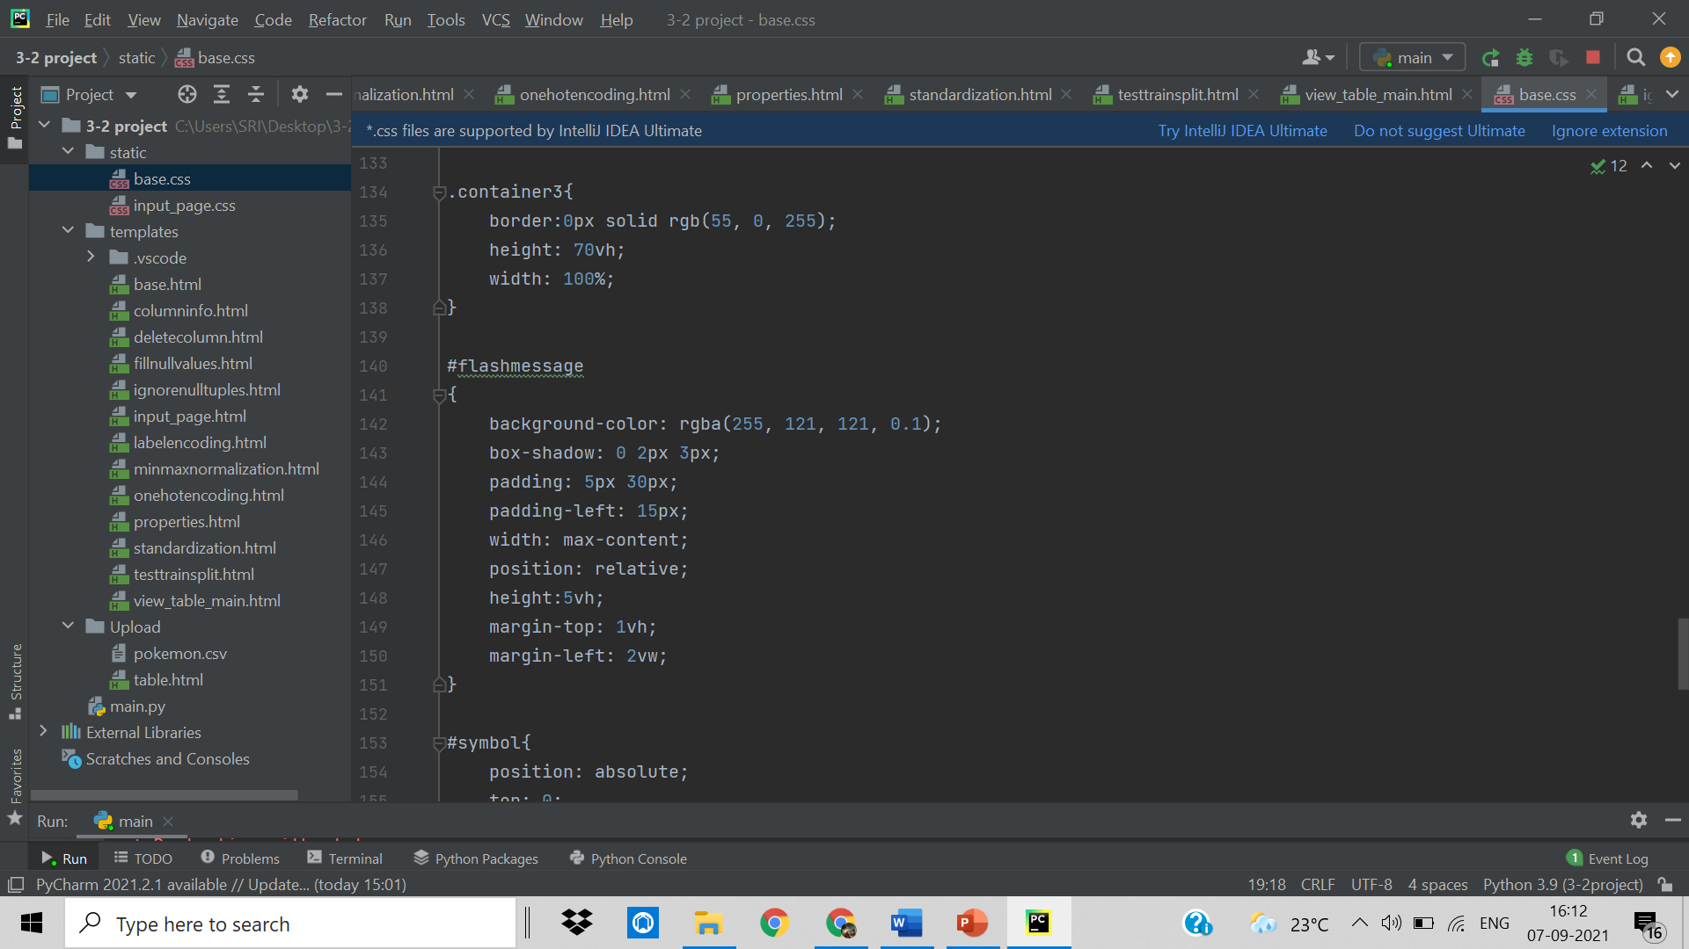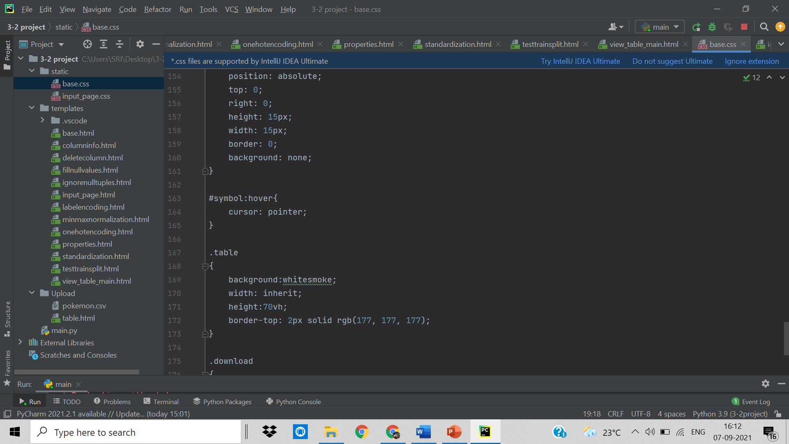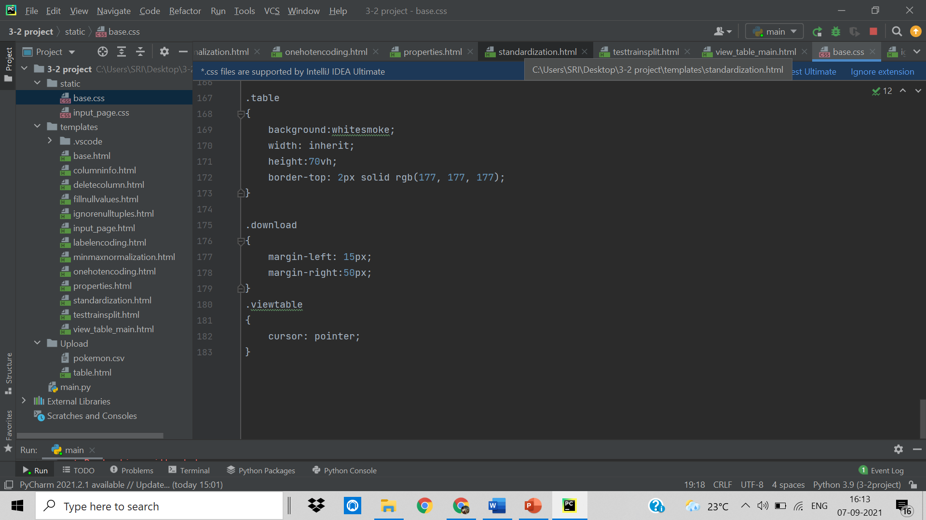

4.3.2 Input_page.css

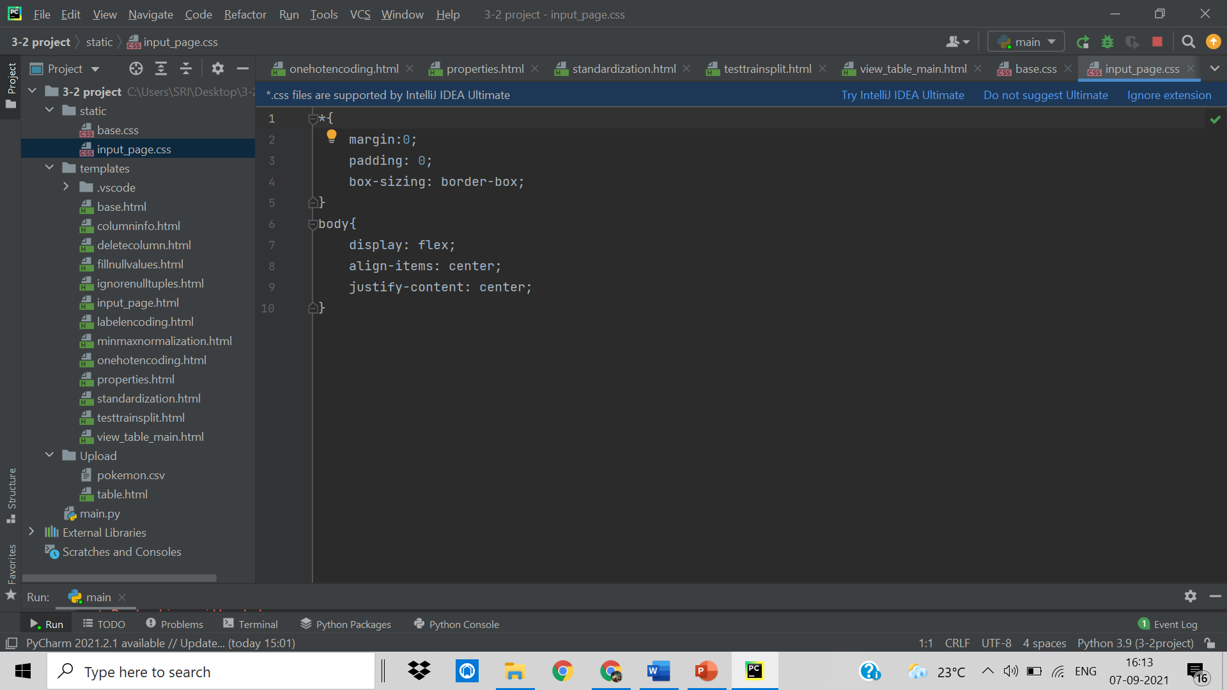

**5. OUTPUT SCREENS**

Output Screens of various functionalities in our application are shown over here along with the description.

**5.1 Input_page:**

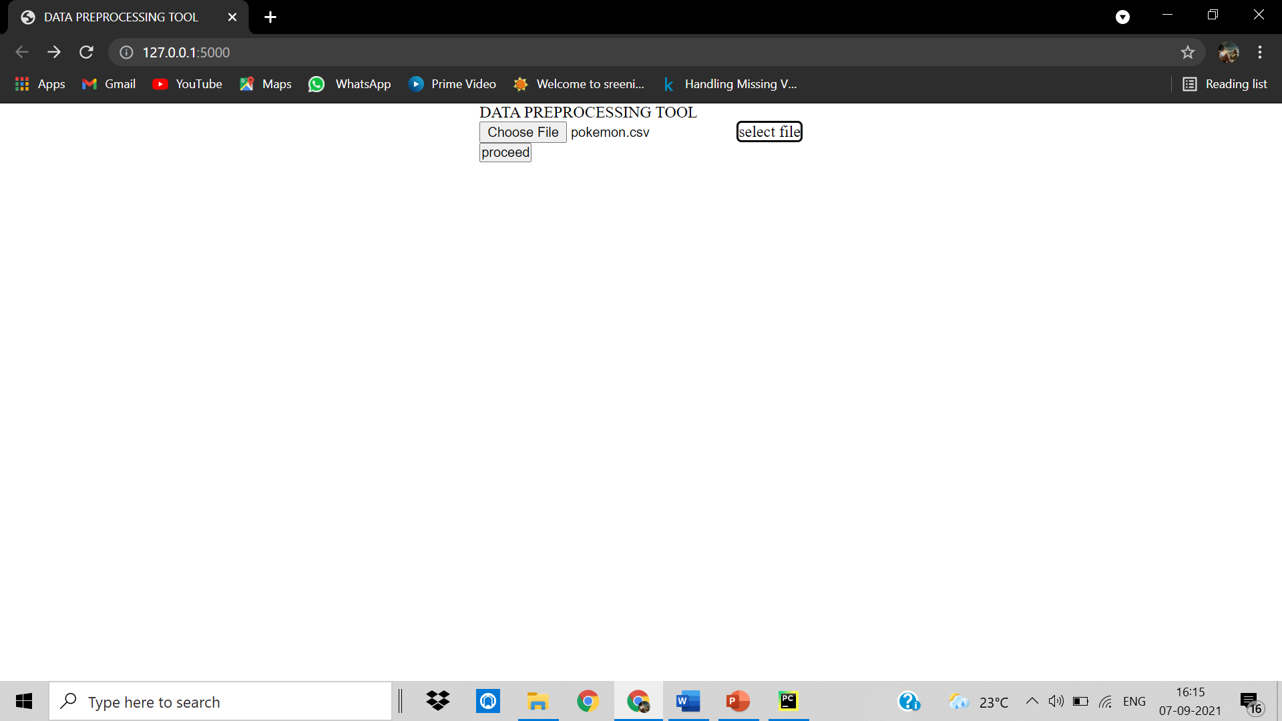

After selecting a csv file:

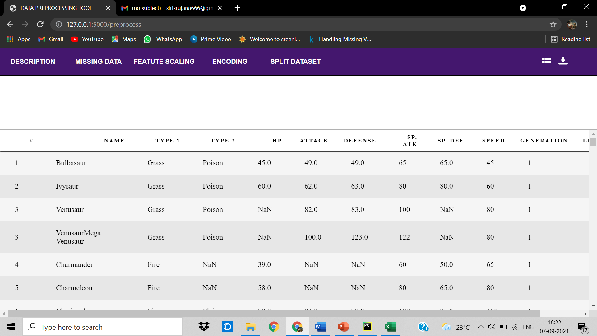

**5.2 Description:**

5.2.1 Properties of file:

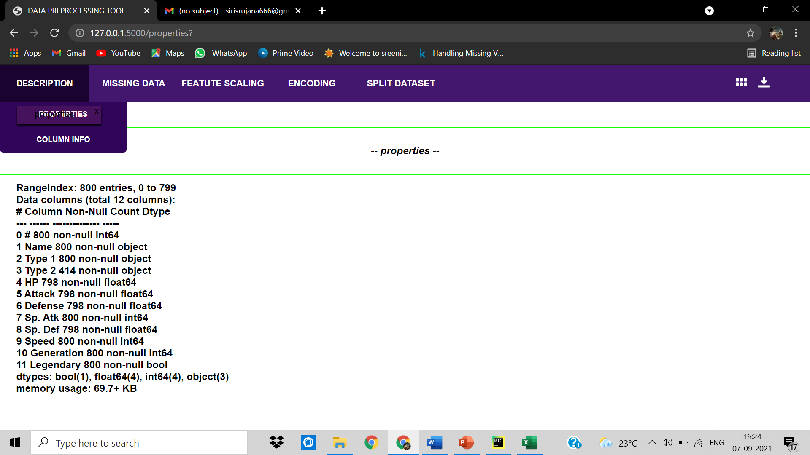

5.2.2 Column Info:

Checks Whether the column is present in the file

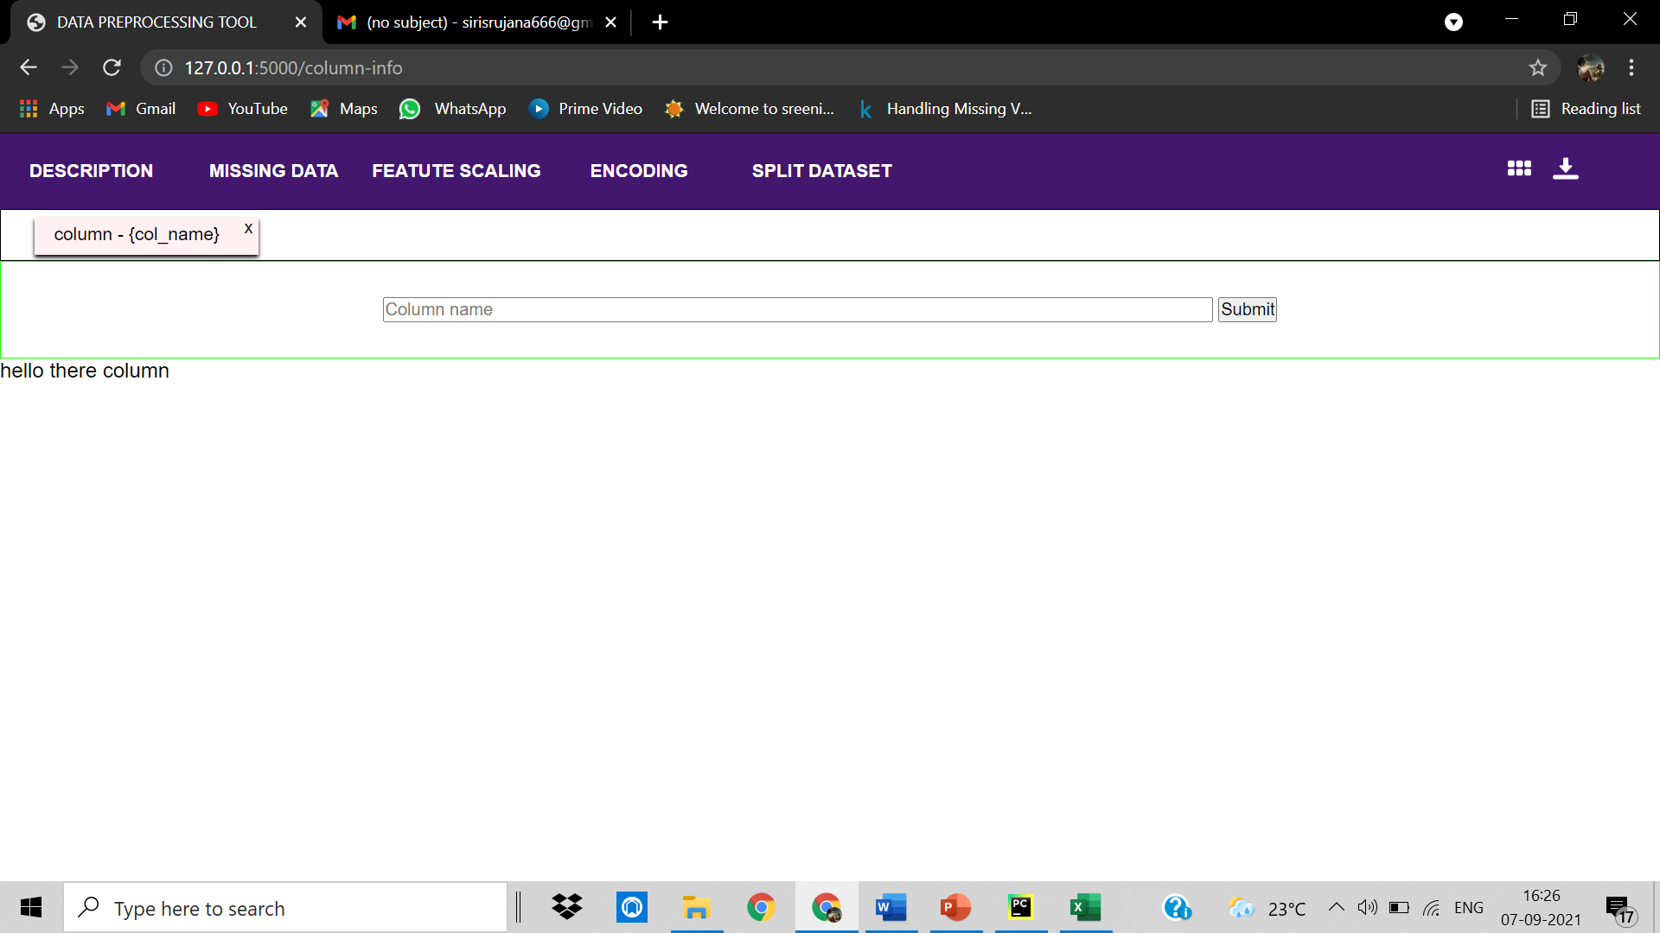

**5.3 Missing Data:**

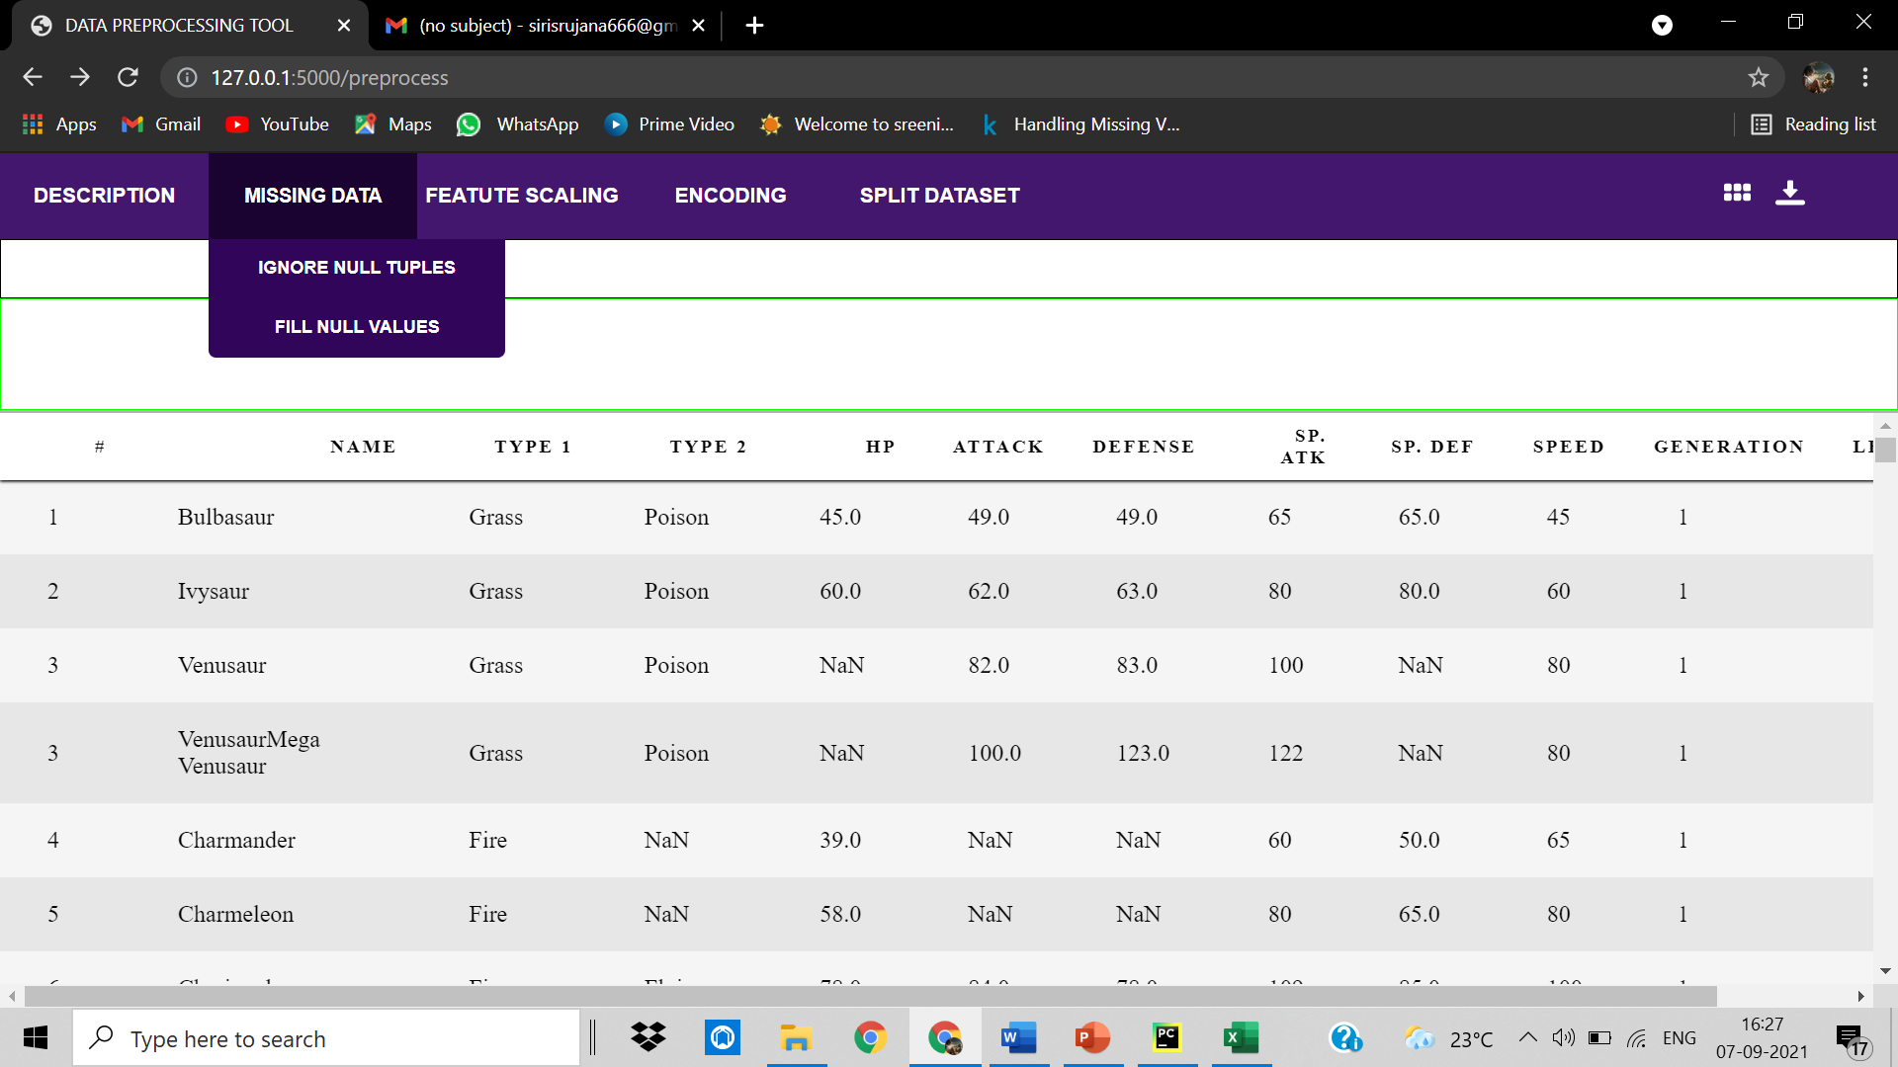

5.3.1 Ignore null tuples:

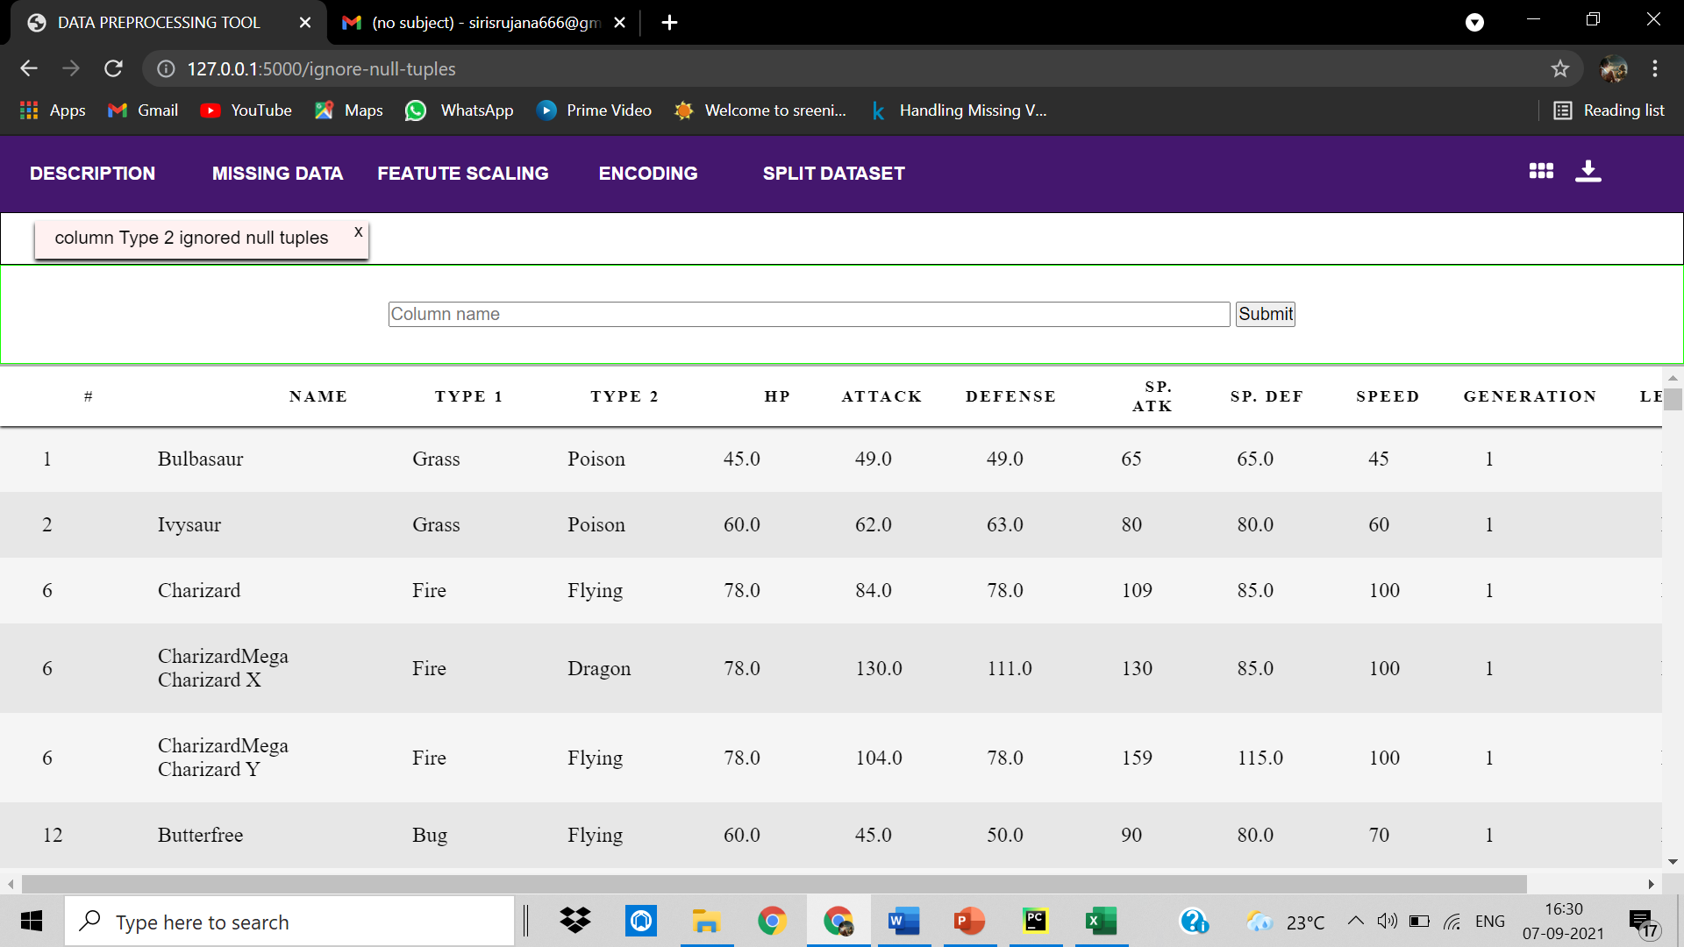

5.3.2 Fill null values:

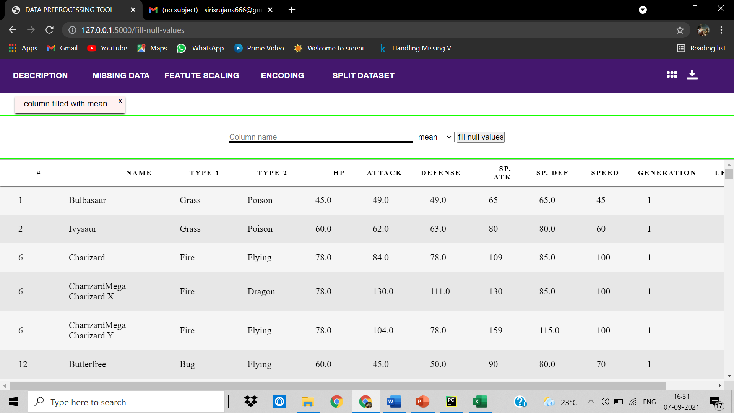

**5.4 Feature Scaling:**

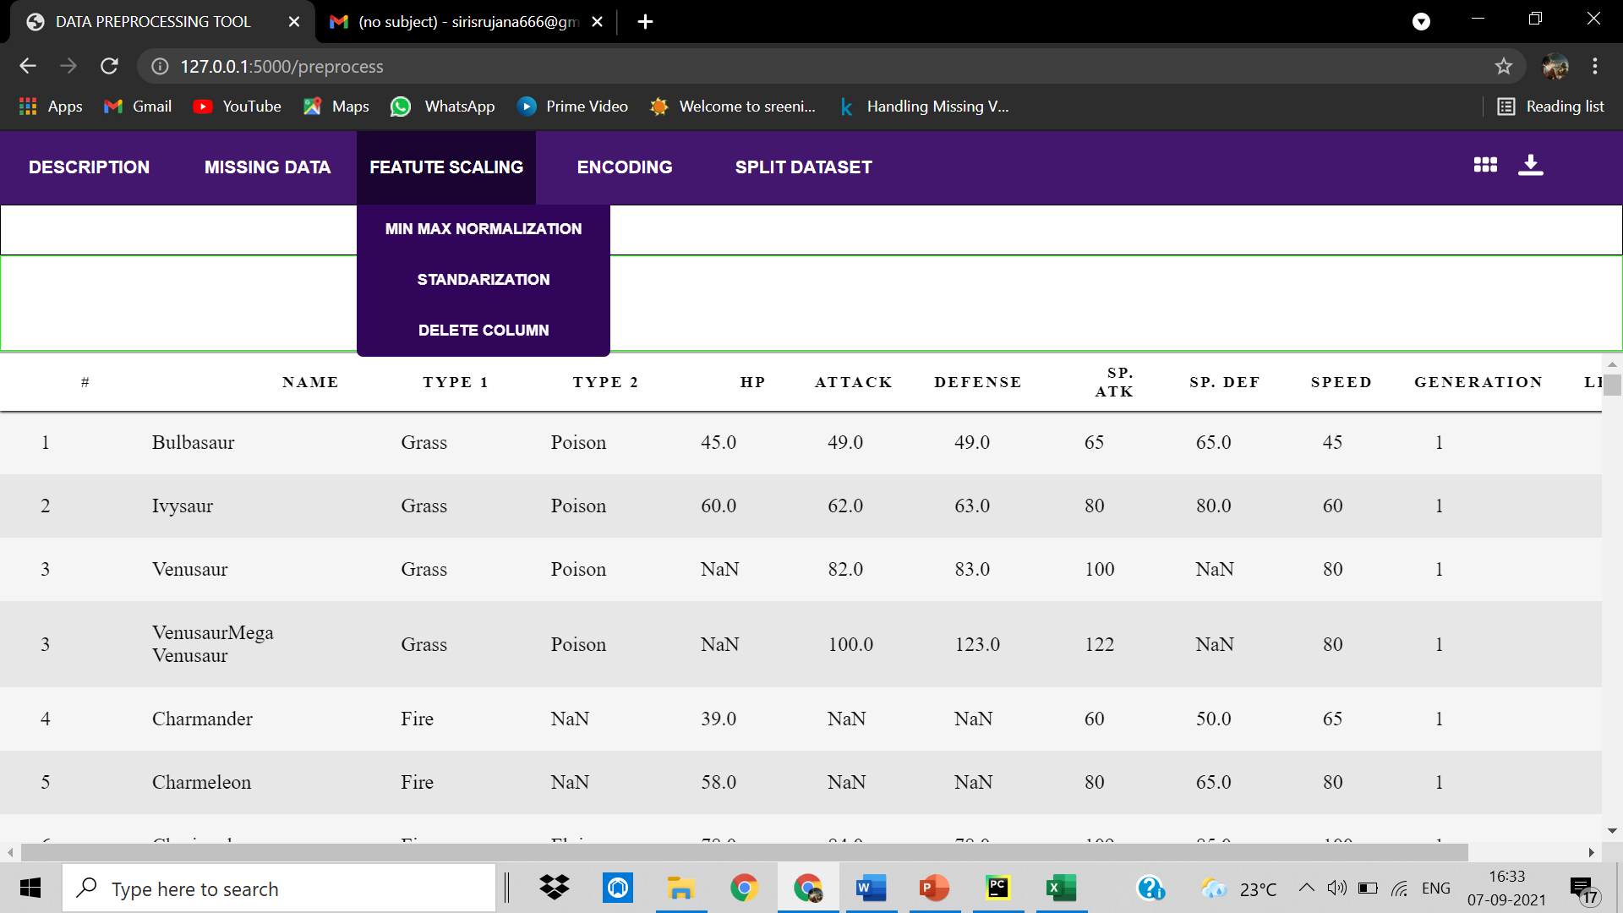

5.4.1 MIN-MAX normalization:

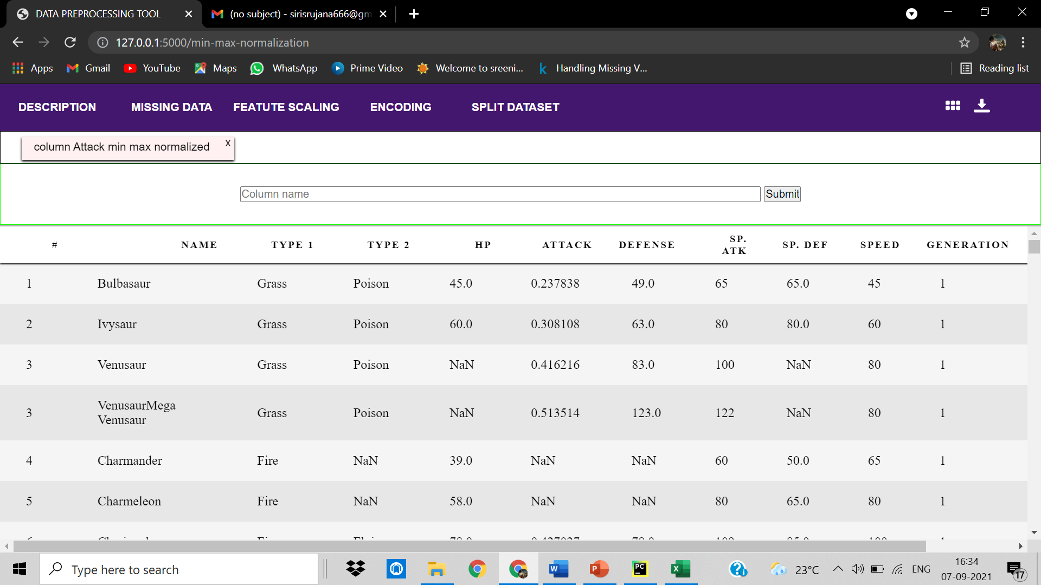

5.4.2 Delete column

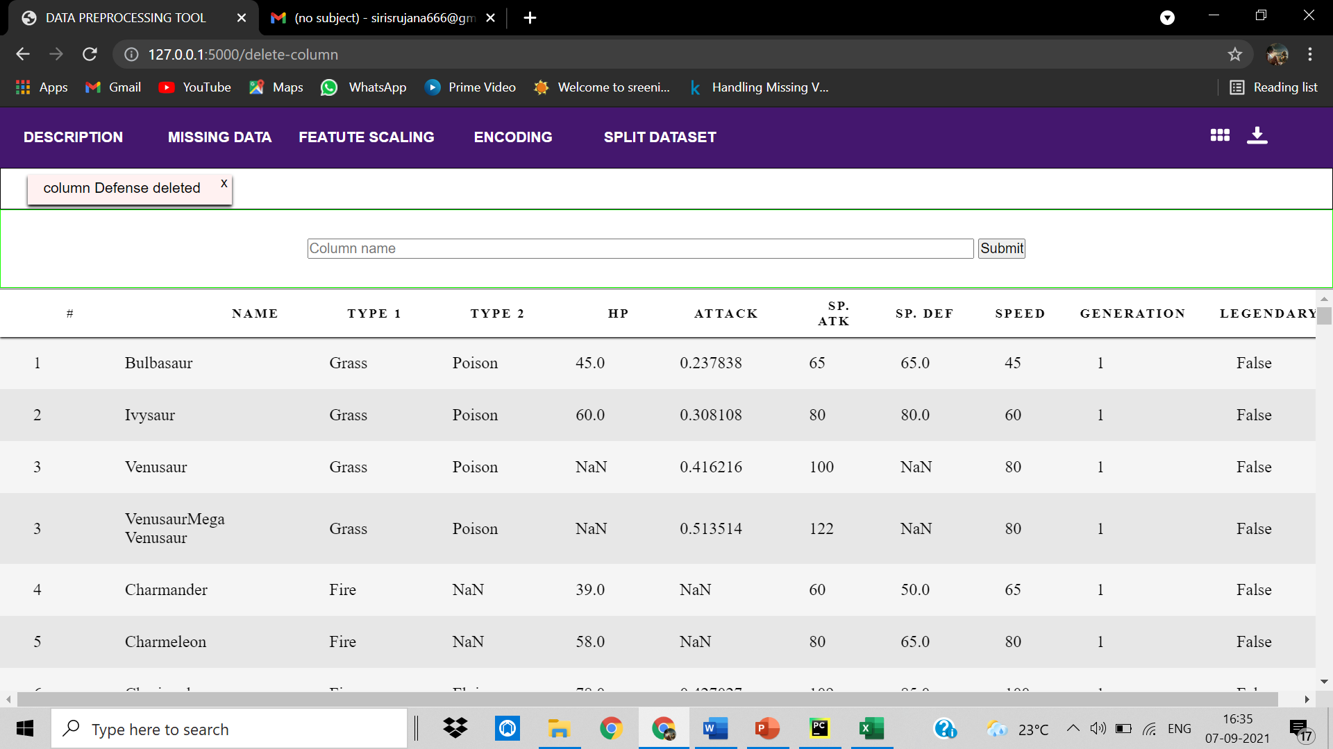

**5.5 Encoding:**

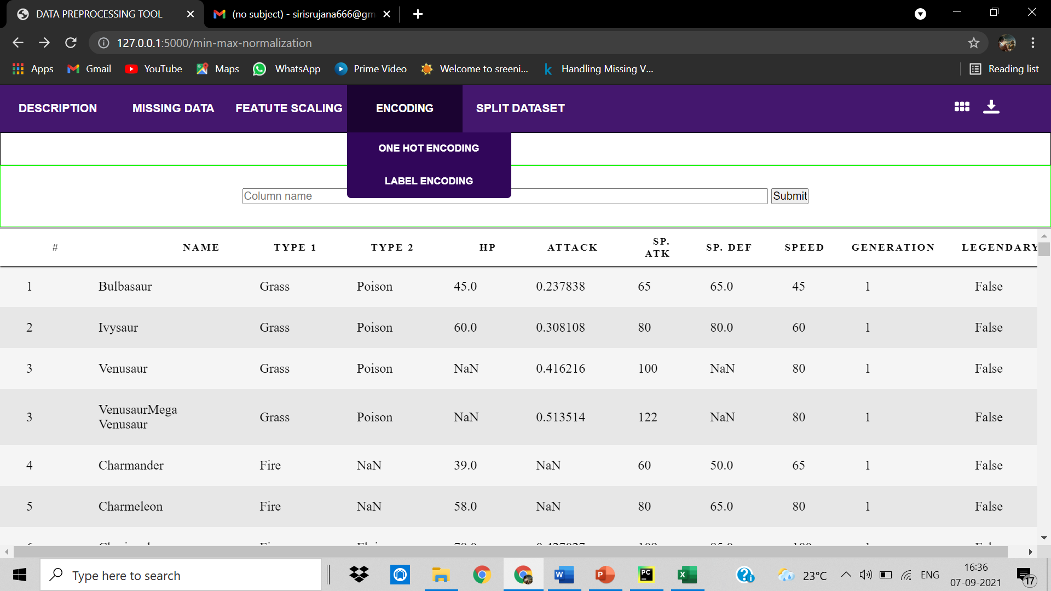

5.5.1 One Hot Encoding

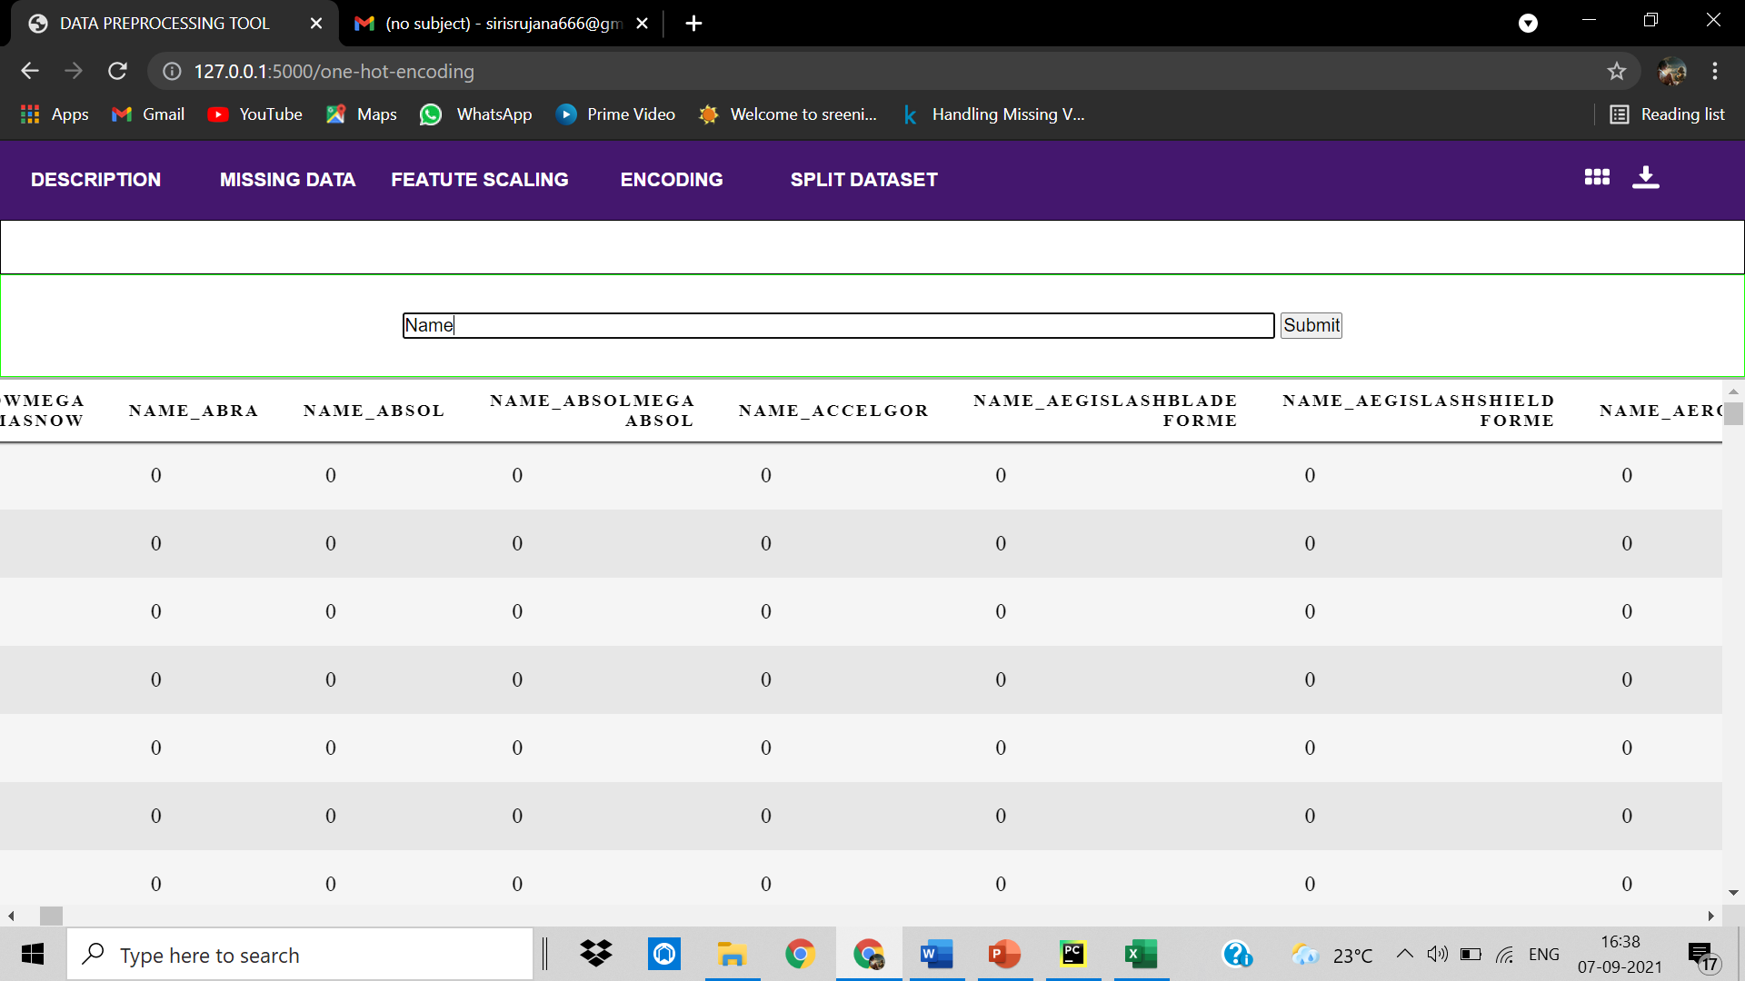

5.5.2 Label Encoding

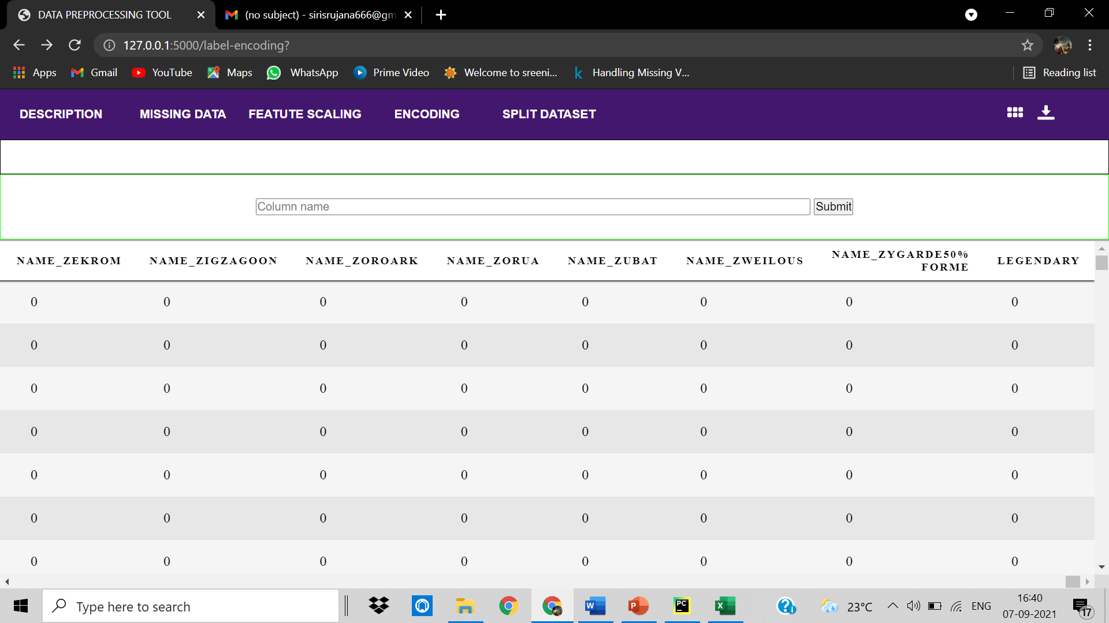

**5.6 Split dataset:**

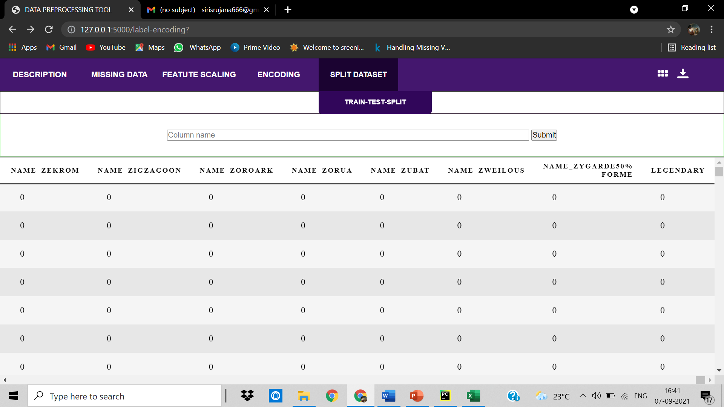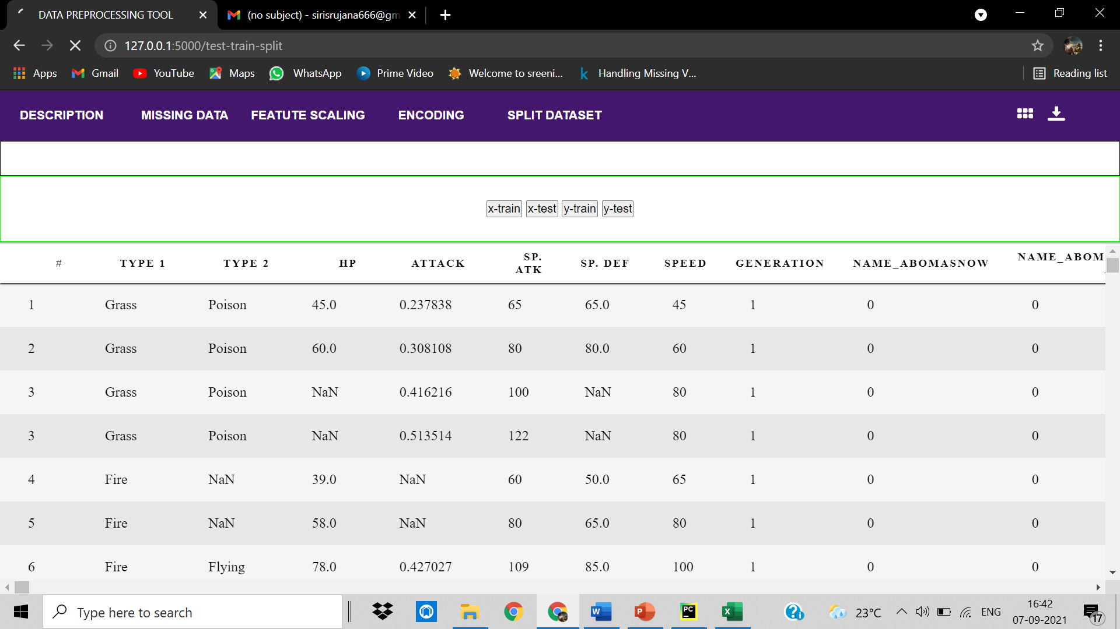

**5.7 Downloading the dataset:**

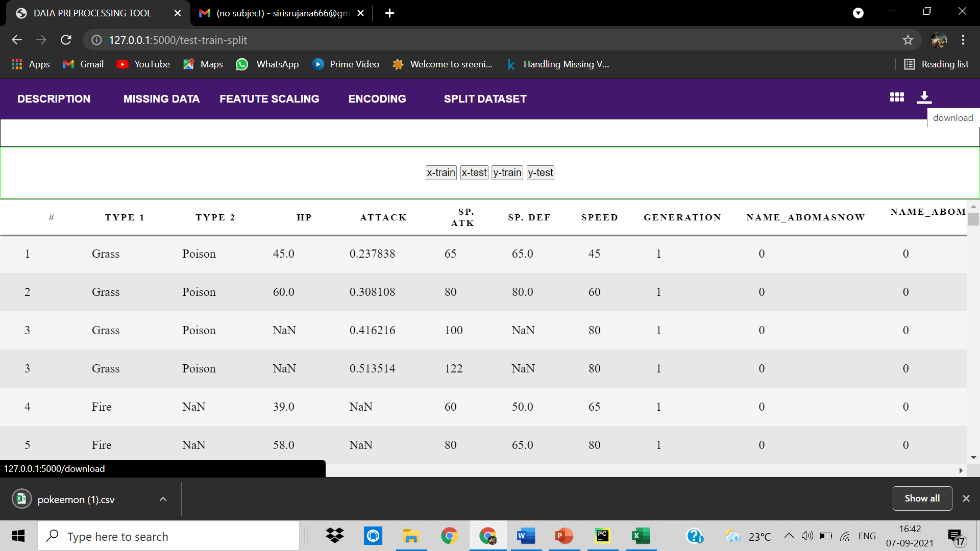

**5.8 View table:**

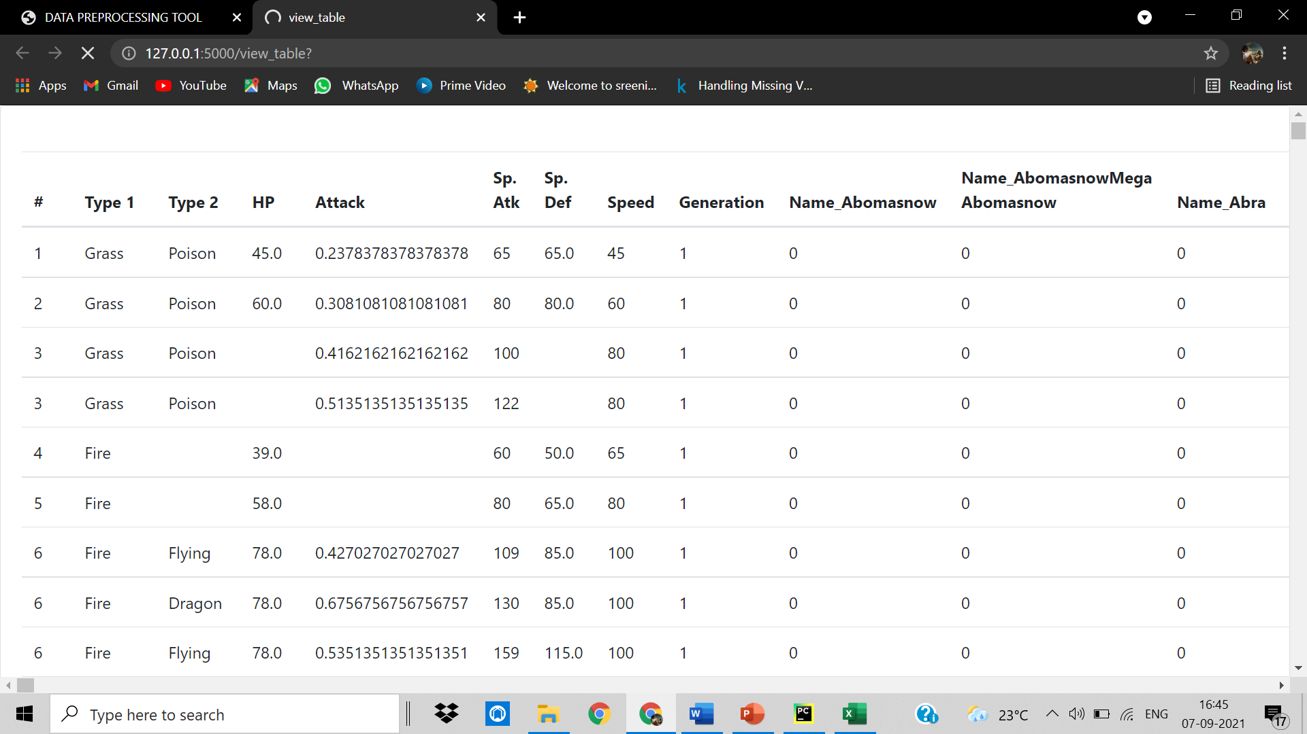

**6. CONCLUSION AND FUTURE SCOPE**

**Conclusion:**

A variety of quality control issues are common when using raw clinical data collected for non-study purposes. Data pre-processing is an important step in preparing raw data for statistical analysis. Several distinct steps are involved in pre-processing raw data as described in this chapter: cleaning, integration, transformation, and reduction. Throughout the process it is important to understand the choices made in pre-processing steps and how different methods can impact the validity and applicability of study results. In the case of EHR data, such as that in the MIMIC database, pre-processing often requires some understanding of the clinical context under which data were entered in order to guide these pre-processing choices. The objective of all the steps is to arrive at a “clean” and “tidy” dataset suitable for effective statistical analyses while avoiding inadvertent introduction of bias into the data.

**Future Scope:**

This tool can be fully developed and launched into a full scale application for data preprocessing and various more functionalities can be added like visualisation, clustering, handling very large datasets as every machine learning, deep learning, aritificial intelligence algorithms, big data analytics requires their data to be clean before feeding into the algorithms.

**BIBLIOGRAPHY**

* *Pyle, D., 1999. Data Preparation for Data Mining. Morgan Kaufmann Publishers,*[*Los Altos, California*](https://en.wikipedia.org/wiki/Los_Altos,_California)*.*
* [***^***](https://en.wikipedia.org/wiki/Data_pre-processing#cite_ref-2)Chicco D (December 2017). [*"Ten quick tips for machine learning in computational biology"*](https://www.ncbi.nlm.nih.gov/pmc/articles/PMC5721660). BioData Mining. **10** (35): 35. [*doi*](https://en.wikipedia.org/wiki/Doi_(identifier)):[*10.1186/s13040-017-0155-3*](https://doi.org/10.1186%2Fs13040-017-0155-3). [*PMC*](https://en.wikipedia.org/wiki/PMC_(identifier)) [*5721660*](https://www.ncbi.nlm.nih.gov/pmc/articles/PMC5721660). [*PMID*](https://en.wikipedia.org/wiki/PMID_(identifier)) [*29234465*](https://pubmed.ncbi.nlm.nih.gov/29234465).
* [***^***](https://en.wikipedia.org/wiki/Data_pre-processing#cite_ref-3)Oliveri, Paolo; Malegori, Cristina; Simonetti, Remo; Casale, Monica (2019). "The impact of signal preprocessing on the final interpretation of analytical outcomes – A tutorial". Analytica Chimica Acta. **1058**: 9–17. [*doi*](https://en.wikipedia.org/wiki/Doi_(identifier)):[*10.1016/j.aca.2018.10.055*](https://doi.org/10.1016%2Fj.aca.2018.10.055). [*PMID*](https://en.wikipedia.org/wiki/PMID_(identifier)) [*30851858*](https://pubmed.ncbi.nlm.nih.gov/30851858).
* [***^***](https://en.wikipedia.org/wiki/Data_pre-processing#cite_ref-4)Culmone, Rosario and Falcioni, Marco and Quadrini, Michela (2014). An ontology-based framework for semantic data preprocessing aimed at human activity recognition. SEMAPRO 2014: The Eighth International Conference on Advances in Semantic Processing. Alexey Cheptsov, High Performance Computing Center Stuttgart (HLRS). [*S2CID*](https://en.wikipedia.org/wiki/S2CID_(identifier)) [*196091422*](https://api.semanticscholar.org/CorpusID:196091422).
* [***^***](https://en.wikipedia.org/wiki/Data_pre-processing#cite_ref-5)David Perez-Rey and Alberto Anguita and Jose Crespo (2006). OntoDataClean: Ontology-Based Integration and Preprocessing of Distributed Data. Biological and Medical Data Analysis. Springer Berlin Heidelberg. pp. 262–272. [*doi*](https://en.wikipedia.org/wiki/Doi_(identifier)):[*10.1007/11946465_24*](https://doi.org/10.1007%2F11946465_24).
* [***^***](https://en.wikipedia.org/wiki/Data_pre-processing#cite_ref-6)F. Mary Harin Fernandez and R. Ponnusamy (2016). [*"Data Preprocessing and Cleansing in Web Log on Ontology for Enhanced Decision Making"*](https://doi.org/10.17485%2Fijst%2F2016%2Fv9i10%2F88899). Indian Journal of Science and Technology. Indian Society for Education and Environment. **9** (10). [*doi*](https://en.wikipedia.org/wiki/Doi_(identifier)):[*10.17485/ijst/2016/v9i10/88899*](https://doi.org/10.17485%2Fijst%2F2016%2Fv9i10%2F88899).

**APPENDIX-A:PYTHON TECHNOLOGY**

**About Python**

**Python** is a programming language, which means it’a a language both people and computers can understand. Python was developed by a Dutch software engineer named Guido van Rossum, who created the language to solve some problems he saw in computer languages of the time.

**Python** is an interpreted high-level programming language for general-purpose programming. Created by Guido van Rossum and first released in 1991, Python has a design philosophy that emphasizes code readability, and a syntax that allows programmers to express concepts in fewer lines of code, notably using significant whitespace. It provides constructs that enable clear programming on both small and large scales.

Python features a dynamic type system and automatic memory management. It supports multiple programming paradigms, including object-oriented, imperative, functional and procedural, and has a large and comprehensive standard library.

Python interpreters are available for many operating systems. C Python, the reference implementation of Python, is open source software and has a community-based development model, as do nearly all of its variant implementations. C Python is managed by the non-profit

Python interpreters are available for many operating systems. C Python, the reference implementation of Python, is open source software and has a community-based development model, as do nearly all of its variant implementations. C Python is managed by the non-profit. C Python is managed by the non-profit Python Software Foundation.

**You Can Use Python for Pretty Much Anything**

One significant advantage of learning Python is that it’s a general-purpose language that can be applied in a large variety of projects. Below are just some of the most common fields where Python has found its use:

* Data science
* Scientific and mathematical computing
* Web development
* Computer graphics
* Basic game development
* Mapping and geography (GIS software)

**Python Is Widely Used in Data Science**

Python’s ecosystem is growing over the years and it’s more and more capable of the statistical analysis.

It’s the best compromise between scale and sophistication (in terms od data processing).

Python emphasizes productivity and readability.

Python is used by programmers that want to delve into data analysis or apply statistical techniques (and by devs that turn to data science)

There are plenty of Python scientific packages for data visualization, machine learning, natural language processing, complex data analysis and more. All of these factors make Python a great tool for scientific computing and a solid alternative for commercial packages such as MatLab. The most popular libraries and tools for data science are:

**Pandas**: a library for data manipulation and analysis. The library provides data structures and operations for manipulating numerical tables and time series.

**NumPy**: the fundamental package for scientific computing with Python, adding support for large, multi-dimensional arrays and matrices, along with a large library of high-level mathematical functions to operate on these arrays.

**SciPy**: a library used by scientists, analysts, and engineers doing scientific computing and technical computing.

Being a free, cross-platform, general-purpose and high-level programming language, Python has been widely adopted by the scientific community. Scientists value Python for its precise and efficient syntax, relatively flat learning curve and the fact that it integrates well with other languages (e.g. C/C++).

As a result of this popularity there are plenty of Python scientific packages for data visualization, machine learning, natural language processing, complex data analysis and more. All of these factors make Python a great tool for scientific computing and a solid alternative for commercial packages such as Matlab.

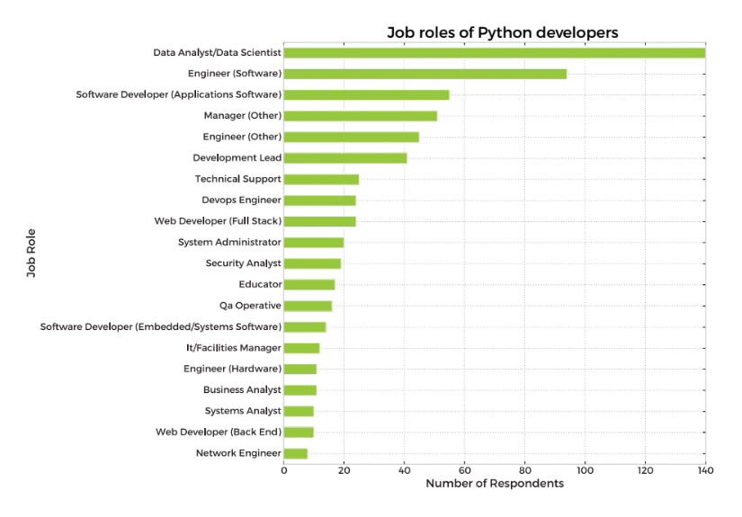

**Here’s our list of the most popular Python scientific libraries and tools**

**Astropy**

The Astropy Project is a collection of packages designed for use in astronomy. The core astropy package contains functionality aimed at professional astronomers and astrophysicists, but may be useful to anyone developing astronomy software.

**Biopython**

Biopython is a collection of non-commercial Python tools for computational biology and bioinformatics. It contains classes to represent biological sequences and sequence annotations, and it is able to read and write to a variety of file formats.

**Cubes**

Cubes is a light-weight Python framework and set of tools for the development of reporting and analytical applications, Online Analytical Processing (OLAP), multidimensional analysis and browsing of aggregated data.

**DEAP**

DEAP is an evolutionary computation framework for rapid prototyping and testing of ideas. It incorporates the data structures and tools required to implement most common evolutionary computation techniques such as genetic algorithm, genetic programming, evolution strategies, particle swarm optimization, differential evolution and estimation of distribution algorithm.

**SCOOP**

SCOOP is a Python module for distributing concurrent parallel tasks on various environments, from heterogeneous grids of workstations to supercomputers.

**PsychoPy**

PsychoPy is a package for the generation of experiments for neuroscience and experimental psychology. PsychoPy is designed to allow the presentation of stimuli and collection of data for a wide range of neuroscience, psychology and psychophysics experiments.

**Pandas**

Pandas is a library for data manipulation and analysis. The library provides data structures and operations for manipulating numerical tables and time series.

**Python Saves Time**

Even the classic “Hello, world” program illustrates this point:

print("Hello, world")

For comparison, this is what the same program looks like in Java:

public class HelloWorld {

public static void main(String[] args) {

System.out.println("Hello, world");

}

}

**Flask Framework:**

**Flask** is a micro [web framework](https://en.wikipedia.org/wiki/Web_framework) written in [Python](https://en.wikipedia.org/wiki/Python_(programming_language)). It is classified as a [microframework](https://en.wikipedia.org/wiki/Microframework) because it does not require particular tools or libraries. It has no database abstraction layer, form validation, or any other components where pre-existing third-party libraries provide common functions. However, Flask supports extensions that can add application features as if they were implemented in Flask itself. Extensions exist for object-relational mappers, form validation, upload handling, various open authentication technologies and several common framework related tools.

The following code shows a simple web application that displays "[Hello World](https://en.wikipedia.org/wiki/Hello_World)!" when visited:

**from** **flask** **import** Flask

app = Flask(__name__)

@app.route("/")

**def** hello() -> str:

**return** "Hello World"

**if** __name__ == "__main__":

app.run(debug=**False**)

A web framework is an architecture containing tools, libraries, and functionalities suitable to build and maintain massive web projects using a fast and efficient approach. They are designed to streamline programs and promote code reuse. To create the server-side of the web application, you need to use a server-side language. Python is home to numerous such frameworks, famous among which are Django and Flask. Python Flask Framework is a lightweight micro-framework based on Werkzeug, Jinja2. It is called a micro framework because it aims to keep its core functionality small yet typically extensible to cover an array of small and large applications.

Initialization: flask applications must create an application instance. The web server passes all the requests it receives from clients to objects for handling using a protocol for WSG from flask import Flask app = Flask (__name__) (An application instance is an object of class Flask.)

## Routes and View Functions in Flask Framework Instance:

Clients send requests to the webserver, in turn, sends them to the Flask application instance. The instance needs to know what code needs to run for each URL requested and map URLs to Python functions. The association between a URL and the function that handles it is called a route. The most convenient way to define a route in a Flask application is through the (app.route). Decorator exposed by the application instance, which registers the ‘decorated function,’ decorators are python feature that modifies the behavior of a function.

### HTTP Methods

#### Request

To process incoming data in Flask, you need to use the request object, including mime-type, IP address, and data. HEAD: Un-encrypted data sent to server w/o response.

#### GET

Sends data to the server requesting a response body.

#### POST

Read form inputs and register a user, send HTML data to the server are methods handled by the route. Flask attaches methods to each route so that different view functions can handle different request methods to the same URL.

#### Response

Flask invokes a view function. It has to return a response value to the client. HTTP requires it to be more than a string response, a status code.

* Informational – 1xx
* Successful – 2xx
* Redirection – 3xx
* Client Error – 4xx
* Server Error – 5xx

#### Templates

To maintain the site. Flask uses a powerful template engine, ‘Jinja2’, in its simplest form. A Jinja2 template is a file that contains the text of a response, returned by a view function that has a dynamic component represented by a variable.

#### Linking

Dynamic url routing support is included using ‘url_for()’ helper function. For example, url_for('sagar', name='project_file', _external=True) would return http://localhost:5000/sagar/project_file.

#### Security

CSRF(Cross-Site-Request-Forgery) occurs when a malicious website sends requests to a different website on which the victim logs in. Flask-WTF protects against all such attacks. Apart from that, Flask also implements some common security mechanisms like session-based management, role mgmt, password hashing, basic HTTP and token-based authentication, optional log-in tracking.

**MACHINE LEARNING:**

Machine learning is a branch of [artificial intelligence (AI)](https://www.ibm.com/cloud/learn/what-is-artificial-intelligence) and computer science which focuses on the use of data and algorithms to imitate the way that humans learn, gradually improving its accuracy.

IBM has a rich [history](https://www.ibm.com/ibm/history/ibm100/us/en/icons/ibm700series/impacts/) with machine learning. One of its own, Arthur Samuel, is credited for coining the term, “machine learning” with his [research](https://hci.iwr.uni-heidelberg.de/system/files/private/downloads/636026949/report_frank_gabel.pdf) (PDF, 481 KB) (link resides outside IBM) around the game of checkers. Robert Nealey, the self-proclaimed checkers master, played the game on an IBM 7094 computer in 1962, and he lost to the computer. Compared to what can be done today, this feat almost seems trivial, but it’s considered a major milestone within the field of artificial intelligence. Over the next couple of decades, the technological developments around storage and processing power will enable some innovative products that we know and love today, such as Netflix’s recommendation engine or self-driving cars.

Machine learning is an important component of the growing field of data science. Through the use of statistical methods, algorithms are trained to make classifications or predictions, uncovering key insights within data mining projects. These insights subsequently drive decision making within applications and businesses, ideally impacting key growth metrics. As big data continues to expand and grow, the market demand for data scientists will increase, requiring them to assist in the identification of the most relevant business questions and subsequently the data to answer them.

# **Data Preprocessing in Machine learning:**

Data preprocessing is a process of preparing the raw data and making it suitable for a machine learning model. It is the first and crucial step while creating a machine learning model.

When creating a machine learning project, it is not always a case that we come across the clean and formatted data. And while doing any operation with data, it is mandatory to clean it and put in a formatted way. So for this, we use data preprocessing task.

## Why do we need Data Preprocessing?

A real-world data generally contains noises, missing values, and maybe in an unusable format which cannot be directly used for machine learning models. Data preprocessing is required tasks for cleaning the data and making it suitable for a machine learning model which also increases the accuracy and efficiency of a machine learning model.

It involves below steps:

* **Getting the dataset**
* **Importing libraries**
* **Importing datasets**
* **Finding Missing Data**
* **Encoding Categorical Data**
* **Splitting dataset into training and test set**
* **Feature scaling**

**Sreenidhi Institute of Science and Technology Department of Computer Science and Engineering PROJECT-I**

|  |  |  |
| --- | --- | --- |
| **Batch N0.:3** | | **Title of the Project** |
| **Roll No** | **Name** |
| 18311A05T3 | Gundla Kavya | Data Preprocessing using Web Interface |
| 18311A05R4 | Chityala Udhay |
| 18311A05W2 | Rishabh Semwal |

**ABSTRACT**

Data Preprocessing for Data Mining addresses one of the most important issues within the well-known Knowledge Discovery from Data process. Data directly taken from the source will likely have inconsistencies, errors or most importantly, it is not ready to be considered for a data mining process. Furthermore, the increasing amount of data in recent science, industry and business applications, calls to the requirement of more complex tools to analyze it.

The idea is to make one such tool that helps in preprocessing the data as per the user convenience with a proper and comprehensive set of functions and to preprocess the data with a interactive web interface.

|  |  |  |
| --- | --- | --- |
| **Student Name &Roll No.** | **Guide** | **HOD** |
| **Gundla Kavya(**18311A05T3**)** | **Archana Nagelli** | **Dr.Aruna Varanasi** |
| **Chityala Udhay(**18311A05R4**)** | **Assistant Professor** | **Professor & HOD** |
| **Rishabh Semwal(**18311A05W2**)** | **Department of CSE** | **Department of CSE** |

|  |  |  |
| --- | --- | --- |
| **Batch No.:3** | | **Title of the Project** |
| **Roll No** | **Name** |
| **18311A05T3** | Gundla Kavya | **Data Preprocessing using Web Interface** |
| **18311A05R4** | Chityala Udhay |
| **18311A05W2** | Rishabh Semwal |

# Table 1: Project correlation with appropriate POs/PSOs (Please specify level of Correlation, H/M/L against POs/PSOs)

|  |  |  |  |  |  |
| --- | --- | --- | --- | --- | --- |
| **H** | **High** | **M** | **Moderate** | **L** | **Low** |

|  |  |  |  |  |  |  |  |  |  |  |  |  |  |  |
| --- | --- | --- | --- | --- | --- | --- | --- | --- | --- | --- | --- | --- | --- | --- |
| **SREENIDHI INSTITUTE OF SCIENCE AND TECHNOLOGY**  **DEPARTMENT OF COMPUTER SCIENCE AND ENGINEERING**  **Projects Correlation with POs and PSOs** | | | | | | | | | | | | | | |
| **POs** | | | | | | | | | | | | **PSOs** | | |
| **PO1** | **PO2** | **PO3** | **PO4** | **PO5** | **PO6** | **PO7** | **PO8** | **PO9** | **PO10** | **PO11** | **PO12** | **PSO1** | **PSO2** | **PSO3** |
| **M** | **M** | **H** | **H** | **M** | **M** | **M** | **L** | **M** | **H** | **H** | **H** | **H** | **H** | **H** |

Table 2: Nature of the Project (Please tick √ Appropriate for your project)

|  |  |  |  |  |  |
| --- | --- | --- | --- | --- | --- |
| **Batch No.** | **Roll No.** | **Product** | **App** | **research** | **Others** |
| **03** | **18311A05T3** |  |  |  |  |
| **18311A05R4** |
| **18311A05W2** |

|  |  |  |
| --- | --- | --- |
| **Student Name &Roll No.** | **Guide** | **HOD** |
| **Gundla Kavya (**18311A05T3**)** | **Archana Nagelli** | **Dr.Aruna Varanasi** |
| **Chityala Udhay (**18311A05R4**)** | **Assistant Professor** | **Professor & HOD** |
| **Rishabh Semwal(**18311A05W2**)** | **Department of CSE** | **Department of CSE** |

Table 3: Domain of the Project (Please tick √ Appropriate for your project)`

|  |  |  |  |  |  |  |
| --- | --- | --- | --- | --- | --- | --- |
|  |  | Domain of the Project | | | | |
| **Batch No.** | **Title** | **ARTIFICIAL INTELLIGENC** | **COMPUTER NETWORKS,** | **DATA WAREHOUSI NG, DATA MINING, BIG DATA ANALYTICS** | **CLOUD COMPUTING,** | **SOFTWARE ENGINEERING, IMAGE PROCESSING** |
|  |  | **E, MACHINE** | **INFORMATION** | **INTERNET OF** |
|  |  | **LEARNING** | **SECURITY,** | **THINGS** |
|  |  | **AND DEEP** | **CYBER** |  |
|  |  | **LEARNING** | **SECURITY** |  |
| 03 | Data Preprocessing using Web Interface |  |  |  |  |  |

|  |  |  |
| --- | --- | --- |
| **Student Name &Roll No.** | **Guide** | **HOD** |
| **Gundla Kavya(**18311A05T3**)** | **Archana Nagelli** | **Dr.Aruna Varanasi** |
| **Chityala Udhay (**18311A05R4**)** | **Assistant Professor** | **Professor & HOD** |
| **Rishabh Semwal (**18311A05W2**)** | **Department of CSE** | **Department of CSE** |